- Testing and Validation
- Home Page Window (1st Screen)

Sl No. | Test Case Description | Expected Result | Remarks
1. | Canvas dimensions | Verify that the canvas size is 2000x1000 pixels. | Yes
2. | Canvas background image | Ensure that the canvas displays the "purple.png"  Image. | Yes
3. | Label text placement and appearance | Check that the labels "USB" and "Security" are displayed correctly. | Yes
4. | Label text font and color | Ensure that the labels have the specified font and  Color. | Yes
5. | Label button functionalities (About us, Signup, Login) | Clicking on each label button should trigger the corresponding action/function. | Yes
6. | Label button appearance | Verify that the label buttons have the specified background color, text color, font, and size. | Yes
7. | Video frame display | Check that the video frames are displayed  correctly on the canvas. | Yes
8. | Video frame update | Verify that the video frames update at a  regular interval. | Yes
9. | Window title | Verify that the window title is set to "Home Page". | Yes

- About Us Page Window (2nd Screen)
Sl No. | Test Case Description | Expected Result | Remarks
1. | Window title | Verify that the window title is set to "About us". | Yes
2. | Canvas dimensions | Ensure that the canvas size is 1600x1000 pixels. | Yes
3. | Canvas background image | Ensure that the canvas displays the "purple.png"  Image. | Yes
4. | Video playback | Verify that the video is played correctly on the window. | Yes
5. | Hyperlink functionality - Open link1 | Clicking on "@mr_manoj7022" should open the specified Instagram profile in a web browser. | Yes
6. | Hyperlink functionality - Open link2 | Clicking on "@itss_vin_17" should open the specified Instagram profile in a web browser. | Yes
7. | Hyperlink functionality - Open link3 | Clicking on "@vishal_k01" should open the specified Instagram profile in a web browser. | Yes
8. | Phone number functionality - Label4 | Clicking on the phone number "+91 7022820630" should perform the expected action. | No
9. | Phone number functionality - Label5 | Clicking on the phone number "+91 9380338484" should perform the expected action. | No
10. | Phone number functionality - Label6 | Clicking on the phone number "+91 6360430056" should perform the expected action. | No
11. | Button functionality - w1b1 (Back button) | Clicking on the "Back" button should close the current window. | Yes

- Guide Page Window(3rd Screen)

Sl No. | Test Case Description | Expected Result | Remarks
1. | Window title | Verify that the window title is set to "Guide". | Yes
2. | Canvas dimensions | Ensure that the canvas size is 1600x1000 pixels. | Yes
3. | Canvas background image | Check that the canvas displays the "purple.png" image. | Yes
4. | Video playback | Verify that the video is played correctly on  the window. | Yes
5. | Button functionality - w8b8 (Back button) | Clicking on the "Back" button should close the current window. | Yes

- Signup Page Window(4th Screen)

Sl No. | Test Case Description | Expected Result | Remarks
1. | Window title | Verify that the window title is set to "Signup". | Yes
2. | Database connection | Ensure that the connection to the MySQL database is successful. | Yes
3. | Insert values into the database | Verify that the values entered by the user are inserted into the database. | Yes
4. | Entry fields - Name, Last Name, Phone No, Email, Username | Check that the entry fields display the default text and accept user input. | Yes
5. | Entry fields validation | Verify that the entry fields are cleared when the user clicks on it. | Yes
6. | Sign up button | Verify that clicking on the "Sign up" button triggers the insertion of values into the database. | Yes
7. | Sign in button | Verify that clicking on the "Sign in" button navigates to the sign-in window. | Yes
8. | Button functionality - w2b2 (Back button) | Clicking on the "Back" button should close the current window. | Yes
9. | Canvas background image | Check that the canvas displays the "purple.png" image. | Yes
10. | Canvas image | Check that the canvas displays the  “insideimage-removebg-preview.png” image. | Yes

- Login Page Window(5th Screen)

Sl No. | Test Case Description | Expected Result | Remarks
1. | Window title | Verify that the window title is set to "Login". | Yes
2. | Database connection | Ensure that the connection to the MySQL database is successful. | Yes
3. | Valid Login Credentials | The user should be logged in successfully, and the "generate_key()" function should be called. | Yes
4. | Invalid Login Credentials | An message box should be displayed, indicating  that the “Record does not exist”. | Yes
5. | Empty Username and Password | The input fields should display the default placeholder text ("Username" and "Password") without any error messages. | Yes
6. | Sign up button | Verify that clicking on the "Sign in" button navigates to the sign-up window. | Yes
7. | Button functionality – w3b3 (Back button) | Clicking on the "Back" button should close the current window. | Yes
8. | Canvas background image | Check that the canvas displays the "purple.png" image. | Yes
9. | Canvas image | Check that the canvas displays the  “login image.png” image. | Yes
10. | Sign in button | Verify that clicking on the "Sign up" button triggers the next window. | Yes

- Detection of USB(6th Screen)

Sl No. | Test Case Description | Expected Result | Remarks
1. | Window title | Verify that the window title is set to "USB Detection". | Yes
2. | Check Button | Verify that clicking the "Check" button when a removable disk is detected or not detected plays the appropriate video and displays the correct message. | Yes
3. | Next Button | Verify that clicking the "Next" button after a removable disk is detected proceeds to the next window. | Yes
4. | Exit Button | Verify that clicking the "Exit" button when a removable disk is not detected closes the USB detection window. | Yes
5. | Back Button | Varify that clicking on “Back” Button returns to the previous window. | Yes
6. | Canvas background image | Check that the canvas displays the "purple.png" image. | Yes
7. | Canvas image | Check that the canvas displays the  “login image.png” image. | Yes
8. | Video playback | Verify that the specific video is played correctly on  the window when clicking on the check Button. | Yes

- Key Generation(7th Screen)

Sl No. | Test Case Description | Expected Result | Remarks
1. | Window title | Verify that the window title is set to "Key Generation". | Yes
2. | Generate key button clicked | “Decryption Key has sent to Email id” message box displayed. | Yes
3. | Email successfully sent | Email with OTP is sent to the specified address. | Yes
4. | OTP inserted into the database | OTP is successfully inserted into the database. | Yes
5. | Video displayed on the  canvas | Video is displayed in the specified frame on  the canvas. | Yes
6. | Canvas background image | Check that the canvas displays the "blured 1.png" image. | Yes
7. | "< Back" label button clicked | Window is closed and returns to the previous window. | Yes
8. | Canvas Text | Check that canvas text dispayed on the window. | Yes

- Disp – Select Directiory(8th Screen)

Sl No. | Test Case Description | Expected Result | Remarks
1. | Window title | Verify that the window title is set to "Directiory". | Yes
2. | SQL connection | Varify the Sql connection. | Yes
3. | Canvas text | Check that canvas text dispayed on the window. | Yes
4. | "Select Directory" button clicked | A directory selection dialog should open, allowing the user to choose a directory. | Yes
5. | Double-click on a file in the treeview | If the decryption key is correct, the selected file should open. | Yes
6. | Canvas background image | Check that the canvas displays the "purple.png" image. | Yes
7. | "< Back" label button clicked | Window is closed and returns to the previous window. | Yes
8. | Canvas image | Check that the canvas displays the " disp ima.png " image. | Yes
9. | Enter an incorrect  decryption key and  click the "Go" button. | A warning message should be displayed, indicating that the decryption key is incorrect. | Yes
10. | Enter a correct  decryption key and  click the "Go" button. | If the key is correct, the selected file  should open. | Yes

All Windows with Codes and their Screenshots

- Home Page Window (1st Screen)

import tkinter as tk
import cv2
from PIL import ImageTk, Image, ImageDraw
# Create the main window
root = tkinter.Tk()
root.title("Home Page")

# Create a canvas with a transparent background
canvas = tkinter.Canvas(root, width=2000, height=1000, bd=0, highlightthickness=0)
canvas.place(x=2, y=2)

# Set the canvas background image with transparent background
image = Image.open("purple.png")
image = image.resize((1550, 900))
photo = ImageTk.PhotoImage(image)
canvas.create_image(0, 0, image=photo, anchor="nw")

# Render the transparent label text on the canvas
text = "USB"
canvas.create_text(350, 150, text=text, fill="white", font=("Footlight MT Light", 65), anchor="center")

text = "Security"
canvas.create_text(350, 250, text=text, fill="white", font=("Footlight MT Light", 65), anchor="center")

text = "The USB Security Key project aims to enhance data security\nand access control by implementing a secure authentication\nmechanism using USB-based security keys. The project\nfocuses on developing a robust and user-friendly system\nthat leverages USB security keys to provide strong\nauthentication for various files"
canvas.create_text(400, 500, text=text, fill="white", font=("Cambria", 20), anchor="center")

# Create label buttons on the canvas
button1 = tkinter.Label(root, text="About us")
button1.configure(bg='#0F52BA', fg='white', font=("Arial", 11, "bold"))
button1.bind("<Button-1>", fun1)

button2 = tkinter.Label(root, text="Signup")
button2.configure(bg='#0F52BA', fg='white', font=("Arial", 11, "bold"))
button2.bind("<Button-1>", fun2)

button3 = tkinter.Label(root, text="Login")
button3.configure(bg='#0F52BA', fg='white', font=("Arial", 11, "bold"))
button3.bind("<Button-1>", fun3 )

button4 = tkinter.Label(root, text="Guide")
button4.configure(bg='#0F52BA', fg='white', font=("Arial", 11, "bold"))
button4.bind("<Button-1>", gui)

button1_window = canvas.create_window(1020, 100, anchor="nw", window=button1, width=70, height=40)
button2_window = canvas.create_window(1120, 100, anchor="nw", window=button2, width=70, height=40)
button3_window = canvas.create_window(1220, 100, anchor="nw", window=button3, width=70, height=40)
button4_window = canvas.create_window(920, 100, anchor="nw", window=button4, width=70, height=40)

# Load the video frames
frames = []
video_path = "tranparent_usb_AdobeExpress.mp4"

video = cv2.VideoCapture(video_path)
while True:
ret, frame = video.read()
if not ret:
break
frame = cv2.cvtColor(frame, cv2.COLOR_BGR2RGBA)
image = Image.fromarray(frame)
image = image.resize((400, 400))
mask = Image.new('L', image.size, 0)
draw = ImageDraw.Draw(mask)
draw.ellipse((0, 0, image.size[0], image.size[1]), fill=255)
image.putalpha(mask)
frame = ImageTk.PhotoImage(image)
frames.append(frame)

video.release()

# Function to update the canvas with the next frame
def update_frame(idx):
if idx < len(frames):
canvas.itemconfig(video_frame, image=frames[idx])
root.after(100, update_frame, (idx + 1) % len(frames))

# Create an initial image item on the canvas
video_frame = canvas.create_image(1095, 400, anchor="center")

# Start updating the canvas with video frames
root.after(0, update_frame, 0)
root.mainloop()

Output:
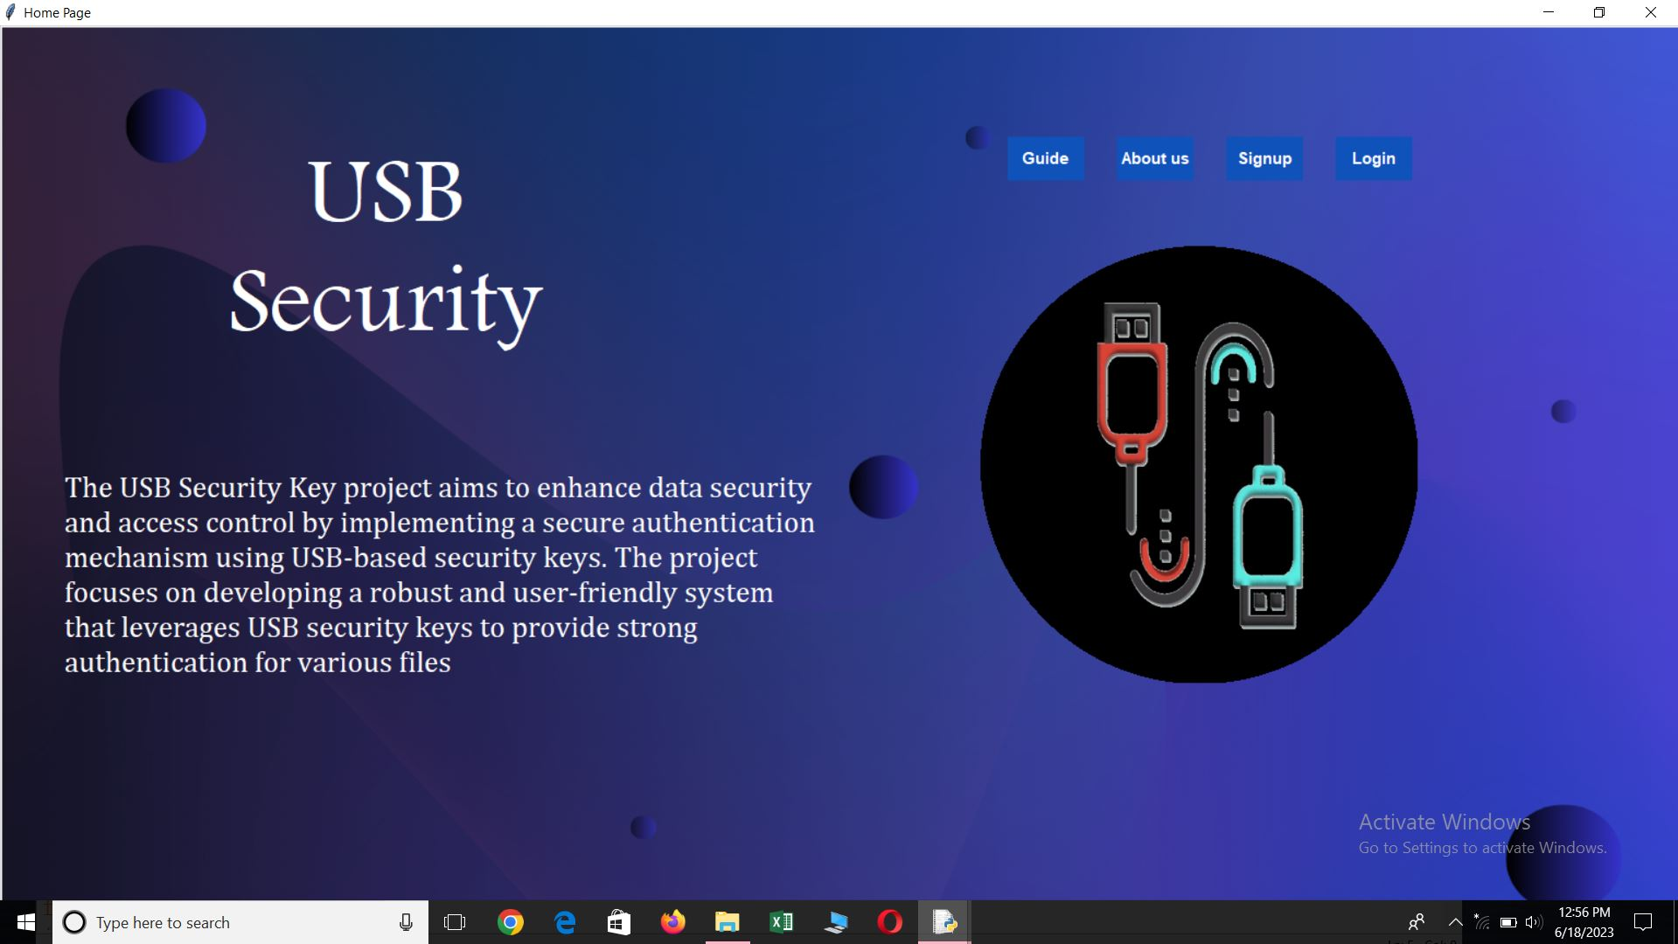

- About Us Page Window (2nd Screen)

import tkinter as tk
import webbrowser
from PIL import ImageTk, Image
from moviepy.editor import VideoFileClip

# Create the main window
window = tk.Tk()
window.title("About Us")

# Create a canvas with a transparent background
canvas = tk.Canvas(window, width=2000, height=1000, bd=0, highlightthickness=0)
canvas.place(x=2, y=2)

image = Image.open("purple.png")
image = image.resize((1600, 1000)) # Adjust the size as per your canvas dimensions

photo = ImageTk.PhotoImage(image)
canvas.create_image(0, 0, image=photo, anchor="nw")

# Function to play the video
def play_video():
video_path = "Blue Purple.mp4"

# Extract a short clip from the video
clip = VideoFileClip(video_path).subclip(0, 10)

# Resize the clip to reduce memory usage
resized_clip = clip.resize(height=670)

# Convert the resized clip to an image sequence
frames = []
for t in range(int(resized_clip.duration * resized_clip.fps)):
frame = resized_clip.get_frame(t / resized_clip.fps)
frames.append(frame)

# Convert the image sequence to a Tkinter-compatible format
images = [ImageTk.PhotoImage(image=Image.fromarray(frame)) for frame in frames]

# Create a label and place the first image on it
video_label = tk.Label(window)
video_label.config(image=images[0])
video_label.image = images[0]
video_label.place(x=190, y=80)

# Function to update the label with the next image
def update_image(idx):
video_label.config(image=images[idx])
video_label.image = images[idx]
window.after(33, lambda: update_image((idx + 1) % len(images))) # Update every 33 ms (30 fps)

# Start updating the label with subsequent images
window.after(33, lambda: update_image(1))

play_video()

# MANOJ INSTA ID
def open_link1(event):
# This function will be called when the link is clicked
webbrowser.open("https://www.instagram.com/mr_manoj7022/")

# Create a label with a link
link_label1 = tk.Label(window, text="@mr_manoj7022", fg="white", bg="#B65FCF", cursor="hand2", font=("Times new Roman", 12))
link_label1.place(x=375, y=555)

# Bind the callback function to the label's click event
link_label1.bind("<Button-1>", open_link1)

# VINAYAK INSTA ID
def open_link2(event):
# This function will be called when the link is clicked
webbrowser.open("https://www.instagram.com/itss_vin_17/")

# Create a label with a link
link_label2 = tk.Label(window, text="@itss_vin_17", fg="white", bg="#B65FCF", cursor="hand2", font=("Times new Roman", 12))
link_label2.place(x=725, y=620)

# Bind the callback function to the label's click event
link_label2.bind("<Button-1>", open_link2)

# VISHAL INSTA ID
def open_link3(event):
# This function will be called when the link is clicked
webbrowser.open("https://www.instagram.com/vishal_k01/")

# Create a label with a link
link_label3 = tk.Label(window, text="@vishal_k01", fg="white", bg="#B65FCF", cursor="hand2", font=("Times new Roman", 12))
link_label3.place(x=1090, y=565)

# Bind the callback function to the label's click event
link_label3.bind("<Button-1>", open_link3)

#---------------Phone no....------------------

# Create a label with a link
label4 = tk.Label(window, text="+91 7022820630", fg="white", bg="#0F52BA", cursor="hand2", font=("Times new Roman", 16))
label4.place(x=355, y=520)

label5 = tk.Label(window, text="+91 9380338484", fg="white", bg="#0F52BA", cursor="hand2", font=("Times new Roman", 16))
label5.place(x=695, y=585)

label6 = tk.Label(window, text="+91 6360430056", fg="white", bg="#0F52BA", cursor="hand2", font=("Times new Roman", 16))
label6.place(x=1055, y=530)

window.mainloop() # Start the Tkinter event loop
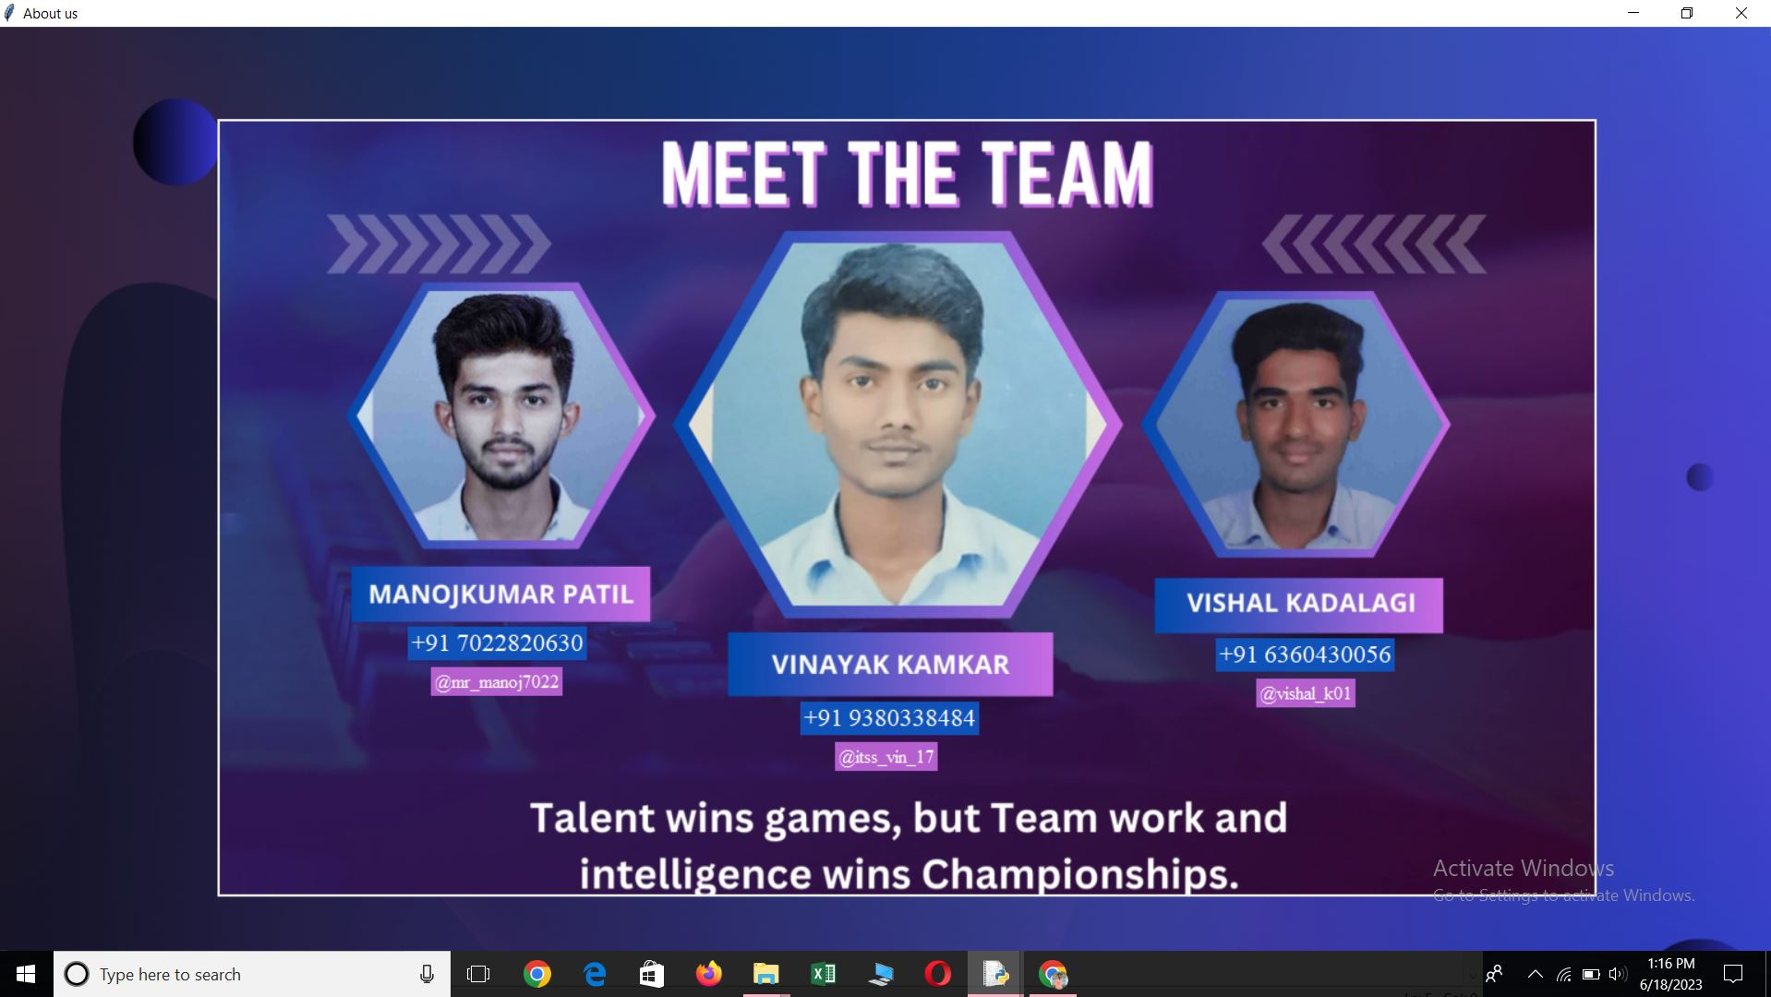
Output:

- Guide Page Window (3rd Screen)

import tkinter as tk
import webbrowser
from PIL import ImageTk, Image
from moviepy.editor import VideoFileClip

# Create the main window
window = tk.Tk()
window.title("Guide")

# Create a canvas with a transparent background
canvas = tk.Canvas(window, width=2000, height=1000, bd=0, highlightthickness=0)
canvas.place(x=2, y=2)

image = Image.open("purple.png")
image = image.resize((1600, 1000)) # Adjust the size as per your canvas dimensions

photo = ImageTk.PhotoImage(image)
canvas.create_image(0, 0, image=photo, anchor="nw")

# Function to play the video
def play_video():
video_path = " guidance.mp4"

# Extract a short clip from the video
clip = VideoFileClip(video_path).subclip(0, 10)

# Resize the clip to reduce memory usage
resized_clip = clip.resize(height=670)

# Convert the resized clip to an image sequence
frames = []
for t in range(int(resized_clip.duration * resized_clip.fps)):
frame = resized_clip.get_frame(t / resized_clip.fps)
frames.append(frame)

# Convert the image sequence to a Tkinter-compatible format
images = [ImageTk.PhotoImage(image=Image.fromarray(frame)) for frame in frames]

# Create a label and place the first image on it
video_label = tk.Label(window)
video_label.config(image=images[0])
video_label.image = images[0]
video_label.place(x=190, y=80)

# Function to update the label with the next image
def update_image(idx):
video_label.config(image=images[idx])
video_label.image = images[idx]
window.after(33, lambda: update_image((idx + 1) % len(images))) # Update every 33 ms (30 fps)

# Start updating the label with subsequent images
window.after(33, lambda: update_image(1))

play_video()

window.mainloop() # Start the Tkinter event loop

Output:
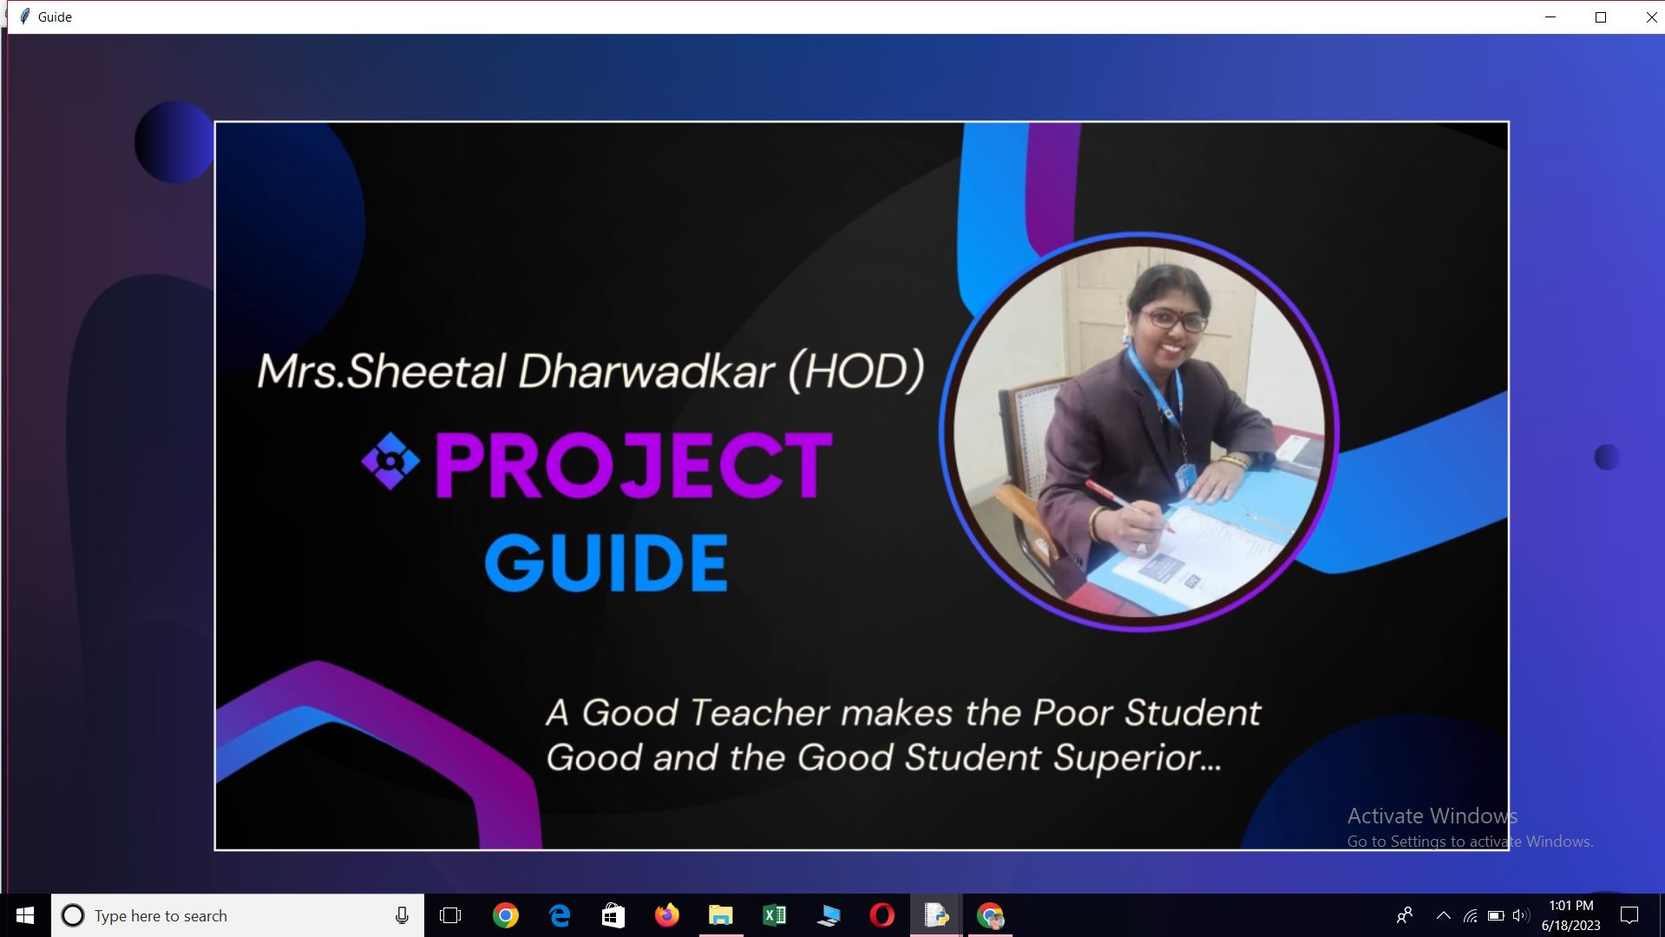

- Signup Page Window (4th Screen)

from tkinter import *
from tkinter import messagebox
import ast
from PIL import ImageTk, Image, ImageDraw
import mysql.connector
import cv2

window = Tk()
window.title("Signup")
window.geometry('925x500+300+200')
window.configure(bg='#fff')

connection = mysql.connector.connect(
host="localhost",
user="root",
password="",
database="user"
)

def insert_values():
cursor = connection.cursor()
sql = ("INSERT INTO userinfo (name, lastname, phoneno, emailid, password, user_name) VALUES (%s, %s, %s, %s, %s, %s)")
val = (name.get(), lastname.get(), phno.get(), email.get(), code.get(), user.get())
cursor.execute(sql, val)
print("Record Inserted Successfully")
connection.commit()
cursor.close()
connection.close()

# Load and resize the background image
background_image = Image.open("purple.png")
background_image = background_image.resize((window.winfo_screenwidth(), window.winfo_screenheight()))
background_photo = ImageTk.PhotoImage(background_image)

# Create a Canvas widget with the same dimensions as the window
canvas = Canvas(window, width=window.winfo_screenwidth(), height=window.winfo_screenheight())
canvas.pack()

# Display the background image on the Canvas
canvas.create_image(0, 0, image=background_photo, anchor=NW)

# Load and resize the transparent image
#transparent_image = Image.open("design1.png")
#transparent_image = transparent_image.resize((1000, 600))
#transparent_photo = ImageTk.PhotoImage(transparent_image)

# Add the transparent image to the Canvas
#canvas.create_image(550, 2, image=transparent_photo, anchor=NW)

# Load and resize the transparent image
#transparent_image1 = Image.open("design2.png")
#transparent_image1 = transparent_image1.resize((1000, 600))
#transparent_photo1 = ImageTk.PhotoImage(transparent_image1)
# Add the transparent image to the Canvas
#canvas.create_image(0, 200, image=transparent_photo1, anchor=NW)

transparent_image2 = Image.open("insideimage-removebg-preview.png")
transparent_image2 = transparent_image2.resize((500, 500))
transparent_photo2 = ImageTk.PhotoImage(transparent_image2)

# Add the transparent image to the Canvas
canvas.create_image(300, 150, image=transparent_photo2, anchor=NW)

transparent_image3 = Image.open("border.png")
transparent_image3 = transparent_image3.resize((570, 620))
transparent_photo3 = ImageTk.PhotoImage(transparent_image3)

# Add the transparent image to the Canvas
canvas.create_image(740, 83, image=transparent_photo3, anchor=NW)

frame = Frame(window, width=350, height=410, bg='#fff')
frame.place(x=850, y=200)

heading = Label(frame, text='Create Account', fg="#57a1f8", bg='white', font=('Microsoft Yahei UI Light', 20, 'bold'))
heading.place(x=65, y=0)

# --------------------
def on_enter(e):
name.delete(0, 'end')
def on_leave(e):
if name.get() == '':
name.insert(0, 'Name')

name = Entry(frame, width=25, fg='black', border=0, bg='white', font=('Microsoft Yahei UI Light', 11))
name.place(x=30, y=45)
name.insert(0, 'Name')
name.bind("<FocusIn>", on_enter)
name.bind("<FocusOut>", on_leave)

Frame(frame, width=295, height=2, bg='black').place(x=25, y=67)

# --------------------
def on_enter(e):
lname.delete(0, 'end')
def on_leave(e):
if lname.get() == '':
lname.insert(0, 'Last Name')

lname = Entry(frame, width=25, fg='black', border=0, bg='white', font=('Microsoft Yahei UI Light', 11))
lname.place(x=30, y=85)
lname.insert(0, 'Last Name')
lname.bind("<FocusIn>", on_enter)
lname.bind("<FocusOut>", on_leave)

Frame(frame, width=295, height=2, bg='black').place(x=25, y=107)

# --------------------
def on_enter(e):
phno.delete(0, 'end')
def on_leave(e):
if phno.get() == '':
phno.insert(0, 'Phone no')

phno = Entry(frame, width=25, fg='black', border=0, bg='white', font=('Microsoft Yahei UI Light', 11))
phno.place(x=30, y=125)
phno.insert(0, 'Phone no')
phno.bind("<FocusIn>", on_enter)
phno.bind("<FocusOut>", on_leave)

Frame(frame, width=295, height=2, bg='black').place(x=25, y=147)

# --------------------
def on_enter(e):
email.delete(0, 'end')
def on_leave(e):
if email.get() == '':
email.insert(0, 'Email id')

email = Entry(frame, width=25, fg='black', border=0, bg='white', font=('Microsoft Yahei UI Light', 11))
email.place(x=30, y=165)
email.insert(0, 'Email id')
email.bind("<FocusIn>", on_enter)
email.bind("<FocusOut>", on_leave)

Frame(frame, width=295, height=2, bg='black').place(x=25, y=187)

# --------------------
def on_enter(e):
user.delete(0, 'end')
def on_leave(e):
if user.get() == '':
user.insert(0, 'Username')

user = Entry(frame, width=25, fg='black', border=0, bg='white', font=('Microsoft Yahei UI Light', 11))
user.place(x=30, y=205)
user.insert(0, 'Username')
user.bind("<FocusIn>", on_enter)
user.bind("<FocusOut>", on_leave)

Frame(frame, width=295, height=2, bg='black').place(x=25, y=227)

# --------------------
def on_enter(e):
code.delete(0, 'end')
def on_leave(e):
if code.get() == '':
code.insert(0, 'Password')

code = Entry(frame, width=25, fg='black', border=0, bg='white', font=('Microsoft Yahei UI Light', 11))
code.place(x=30, y=245)
code.insert(0, 'Password')
code.bind("<FocusIn>", on_enter)
code.bind("<FocusOut>", on_leave)

Frame(frame, width=295, height=2, bg='black').place(x=25, y=267)

# --------------------
def on_enter(e):
conform_code.delete(0, 'end')
def on_leave(e):
if conform_code.get() == '':
conform_code.insert(9, 'Confirm Password')

conform_code = Entry(frame, width=25, fg='black', border=0, bg='white', font=('Microsoft Yahei UI Light', 11))
conform_code.place(x=30, y=285)
conform_code.insert(0, 'Confirm Password')
conform_code.bind("<FocusIn>", on_enter)
conform_code.bind("<FocusOut>", on_leave)

Frame(frame, width=295, height=2, bg='black').place(x=25, y=307)

# -------------

Button(frame, width=39, pady=7, text='Sign up', bg='#57a1f8', fg='white', border=0, command=insert_values).place(x=35, y=327)
label = Label(frame, text='I have an account', fg='black', bg='white', font=('Microsoft YaHei UI Light', 9))
label.place(x=90, y=363)

signin = Button(frame, width=6, text='Sign in', border=0, bg='white', cursor='hand2', fg='#57a1f8')
signin.place(x=200, y=363)

window.mainloop()

Output:

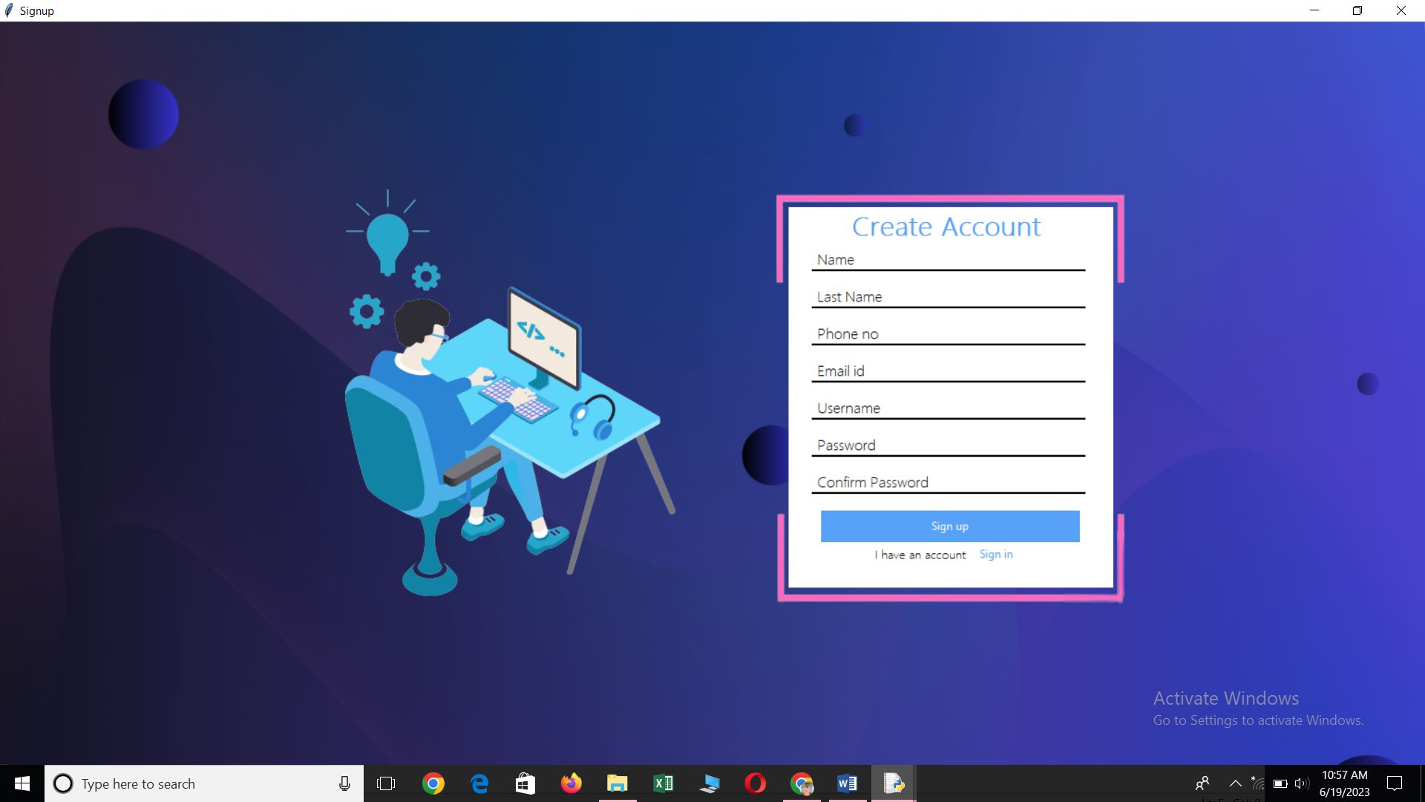

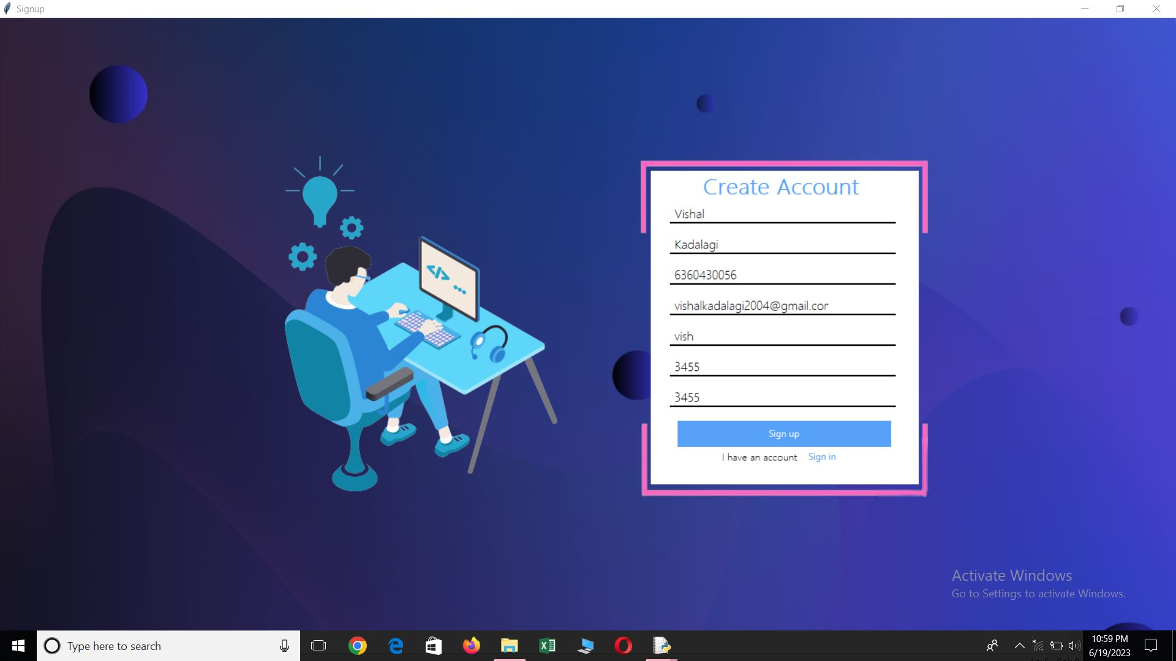

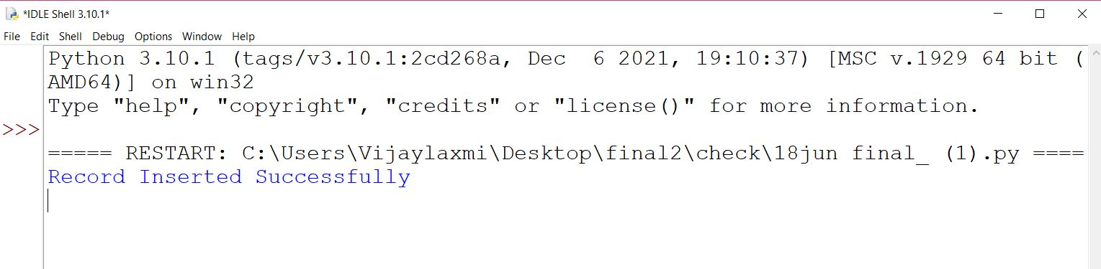

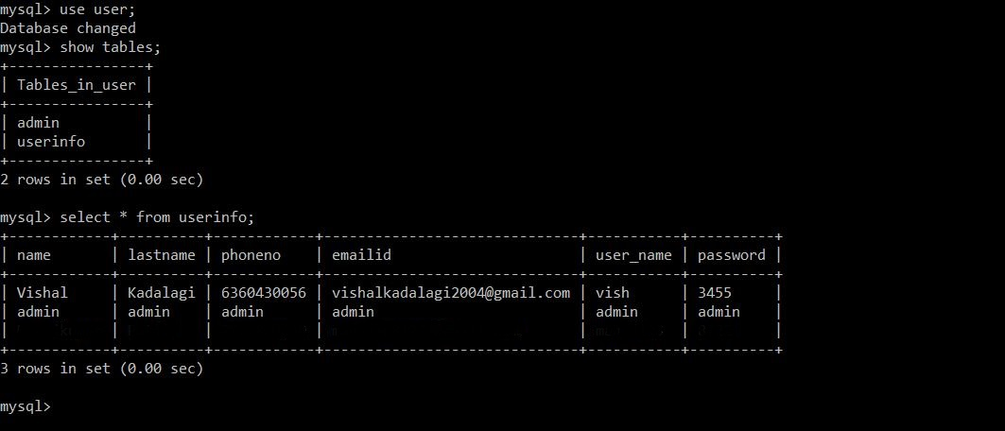

- Login Page Window (5th Screen)

from tkinter import Tk, messagebox, Frame, Button, Label, Entry, Canvas
from PIL import Image, ImageTk, ImageDraw
import mysql.connector
import cv2
import tkinter as tk

window = Tk()
window.title("Login")
window.geometry('925x500+300+200')
window.configure(bg="#fff")
#root.attributes('-fullscreen', True) # Set window as fullscreen

# Create a Canvas
canvas = Canvas(window, width=window.winfo_screenwidth(), height=window.winfo_screenheight(), bg='#fff')
canvas.pack(fill='both', expand=True)

# Load and resize the background image
background_image = Image.open("purple.png")
background_image = background_image.resize((window.winfo_screenwidth(), window.winfo_screenheight()), Image.LANCZOS)
background_image = ImageTk.PhotoImage(background_image)

# Display the background image on the Canvas
canvas.create_image(0, 0, anchor='nw', image=background_image)

# Load and resize the transparent image
transparent_image = Image.open("login image.png")
transparent_image = transparent_image.resize((400, 500))
transparent_photo = ImageTk.PhotoImage(transparent_image)

# Add the transparent image to the Canvas
canvas.create_image(300, 180, image=transparent_photo, anchor='nw')

#window.resizable(False,False)
connection = mysql.connector.connect(
host="localhost",
user="root",
password="",
database="user"
)

def signin():
cursor = connection.cursor()
query = ("SELECT * FROM userinfo WHERE user_name = %s and password = %s")
val = (user.get(), code.get())
cursor.execute(query, val)
if not cursor.fetchone():
print("The record does not exist.")
# if (val[0]=='admin' and val[1]=='admin'):

transparent_image1 = Image.open("border.png")
transparent_image1 = transparent_image1.resize((570, 530))
transparent_photo1 = ImageTk.PhotoImage(transparent_image1)

# Add the transparent image to the Canvas
canvas.create_image(840, 120, image=transparent_photo1, anchor='nw')

frame = Frame(window, width=350, height=350, bg="white")
frame.place(x=950, y=220)

heading = Label(frame, text='Login', fg='#57a1f8', bg='white', font=('Tahoma', 23, 'bold'))
heading.place(x=120, y=10)

###########----------------------------------------------------

def on_enter(e):
user.delete(0, 'end')

def on_leave(e):
name = user.get()
if name == '':
user.insert(0, 'Username')

user = Entry(frame, width=25, fg='black', border=0, bg='white', font=('Tahoma', 11))
user.place(x=30, y=90)
user.insert(0, 'Username')
user.bind('<FocusIn>', on_enter)
user.bind('<FocusOut>', on_leave)

Frame(frame, width=295, height=2, bg='black').place(x=25, y=117)

###########-----------------------------------------------------

def on_enter(e):
code.delete(0, 'end')

def on_leave(e):
name = code.get()
if name == '':
code.insert(0, 'Password')

code = Entry(frame, width=25, fg='black', border=0, bg='white', font=('Tahoma', 11))
code.place(x=30, y=160)
code.insert(0, 'Password')
code.bind('<FocusIn>', on_enter)
code.bind('<FocusOut>', on_leave)

Frame(frame, width=295, height=2, bg='black').place(x=25, y=187)

###############################################################

Button(frame, width=39, pady=7, text='Sign in', bg='#57a1f8', fg='white', border=0, command=signin).place(x=35, y=219)
label = Label(frame, text="Don't have an account?", fg='black', bg='white', font=('Tahoma', 9))
label.place(x=75, y=280)

sign_up = Button(frame, width=6, text='Sign up', border=0, bg='white', cursor='hand2', fg='#57a1f8')
sign_up.place(x=215, y=280)

window.mainloop()

Output:
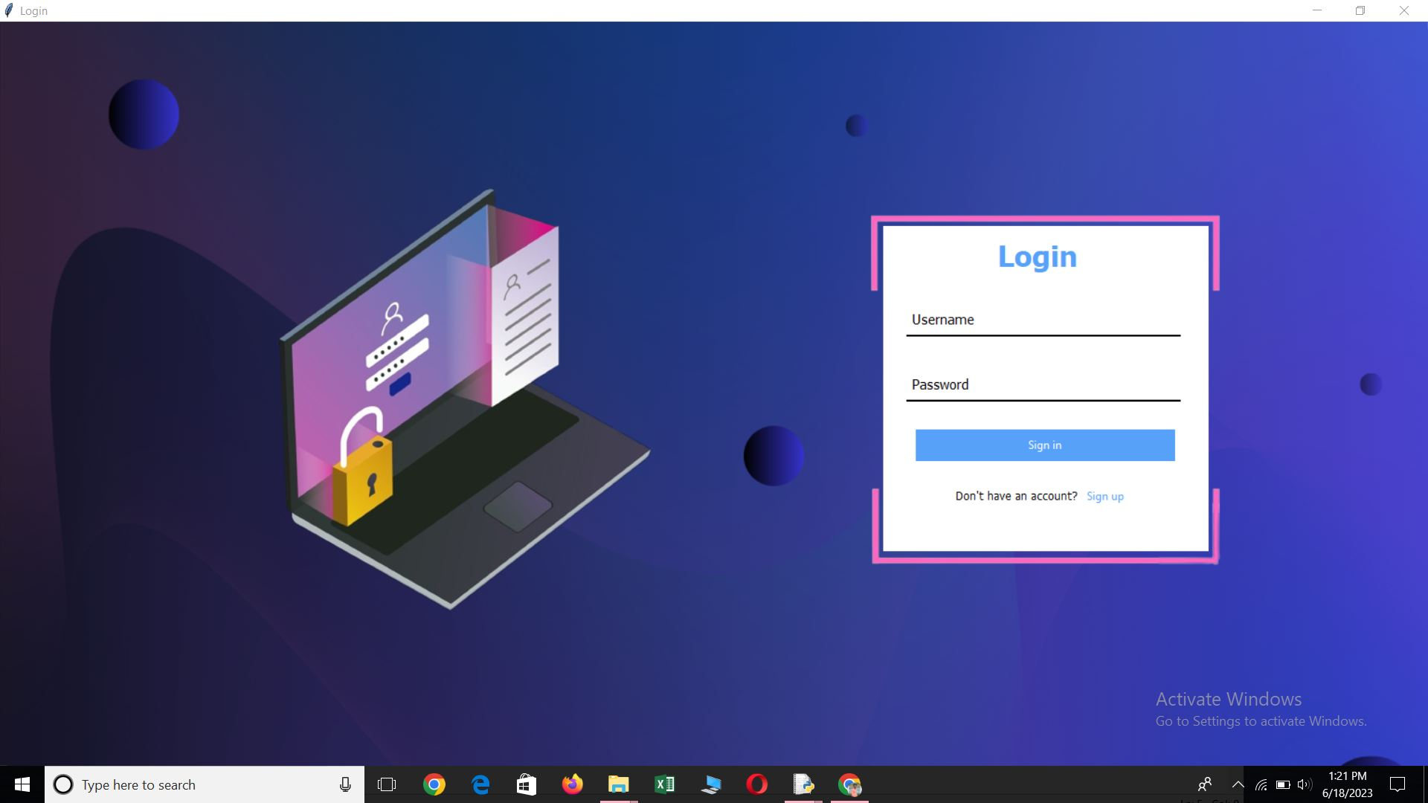

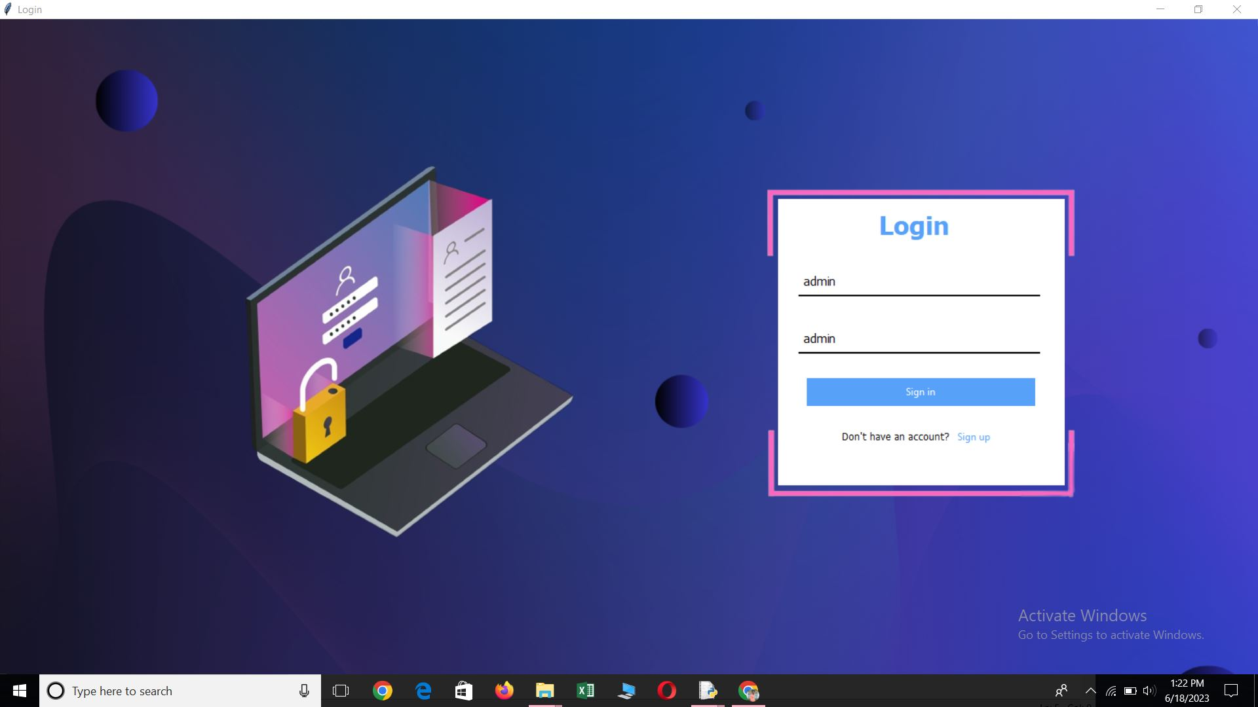

- Key-Generation(Email otp) Page Window (6th Screen)

import tkinter as tk
from tkinter import messagebox
import cv2
from PIL import ImageTk, Image, ImageDraw
import secrets
from email.mime.text import MIMEText
from email.mime.multipart import MIMEMultipart
import smtplib
import mysql.connector

root = tk.Tk()
root.title("USB Security - Key Generator")

def generate_key():
def insert_db(otp):
connection = mysql.connector.connect(
host="localhost",
user="root",
password="",
database="user"
)
cursor = connection.cursor()
query = "INSERT INTO admin VALUES (%s)"
val = (str(otp), )
cursor.execute(query, val)
connection.commit()
cursor.close()
connection.close()

def send_otp(sender_email, otp):
server = smtplib.SMTP('smtp.gmail.com', 587)
server.starttls()
server.login('vishalkadalagi2004@gmail.com', 'qfjulxrdczpxnqzx')

subject = 'Security Key'
message = MIMEMultipart()
message['From'] = 'vishalkadalagi2004@gmail.com'
message['To'] = 'manojmp81977@gmail.com'
message['Subject'] = subject

body = 'Your OTP is ' + str(otp)
message.attach(MIMEText(body, 'plain'))

server.sendmail('vishalkadalagi2004@gmail.com', 'manojmp81977@gmail.com', message.as_string())
print("OTP sent successfully")
server.quit()

# Generate a security key with numbers only
security_key = ''.join(secrets.choice('0123456789') for _ in range(4))
messagebox.showinfo("Alert", f"The Decryption Key has sent to the Email id")

sender_email = 'vishalkadalagi2004@gmail.com' # Enter the sender's email address here
send_otp(sender_email, security_key)
insert_db(security_key)

# Create a canvas with a transparent background
canvas = tk.Canvas(root, width=1600, height=1000, bd=0, highlightthickness=0)
canvas.place(x=-40, y=0)

# Load and resize the background image
image = Image.open("blured 1.png")
image = image.resize((1600, 1000))
photo = ImageTk.PhotoImage(image)
canvas.create_image(0, 0, image=photo, anchor="nw")

# Render the transparent label text on the canvas
text = "USB Security Key Generator"
canvas.create_text(800, 100, text=text, fill="white", font=("Times New Roman", 35, "bold"), anchor="center")

# Create label buttons on the canvas
button1 = tkinter.Label(w4, text="Generate Security Key")
button1.configure(bg='#0F52BA', fg='white', font=("Arial", 15, "bold"))
button1.bind("<Button-1>", generate_key_button)

button1_window = canvas.create_window(680, 600, anchor="nw", window=button1, width=250, height=50)

# Load the video frames
frames = []
video_path = "key logo.mp4" # Update the file path to your video file

video = cv2.VideoCapture(video_path)
while True:
ret, frame = video.read()
if not ret:
break
# Convert frame to RGBA format with alpha channel
frame = cv2.cvtColor(frame, cv2.COLOR_BGR2RGBA)
image = Image.fromarray(frame)
image = image.resize((400, 400)) # Adjust the size as per your requirements

# Create a circular mask
mask = Image.new('L', image.size, 0)
draw = ImageDraw.Draw(mask)
draw.ellipse((0, 0, image.size[0], image.size[1]), fill=255)

# Apply the circular mask to the frame
image.putalpha(mask)

frame = ImageTk.PhotoImage(image)
frames.append(frame)

video.release()

# Function to update the canvas with the next frame
def update_frame(idx):
if idx < len(frames):
canvas.itemconfig(video_frame, image=frames[idx])
root.after(100, update_frame, (idx + 1) % len(frames))

# Create an initial image item on the canvas
video_frame = canvas.create_image(800, 370, anchor="center")

# Start updating the canvas with video frames
root.after(0, update_frame, 0)

root.mainloop()

Output:

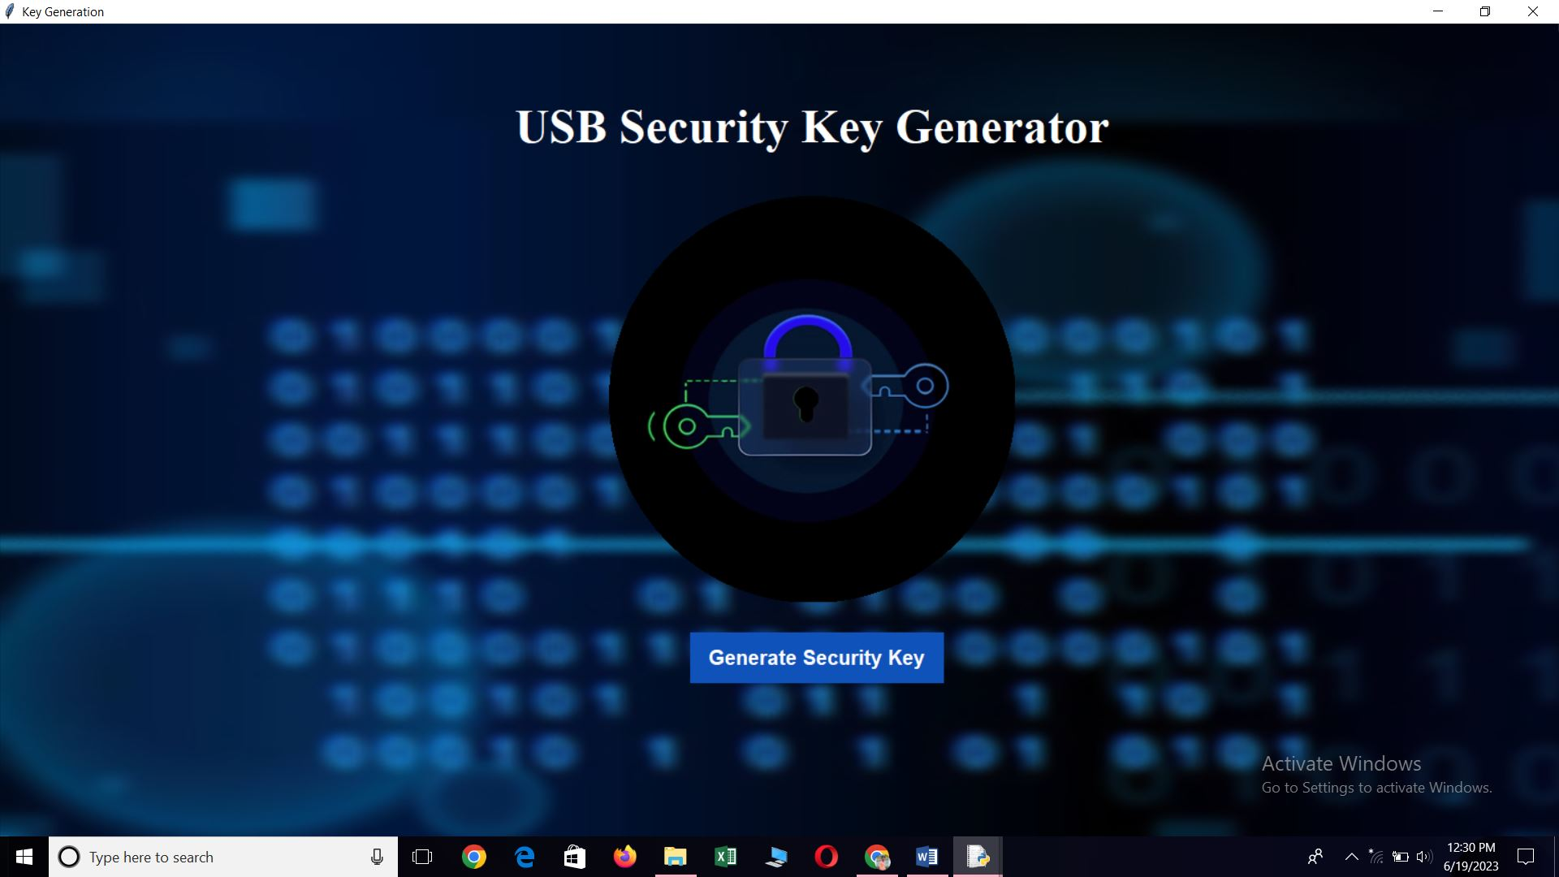

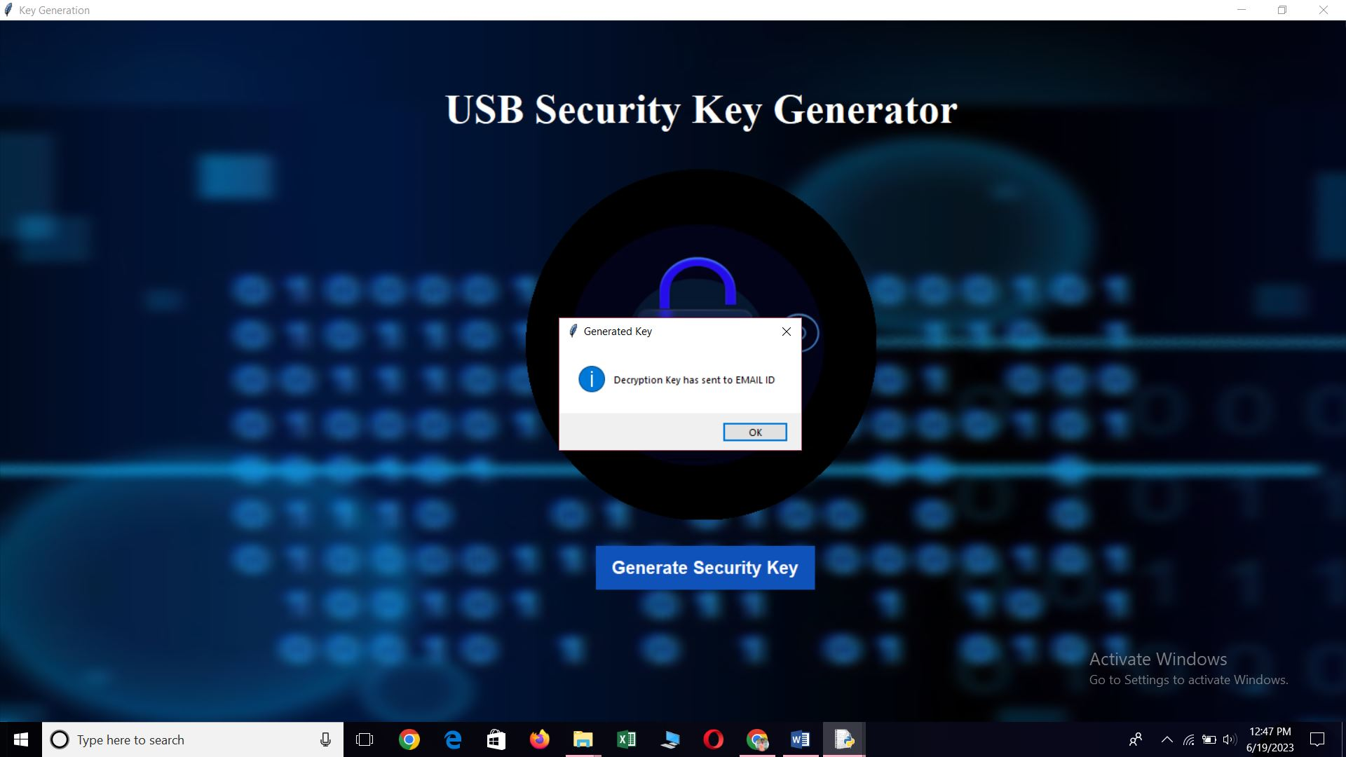

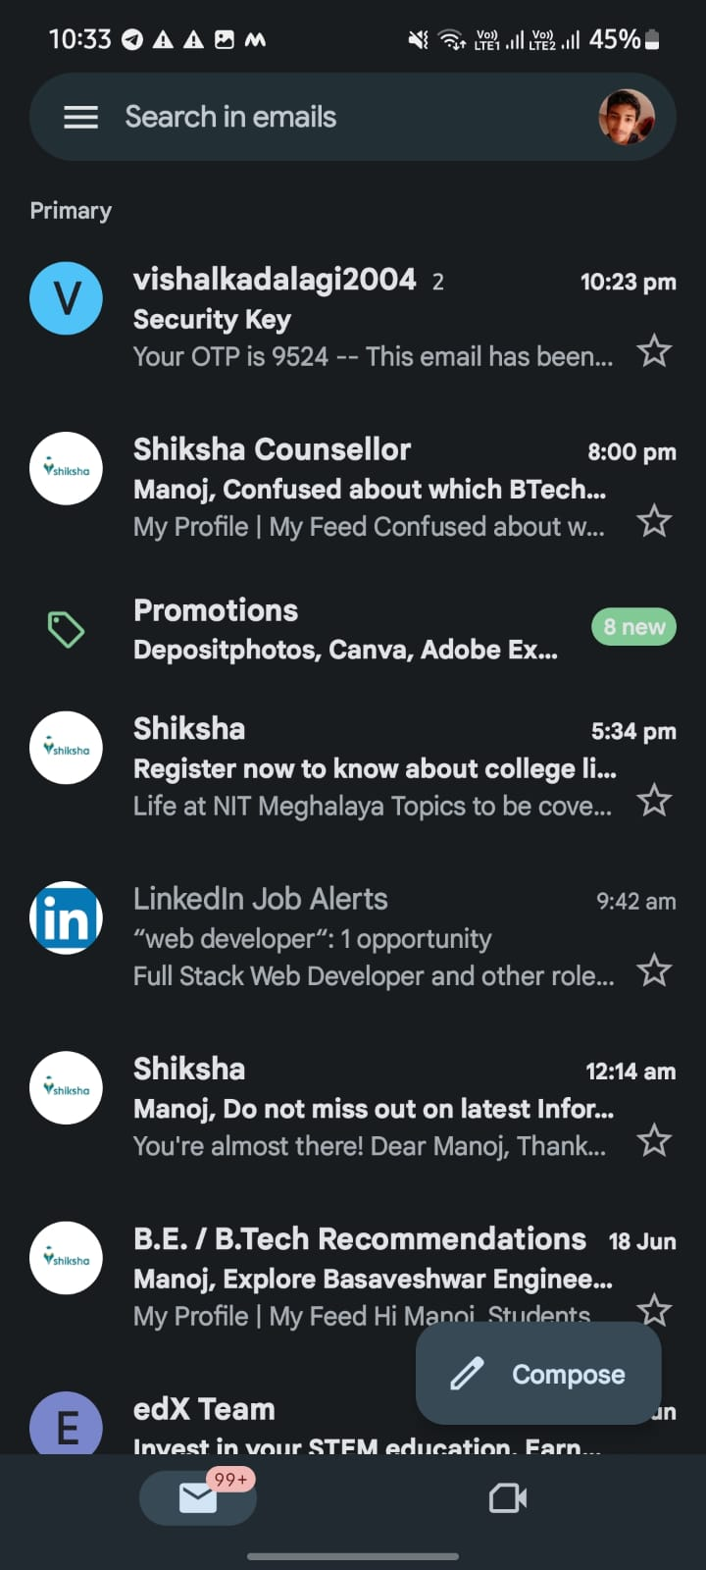
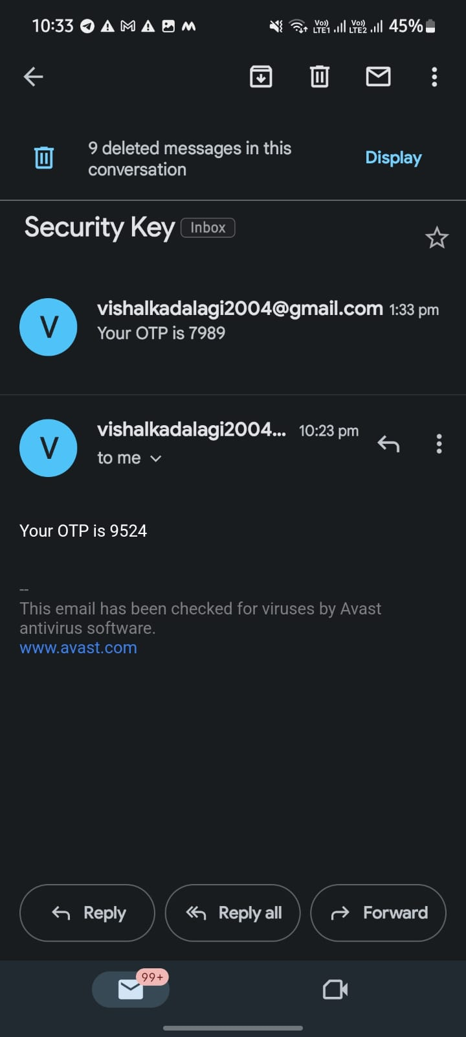
- USB Detection Page Window (7th Screen)

import subprocess
from tkinter import Button, Canvas, Label, Tk
from PIL import Image, ImageTk
import cv2
import numpy as np

window = Tk()
window.title("USB Detection")
window.geometry('925x500+300+200')
window.configure(bg="#fff")

# Function to check if a removable disk is detected
def check_removable_disk():
out = subprocess.check_output('wmic logicaldisk get DriveType, caption', shell=True)
for drive in str(out).strip().split('\\r\\r\\n'):
if '2' in drive:
drive_letter = drive.split(':')[0]
drive_type = drive.split(':')[1].strip()
if drive_type == '2':
return True
return False

# Function to execute when the button is clicked
def button_click():
if check_removable_disk():
play_video("usb2.mp4")
label.config(text="Removable disk detected")
else:
play_video("usbnot1.mp4")
label.config(text="Removable disk not detected")

# Function to play the transparent video
def play_video(video_path):
video = cv2.VideoCapture(video_path)
if video.isOpened():
width = int(video.get(cv2.CAP_PROP_FRAME_WIDTH))
height = int(video.get(cv2.CAP_PROP_FRAME_HEIGHT))
resized_width = 400
resized_height = 400 * height // width

# Create a circular mask
mask = np.zeros((resized_height, resized_width), dtype=np.uint8)
center = (resized_width // 2, resized_height // 2)
radius = min(center) - 10
cv2.circle(mask, center, radius, (255, 255, 255), -1, cv2.LINE_AA)

# Function to update the canvas with the next video frame
def update_frame():
ret, frame = video.read()
if ret:
frame = cv2.cvtColor(frame, cv2.COLOR_BGR2RGBA)
frame = cv2.resize(frame, (resized_width, resized_height)) # Resize the frame
frame = cv2.bitwise_and(frame, frame, mask=mask) # Apply circular mask
image = Image.fromarray(frame)
photo = ImageTk.PhotoImage(image)
canvas.create_image(570, 280, anchor='nw', image=photo)
canvas.image = photo
window.after(30, update_frame)

else:
video.set(cv2.CAP_PROP_POS_FRAMES, 0) # Reset to the beginning of the video
update_frame()

# Start updating the canvas with video frames
update_frame()

# Create a Canvas
canvas = Canvas(window, width=window.winfo_screenwidth(), height=window.winfo_screenheight(), bg='#fff')
canvas.pack(fill='both', expand=True)

# Load and resize the background image
background_image = Image.open("usb1.png")
background_image = background_image.resize((window.winfo_screenwidth(), window.winfo_screenheight()), Image.LANCZOS)
background_image = ImageTk.PhotoImage(background_image)

# Display the background image on the Canvas
canvas.create_image(0, 0, anchor='nw', image=background_image)

# Create the label
label = Label(window, text="", fg='white', bg='black', font=('Times new Roman', 55))
label.place(relx=0.5, rely=0.2, anchor='center') # Place the label at the center of the window

# Create the button
button = Button(window, text="Check", command=button_click, bg='black', fg='white', font=('Arial', 17))
button.place(relx=0.5, rely=0.3, anchor='center') # Place the button below the label

# Start the Tkinter event loop
window.mainloop()

Output:

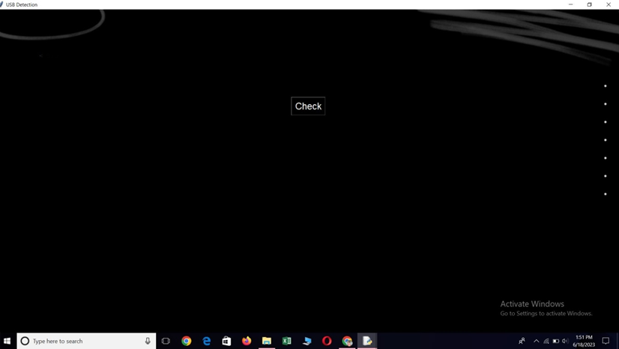

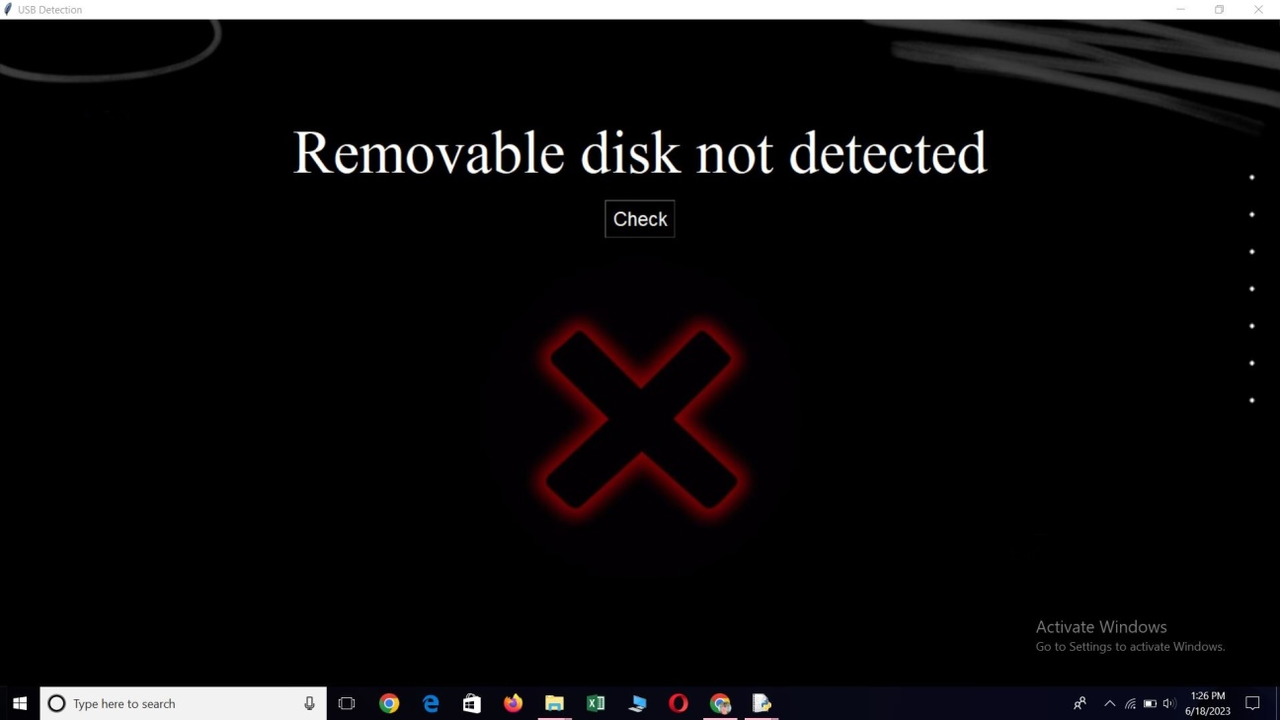

Here the USB is not connected, so kindly plug in the USB and rerun the Program

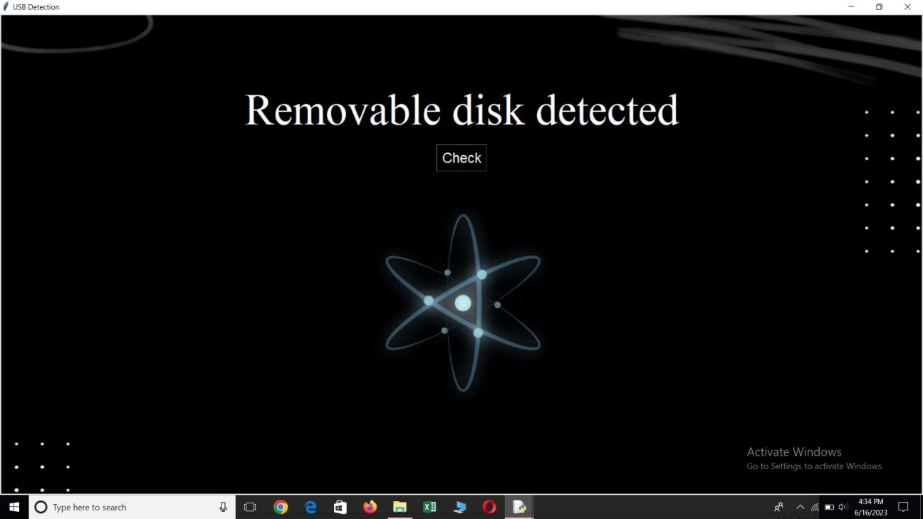

Here USB has connected

- Directory Page Window (8th Screen)

import tkinter as tk
from tkinter import filedialog
import os
from tkinter import ttk
from tkinter import messagebox
from PIL import ImageTk, Image

# Function to list files and directories
def list_files(directory):
root = next(os.walk(directory))[0] # path
dirnames = next(os.walk(directory))[1] # list of directories
files = next(os.walk(directory))[2] # list of files

trv.delete(*trv.get_children()) # Clear existing treeview items

# Insert directories into the treeview
for i, d in enumerate(dirnames, start=1):
trv.insert("", 'end', iid=i, values=d)

path2 = os.path.join(directory, d) # Path for subdirectory
files2 = next(os.walk(path2))[2] # file list of subdirectory

# Insert files within subdirectories into the treeview
for j, f2 in enumerate(files2, start=i*10):
trv.insert(i, 'end', iid='sub'+str(j), values="-"+f2)

# Insert files into the treeview
for k, f in enumerate(files, start=len(dirnames)+1):
trv.insert("", 'end', iid=k, values=f)

# Function to open the selected file
def open_file():
item_id = trv.focus() # Get the selected item
item = trv.item(item_id)
values = item['values']
if values and len(values) > 0 and not values[0].startswith('-'): # If it's a file
file_path = os.path.join(l1.cget("text"), values[0])
os.startfile(file_path)

# Function to handle the decryption key acceptance
def dcription_key_accept(event):
t1.grid(row=5, column=5)
gobtn = tk.Button(my_w, text="Go", command=check_db)
gobtn.grid(row=5, column=7)

# Function to check the decryption key in the database
def check_db():
# Add your database connection code here

# Example code to demonstrate the functionality
key = t1.get() # Get the decryption key from the entry field
if key == "admin":
open_file()
else:
messagebox.showinfo("Access Denied", "Incorrect decryption key.")

# Function to open the directory selection dialog
def open_directory():
directory = filedialog.askdirectory()
if directory:
l1.config(text=directory)
list_files(directory)

# Create the main window
my_w = tk.Tk()
my_w.title("Listing files and dirs") # Title

# Create a canvas with a purple background
canvas = tk.Canvas(my_w, width=2000, height=1000, bd=0, highlightthickness=0)
canvas.place(x=2, y=2)

image = Image.open("purple.png")
image = image.resize((1600, 1000)) # Adjust the size as per your canvas dimensions

photo = ImageTk.PhotoImage(image)
canvas.create_image(0, 0, image=photo, anchor="nw")

# Render the transparent label text on the canvas
text = "Enter Decryption Key"
canvas.create_text(610, 650, text=text, fill="white", font=("Times New Roman", 18), anchor="center")

# Button to select directory
b1 = tk.Button(my_w, text='Select Directory', font=15, command=open_directory, bg='lightblue')
b1.grid(row=0, column=0, padx=5, pady=10)

# Entry field for decryption key
t1 = tk.Entry(my_w)

# Label to display the selected directory path
l1 = tk.Label(my_w, text='', bg='white', font=16)
l1.grid(row=0, column=1, padx=20)

# Treeview to display files and directories
trv = ttk.Treeview(my_w, selectmode='browse', height=30)
trv.grid(row=1, column=0, columnspan=2, padx=20, pady=0)
trv["columns"] = ("1")
trv['show'] = 'tree headings'
trv.column("#0", width=20, anchor='c')
trv.column("1", width=300, anchor='w')
trv.heading("#0", text="#")
trv.heading("1", text="Name", anchor='w')

# Bind double-click event to open_file function
trv.bind("<Double-1>", dcription_key_accept)

# Load and resize the transparent image
transparent_image = Image.open("disp ima.png")
transparent_image = transparent_image.resize((800, 1100))
transparent_photo = ImageTk.PhotoImage(transparent_image)

# Add the transparent image to the Canvas
canvas.create_image(600, -220, image=transparent_photo, anchor='nw')

# Start the main event loop
my_w.mainloop()

Output:

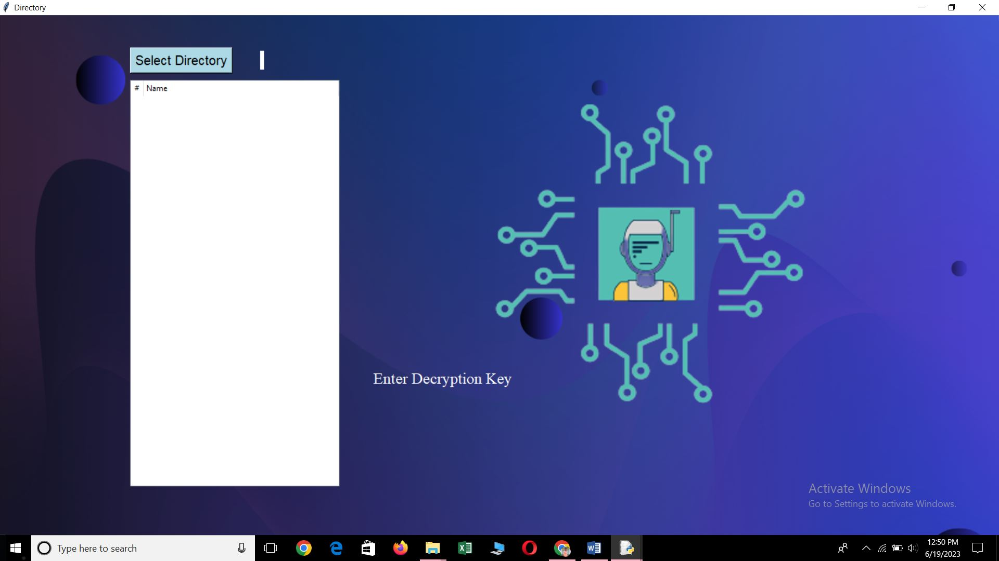

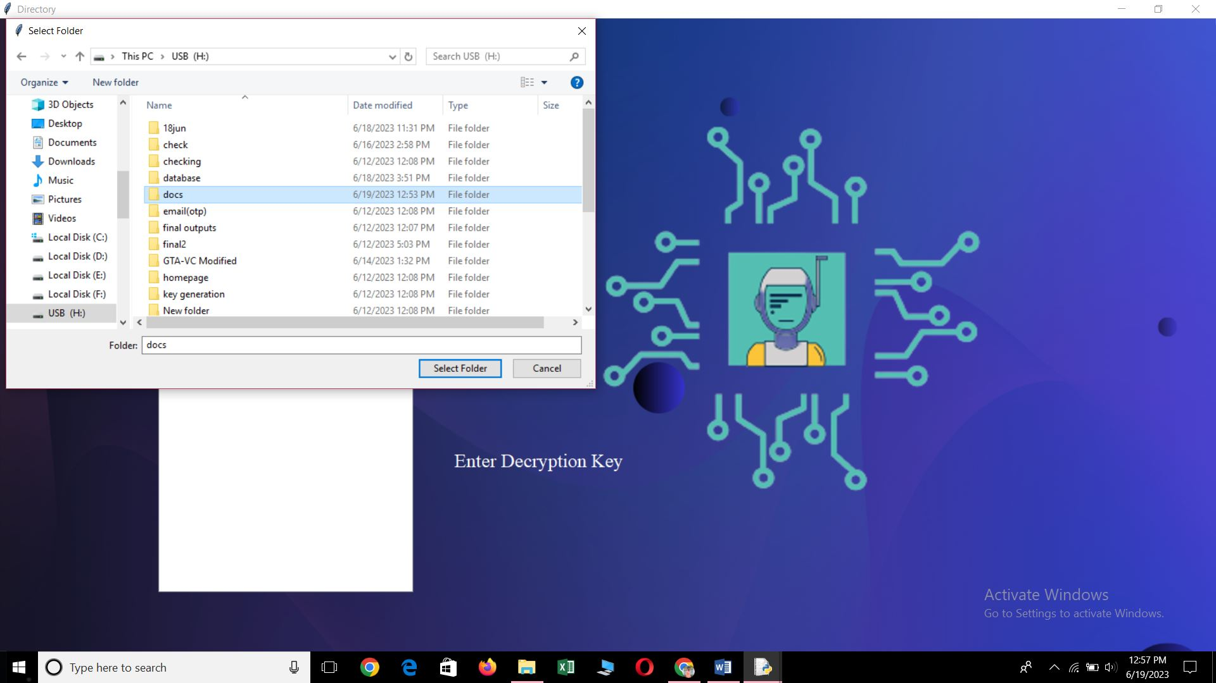

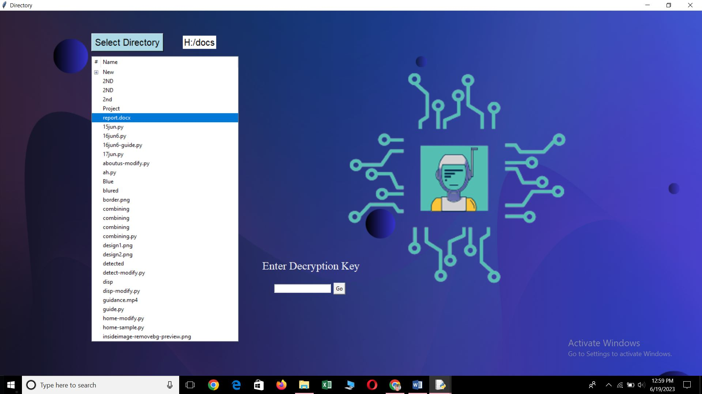

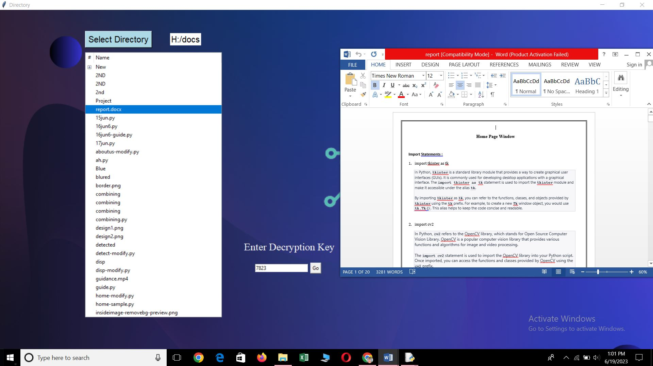

My_SQL connection

- Create Database
Name : user

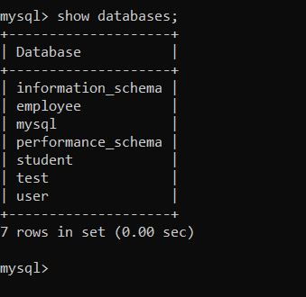

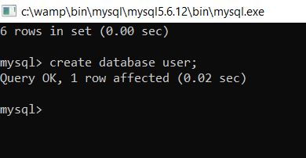

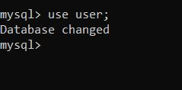

- Create table
Name : userifo

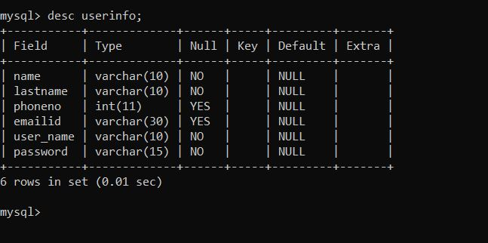

- Create table
Name : admin

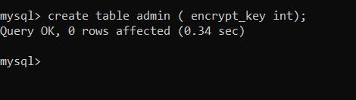

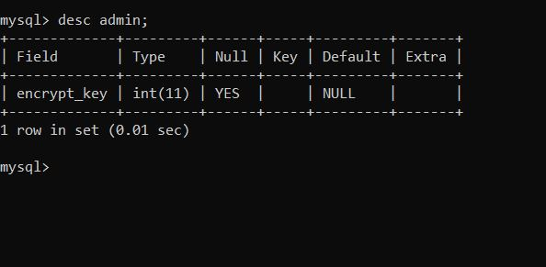

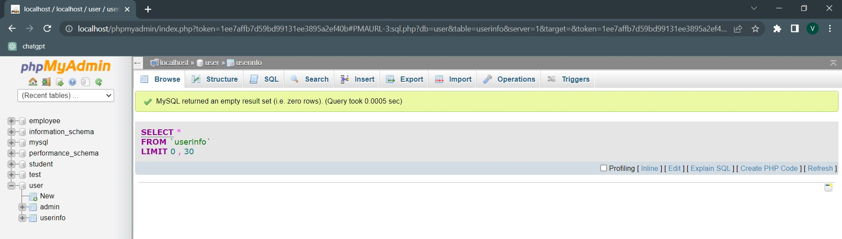
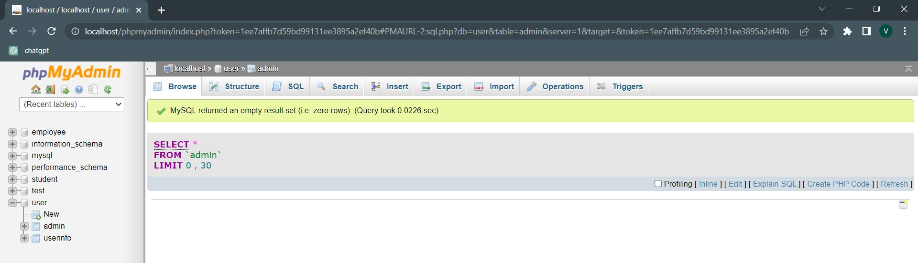
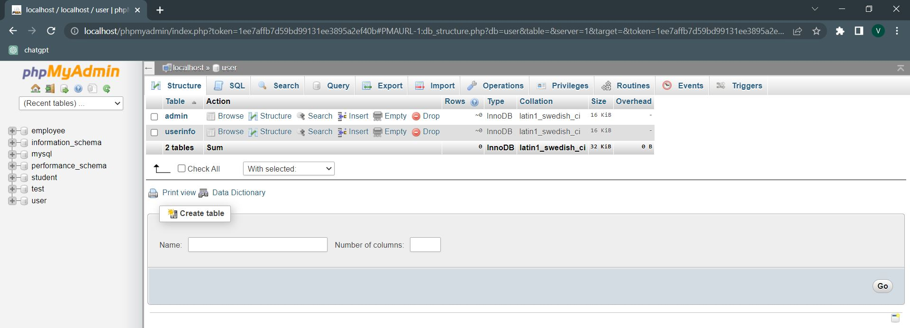
Combining all the Windows with Codes and their Screenshots

#-----------Check USB Software------#
import tkinter as tk
import cv2
from PIL import ImageTk, Image, ImageDraw
import subprocess
from tkinter import messagebox
import sys
#--------Check USB Software END----#

#------Home Page----#
import tkinter as tk
import cv2
from PIL import ImageTk, Image, ImageDraw
#-------Home Page END------#

#------About us------#
import tkinter
from PIL import Image, ImageTk
import webbrowser
from moviepy.editor import *
import cv2
from PIL import Image, ImageDraw
from PIL import Image

#------About us END------#

#-------Guide---------#
import tkinter
from PIL import Image, ImageTk
import webbrowser
from moviepy.editor import *
import cv2
from PIL import Image, ImageDraw
from PIL import Image
#--------Guide End-----#

#------Signup------#
from tkinter import *
from tkinter import messagebox
import ast
from PIL import ImageTk, Image, ImageDraw
import mysql.connector
import cv2
import subprocess
#------Signup END------#

#-------Login------#
from tkinter import Tk, messagebox, Frame, Button, Label, Entry, Canvas
from PIL import Image, ImageTk, ImageDraw
import mysql.connector
import cv2
import tkinter as tk
#-------Login END-----#

#--------KEY GENERATION WITH EMAIL OTP-------#
import tkinter
import mysql.connector
import smtplib
from email.mime.multipart import MIMEMultipart
from email.mime.text import MIMEText
import secrets
from PIL import Image, ImageTk, ImageDraw
import cv2
import numpy as np
from tkinter import messagebox
#---------KEY GENERATION WITH EMAIL OTP END------#

#---------DISP---------#
import tkinter as tk
from tkinter import Tk, Canvas
from PIL import ImageTk, Image
from tkinter import filedialog
import os
from tkinter import ttk
from tkinter import messagebox
from tkinter import *
import mysql.connector
#--------DISP END------#

#-------USB Detection------#
import subprocess
from tkinter import Button, Canvas, Label, Tk
from PIL import Image, ImageTk
import cv2
import numpy as np
#-------USB Detection END-----#

###########-----------------About us----------------#############
def fun1(event):
global w1
w1 = tkinter.Toplevel()
w1.title("About us")

canvas = tkinter.Canvas(w1, width=1600, height=1000, bd=0, highlightthickness=0)
canvas.pack()

image = Image.open("purple.png")
image = image.resize((1600, 1000))
photo = ImageTk.PhotoImage(image)
# Keep a reference to the photo object to prevent it from being garbage-collected
canvas.image = photo
canvas.create_image(0, 0, image=photo, anchor="nw")

# Rest of the code...

def play_video():
video_path = "Blue Purple.mp4"
clip = VideoFileClip(video_path).subclip(0, 10)
resized_clip = clip.resize(height=670)

frames = []
for t in range(int(resized_clip.duration * resized_clip.fps)):
frame = resized_clip.get_frame(t / resized_clip.fps)
frames.append(frame)

images = [ImageTk.PhotoImage(image=Image.fromarray(frame)) for frame in frames]

video_label = tkinter.Label(w1)
video_label.config(image=images[0])
video_label.image = images[0]
video_label.place(x=190, y=80)

def update_image(idx):
video_label.config(image=images[idx])
video_label.image = images[idx]
w1.after(33, lambda: update_image((idx + 1) % len(images)))

w1.after(33, lambda: update_image(1))

play_video()

def open_link1(event):
webbrowser.open("https://www.instagram.com/mr_manoj7022/")

link_label1 = tkinter.Label(w1, text="@mr_manoj7022", fg="white", bg="#B65FCF", cursor="hand2", font=("Times new Roman", 12))
link_label1.place(x=375, y=555)
link_label1.bind("<Button-1>", open_link1)

def open_link2(event):
webbrowser.open("https://www.instagram.com/itss_vin_17/")

link_label2 = tkinter.Label(w1, text="@itss_vin_17", fg="white", bg="#B65FCF", cursor="hand2", font=("Times new Roman", 12))
link_label2.place(x=725, y=620)
link_label2.bind("<Button-1>", open_link2)

def open_link3(event):
webbrowser.open("https://www.instagram.com/vishal_k01/")

link_label3 = tkinter.Label(w1, text="@vishal_k01", fg="white", bg="#B65FCF", cursor="hand2", font=("Times new Roman", 12))
link_label3.place(x=1090, y=565)
link_label3.bind("<Button-1>", open_link3)

label4 = tkinter.Label(w1, text="+91 7022820630", fg="white", bg="#0F52BA", cursor="hand2", font=("Times new Roman", 16))
label4.place(x=355, y=520)

label5 = tkinter.Label(w1, text="+91 9380338484", fg="white", bg="#0F52BA", cursor="hand2", font=("Times new Roman", 16))
label5.place(x=695, y=585)

label6 = tkinter.Label(w1, text="+91 6360430056", fg="white", bg="#0F52BA", cursor="hand2", font=("Times new Roman", 16))
label6.place(x=1055, y=530)

# Create label buttons on the canvas
w1b1 = tkinter.Label(w1, text="< Back")
w1b1.configure(bg='#0F52BA', fg='white', font=("Arial", 11, "bold"))
w1b1.bind("<Button-1>", fun1_back)

w1b1_window = canvas.create_window(100, 100, anchor="nw", window=w1b1, width=60, height=30)

def fun1_back(event):
w1.destroy()

###########----------ABOUT US END---------################

##########----------------Guide---------------###########
def gui(event):
global w8
w8 = tkinter.Toplevel()
w8.title("Guide")

canvas = tkinter.Canvas(w8, width=1600, height=1000, bd=0, highlightthickness=0)
canvas.pack()

image = Image.open("purple.png")
image = image.resize((1600, 1000))
photo = ImageTk.PhotoImage(image)
# Keep a reference to the photo object to prevent it from being garbage-collected
canvas.image = photo
canvas.create_image(0, 0, image=photo, anchor="nw")

# Rest of the code...

def play_video():
video_path = "guidance.mp4"
clip = VideoFileClip(video_path).subclip(0, 10)
resized_clip = clip.resize(height=670)

frames = []
for t in range(int(resized_clip.duration * resized_clip.fps)):
frame = resized_clip.get_frame(t / resized_clip.fps)
frames.append(frame)

images = [ImageTk.PhotoImage(image=Image.fromarray(frame)) for frame in frames]

video_label = tkinter.Label(w8)
video_label.config(image=images[0])
video_label.image = images[0]
video_label.place(x=190, y=80)

def update_image(idx):
video_label.config(image=images[idx])
video_label.image = images[idx]
w8.after(33, lambda: update_image((idx + 1) % len(images)))

w8.after(33, lambda: update_image(1))

play_video()

# Create label buttons on the canvas
w8b8 = tkinter.Label(w8, text="< Back")
w8b8.configure(bg='#0F52BA', fg='white', font=("Arial", 11, "bold"))
w8b8.bind("<Button-1>", gui_back)

w8b8_window = canvas.create_window(100, 100, anchor="nw", window=w8b8, width=60, height=30)

def gui_back(event):
w8.destroy()

##########----------------Guide End---------------###########

##########-----------------SIGNUP----------------###########

def fun2(event):
global w2
w2 = tkinter.Toplevel()
w2.title("Signup")
#w2.geometry('800x770+10+10')
#w2.configure(bg='#fff')

connection = mysql.connector.connect(
host="localhost",
user="root",
password="",
database="user"
)

def insert_values():
cursor = connection.cursor()
sql = ("INSERT INTO userinfo (name, lastname, phoneno, emailid, password, user_name) VALUES (%s, %s, %s, %s, %s, %s)")
val = (name.get(), lname.get(), phno.get(), email.get(), code.get(), user.get())
cursor.execute(sql, val)
print("Record Inserted Successfully")
messagebox.showinfo("Success", "Record Inserted Successfully")
connection.commit()
cursor.close()
connection.close()
#messagebox.showinfo("Success", "Record Inserted Successfully")

canvas = tkinter.Canvas(w2, width=1600, height=1000, bd=0, highlightthickness=0)
canvas.pack()

###----image1----###
# Open and resize the first image
image1 = Image.open("purple.png")
image1 = image1.resize((1600, 1000))
photo1 = ImageTk.PhotoImage(image1)

# Keep a reference to the photo object to prevent it from being garbage-collected
canvas.image1 = photo1

# Create the first image on the canvas
canvas.create_image(0, 0, image=photo1, anchor="nw")
###----image1 END----###

###----image4----###
# Open and resize the fourth image
image4 = Image.open("insideimage-removebg-preview.png")
image4 = image4.resize((500, 500))
photo4 = ImageTk.PhotoImage(image4)

# Keep a reference to the photo object to prevent it from being garbage-collected
canvas.image4 = photo4

# Create the fourth image on the canvas
canvas.create_image(300, 150, image=photo4, anchor="nw")
###----image4 END----###

###----image5----###
# Open and resize the fifth image
image5 = Image.open("border.png")
image5 = image5.resize((570, 620))
photo5 = ImageTk.PhotoImage(image5)

# Keep a reference to the photo object to prevent it from being garbage-collected
canvas.image5 = photo5

# Create the fifth image on the canvas
canvas.create_image(740, 83, image=photo5, anchor="nw")
###----image5 END----###

frame = Frame(w2, width=350, height=410, bg='#fff')
frame.place(x=850, y=200)

heading = Label(frame, text='Create Account', fg="#57a1f8", bg='white', font=('Microsoft Yahei UI Light', 20, 'bold'))
heading.place(x=65, y=0)
# --------------------
def on_enter(e):
name.delete(0, 'end')
def on_leave(e):
if name.get() == '':
name.insert(0, 'Name')

name = Entry(frame, width=25, fg='black', border=0, bg='white', font=('Microsoft Yahei UI Light', 11))
name.place(x=30, y=45)
name.insert(0, 'Name')
name.bind("<FocusIn>", on_enter)
name.bind("<FocusOut>", on_leave)

Frame(frame, width=295, height=2, bg='black').place(x=25, y=67)

# --------------------
def on_enter(e):
lname.delete(0, 'end')
def on_leave(e):
if lname.get() == '':
lname.insert(0, 'Last Name')

lname = Entry(frame, width=25, fg='black', border=0, bg='white', font=('Microsoft Yahei UI Light', 11))
lname.place(x=30, y=85)
lname.insert(0, 'Last Name')
lname.bind("<FocusIn>", on_enter)
lname.bind("<FocusOut>", on_leave)

Frame(frame, width=295, height=2, bg='black').place(x=25, y=107)

# --------------------
def on_enter(e):
phno.delete(0, 'end')
def on_leave(e):
if phno.get() == '':
phno.insert(0, 'Phone no')

phno = Entry(frame, width=25, fg='black', border=0, bg='white', font=('Microsoft Yahei UI Light', 11))
phno.place(x=30, y=125)
phno.insert(0, 'Phone no')
phno.bind("<FocusIn>", on_enter)
phno.bind("<FocusOut>", on_leave)

Frame(frame, width=295, height=2, bg='black').place(x=25, y=147)

# --------------------
def on_enter(e):
email.delete(0, 'end')
def on_leave(e):
if email.get() == '':
email.insert(0, 'Email id')

email = Entry(frame, width=25, fg='black', border=0, bg='white', font=('Microsoft Yahei UI Light', 11))
email.place(x=30, y=165)
email.insert(0, 'Email id')
email.bind("<FocusIn>", on_enter)
email.bind("<FocusOut>", on_leave)

Frame(frame, width=295, height=2, bg='black').place(x=25, y=187)

# --------------------
def on_enter(e):
user.delete(0, 'end')
def on_leave(e):
if user.get() == '':
user.insert(0, 'Username')

user = Entry(frame, width=25, fg='black', border=0, bg='white', font=('Microsoft Yahei UI Light', 11))
user.place(x=30, y=205)
user.insert(0, 'Username')
user.bind("<FocusIn>", on_enter)
user.bind("<FocusOut>", on_leave)

Frame(frame, width=295, height=2, bg='black').place(x=25, y=227)

# --------------------
def on_enter(e):
code.delete(0, 'end')
def on_leave(e):
if code.get() == '':
code.insert(0, 'Password')

code = Entry(frame, width=25, fg='black', border=0, bg='white', font=('Microsoft Yahei UI Light', 11))
code.place(x=30, y=245)
code.insert(0, 'Password')
code.bind("<FocusIn>", on_enter)
code.bind("<FocusOut>", on_leave)

Frame(frame, width=295, height=2, bg='black').place(x=25, y=267)

# --------------------
def on_enter(e):
conform_code.delete(0, 'end')
def on_leave(e):
if conform_code.get() == '':
conform_code.insert(9, 'Confirm Password')

conform_code = Entry(frame, width=25, fg='black', border=0, bg='white', font=('Microsoft Yahei UI Light', 11))
conform_code.place(x=30, y=285)
conform_code.insert(0, 'Confirm Password')
conform_code.bind("<FocusIn>", on_enter)
conform_code.bind("<FocusOut>", on_leave)

Frame(frame, width=295, height=2, bg='black').place(x=25, y=307)

# -------------

Button(frame, width=39, pady=7, text='Sign up', bg='#57a1f8', fg='white', border=0, command=insert_values).place(x=35, y=327)
label = Label(frame, text='I have an account', fg='black', bg='white', font=('Microsoft YaHei UI Light', 9))
label.place(x=90, y=363)

signin = Button(frame, width=6, text='Sign in', border=0, bg='white', cursor='hand2', fg='#57a1f8', command=lambda: fun3(None))
signin.place(x=200, y=363)

# Create label buttons on the canvas
w2b2 = tkinter.Label(w2, text="< Back")
w2b2.configure(bg='#0F52BA', fg='white', font=("Arial", 11, "bold"))
w2b2.bind("<Button-1>", fun2_back)

w2b2_window = canvas.create_window(100, 100, anchor="nw", window=w2b2, width=60, height=30)

def fun2_back(event):
w2.destroy()

###########-----------SIGN UP END--------------############

##########-----------LOG IN------------_##########
def fun3(event):
global w3
w3 = tkinter.Toplevel()
w3.title("Login")

canvas = tkinter.Canvas(w3, width=1600, height=1000, bd=0, highlightthickness=0)
canvas.pack()

###----image1----###
# Open and resize the first image
image1 = Image.open("purple.png")
image1 = image1.resize((1600, 1000))
photo1 = ImageTk.PhotoImage(image1)

# Keep a reference to the photo object to prevent it from being garbage-collected
canvas.image1 = photo1

# Create the first image on the canvas
canvas.create_image(0, 0, image=photo1, anchor="nw")
###----image1 END----###

###----image2----###
# Open and resize the second image
image2 = Image.open("login image.png")
image2 = image2.resize((400, 500))
photo2 = ImageTk.PhotoImage(image2)

# Keep a reference to the photo object to prevent it from being garbage-collected
canvas.image2 = photo2

# Create the second image on the canvas
canvas.create_image(300, 180, image=photo2, anchor="nw")
###----image2 END----###

###----image3----###
# Open and resize the fifth image
image3 = Image.open("border.png")
image3 = image3.resize((570, 530))
photo3 = ImageTk.PhotoImage(image3)

# Keep a reference to the photo object to prevent it from being garbage-collected
canvas.image3 = photo3

# Create the fifth image on the canvas
canvas.create_image(840, 120, image=photo3, anchor="nw")
###----image3 END----###

connection = mysql.connector.connect(
host="localhost",
user="root",
password="",
database="user"
)

def signin():
cursor = connection.cursor()
query = "SELECT * FROM userinfo WHERE user_name = %s AND password = %s"
val = (user.get(), code.get())
cursor.execute(query, val)
if not cursor.fetchone():
print("The record does not exist.")
messagebox.showinfo("ERROR", "Record does not Exist")
elif val[0] == 'admin' and val[1] == 'admin':
#w3.withdraw() # Hide the login window
generate_key()
else:
check_usb()

frame = Frame(w3, width=350, height=350, bg="white")
frame.place(x=950, y=220)

heading = Label(frame, text='Login', fg='#57a1f8', bg='white', font=('Tahoma', 23, 'bold'))
heading.place(x=120, y=10)

###########----------------------------------------------------

def on_enter(e):
user.delete(0, 'end')

def on_leave(e):
name = user.get()
if name == '':
user.insert(0, 'Username')

user = Entry(frame, width=25, fg='black', border=0, bg='white', font=('Tahoma', 11))
user.place(x=30, y=90)
user.insert(0, 'Username')
user.bind('<FocusIn>', on_enter)
user.bind('<FocusOut>', on_leave)

Frame(frame, width=295, height=2, bg='black').place(x=25, y=117)

###########-----------------------------------------------------

def on_enter(e):
code.delete(0, 'end')

def on_leave(e):
name = code.get()
if name == '':
code.insert(0, 'Password')

code = Entry(frame, width=25, fg='black', border=0, bg='white', font=('Tahoma', 11))
code.place(x=30, y=160)
code.insert(0, 'Password')
code.bind('<FocusIn>', on_enter)
code.bind('<FocusOut>', on_leave)

Frame(frame, width=295, height=2, bg='black').place(x=25, y=187)

###############################################################

Button(frame, width=39, pady=7, text='Sign in', bg='#57a1f8', fg='white', border=0, command=signin).place(x=35, y=219)
label = Label(frame, text="Don't have an account?", fg='black', bg='white', font=('Tahoma', 9))
label.place(x=75, y=280)

sign_up = Button(frame, width=6, text='Sign up', border=0, bg='white', cursor='hand2', fg='#57a1f8',command=lambda: fun2(None))
sign_up.place(x=215, y=280)

# Create label buttons on the canvas
w3b3 = tkinter.Label(w3, text="< Back")
w3b3.configure(bg='#0F52BA', fg='white', font=("Arial", 11, "bold"))
w3b3.bind("<Button-1>", fun3_back)

w3b3_window = canvas.create_window(100, 100, anchor="nw", window=w3b3, width=60, height=30)

def fun3_back(event):
w3.destroy()

##########----------LOGIN END---------#########

##########----------DETECTION OF USB---------#########

def check_usb():
global wch;
wch = tkinter.Toplevel()
wch.title("USB Detection")

def check_removable_disk():
out = subprocess.check_output('wmic logicaldisk get DriveType, caption', shell=True)
for drive in str(out).strip().split('\\r\\r\\n'):
if '2' in drive:
drive_letter = drive.split(':')[0]
drive_type = drive.split(':')[1].strip()
if drive_type == '2':
return True
return False

# Function to execute when the button is clicked
def button_click():
if check_removable_disk():
play_video("usb2.mp4")
label.config(text="Removable disk detected")

button = tkinter.Button(wch, text="Next >", command=disp, bg='black', fg='white', font=('Arial', 17))
button.place(relx=0.8, rely=0.8, anchor='center')
else:
play_video("usbnot1.mp4")
label.config(text="Removable disk not detected")
button = tkinter.Button(wch, text="Exit", command=go_back, bg='black', fg='white', font=('Arial', 17))
button.place(relx=0.8, rely=0.8, anchor='center')

# Function to play the transparent video
def play_video(video_path):
video = cv2.VideoCapture(video_path)
if video.isOpened():
width = int(video.get(cv2.CAP_PROP_FRAME_WIDTH))
height = int(video.get(cv2.CAP_PROP_FRAME_HEIGHT))
resized_width = 400
resized_height = 400 * height // width

# Create a circular mask
mask = np.zeros((resized_height, resized_width), dtype=np.uint8)
center = (resized_width // 2, resized_height // 2)
radius = min(center) - 10
cv2.circle(mask, center, radius, (255, 255, 255), -1, cv2.LINE_AA)

# Function to update the canvas with the next video frame
def update_frame():
ret, frame = video.read()
if ret:
frame = cv2.cvtColor(frame, cv2.COLOR_BGR2RGBA)
frame = cv2.resize(frame, (resized_width, resized_height)) # Resize the frame
frame = cv2.bitwise_and(frame, frame, mask=mask) # Apply circular mask
image = Image.fromarray(frame)
photo = ImageTk.PhotoImage(image)
canvas.create_image(570, 280, anchor='nw', image=photo)
canvas.image = photo
wch.after(30, update_frame)
else:
video.set(cv2.CAP_PROP_POS_FRAMES, 0) # Reset to the beginning of the video
update_frame()

# Start updating the canvas with video frames
update_frame()

canvas = tkinter.Canvas(wch, width=1600, height=1000, bd=0, highlightthickness=0)
canvas.pack()

###----image1----###
# Open and resize the first image
image1 = Image.open("usb1.png")
image1 = image1.resize((1600, 1000))
photo1 = ImageTk.PhotoImage(image1)

# Keep a reference to the photo object to prevent it from being garbage-collected
canvas.image1 = photo1

# Create the first image on the canvas
canvas.create_image(0, 0, image=photo1, anchor="nw")
###----image1 END----###

# Create the label
label = tkinter.Label(wch, text="", fg='white', bg='black', font=('Times new Roman', 55))
label.place(relx=0.5, rely=0.2, anchor='center') # Place the label at the center of the window

# Create the button
button = tkinter.Button(wch, text="Check", command=button_click, bg='black', fg='white', font=('Arial', 17))
button.place(relx=0.5, rely=0.3, anchor='center') # Place the button below the label

#Back function
def go_back():
wch.withdraw()

#-----back button windows---#
# Create label buttons on the canvas
w1b1 = tkinter.Label(wch, text="< Back")
w1b1.configure(bg='black', fg='white', font=("Arial", 11, "bold"))
w1b1.bind("<Button-1>", key_back)

w1b1_window = canvas.create_window(100, 100, anchor="nw", window=w1b1, width=60, height=30)

def key_back(event):
wch.destroy()

##########----------DETECTION OF USB END---------#########

##########----------Key Generation---------########

def generate_key():
global w4
w4 = tkinter.Toplevel()
w4.title("Key Generation")

def insert_db(otp):
connection = mysql.connector.connect(
host="localhost",
user="root",
password="",
database="user"
)
cursor = connection.cursor()
query = "INSERT INTO admin VALUES (%s)"
val = (str(otp), )
cursor.execute(query, val)
connection.commit()
cursor.close()
connection.close()

def send_otp(sender_email, otp):
server = smtplib.SMTP('smtp.gmail.com', 587)
server.starttls()
server.login('vishalkadalagi2004@gmail.com', 'qfjulxrdczpxnqzx')

subject = 'Security Key'
message = MIMEMultipart()
message['From'] = 'vishalkadalagi2004@gmail.com'
message['To'] = 'manojmp81977@gmail.com'
message['Subject'] = subject

body = 'Your OTP is ' + str(otp)
message.attach(MIMEText(body, 'plain'))

server.sendmail('vishalkadalagi2004@gmail.com', 'manojmp81977@gmail.com', message.as_string())
print("OTP sent successfully")
insert_db(str(otp))
server.quit()

security_key = ''.join(secrets.choice('0123456789') for _ in range(4))
sender_email = 'vishalkadalagi2004@gmail.com'

canvas = tkinter.Canvas(w4, width=1600, height=1000, bd=0, highlightthickness=0)
canvas.pack()

###----image1----###
# Open and resize the first image
image1 = Image.open("blured 1.png")
image1 = image1.resize((1600, 1000))
photo1 = ImageTk.PhotoImage(image1)

# Keep a reference to the photo object to prevent it from being garbage-collected
canvas.image1 = photo1

# Create the first image on the canvas
canvas.create_image(0, 0, image=photo1, anchor="nw")
###----image1 END----###

text = "USB Security Key Generator"
canvas.create_text(800, 100, text=text, fill="white", font=("Times New Roman", 35, "bold"), anchor="center")

def generate_key_button(event):
send_otp(sender_email, security_key)
messagebox.showinfo("Generated Key", f"Decryption Key has sent to EMAIL ID", parent=w4)

###----Generate Key button------###
# Create label buttons on the canvas
button1 = tkinter.Label(w4, text="Generate Security Key")
button1.configure(bg='#0F52BA', fg='white', font=("Arial", 15, "bold"))
button1.bind("<Button-1>", generate_key_button)

button1_window = canvas.create_window(680, 600, anchor="nw", window=button1, width=250, height=50)

###-----Generate Key button End-----###

frames = []
video_path = "key logo.mp4"

video = cv2.VideoCapture(video_path)
while True:
ret, frame = video.read()
if not ret:
break
frame = cv2.cvtColor(frame, cv2.COLOR_BGR2RGBA)
image = Image.fromarray(frame)
image = image.resize((400, 400))
mask = Image.new('L', image.size, 0)
draw = ImageDraw.Draw(mask)
draw.ellipse((0, 0, image.size[0], image.size[1]), fill=255)
image.putalpha(mask)
frame = ImageTk.PhotoImage(image)
frames.append(frame)

video.release()

def update_frame(idx):
if idx < len(frames):
canvas.itemconfig(video_frame, image=frames[idx])
w4.after(100, update_frame, (idx + 1) % len(frames))

video_frame = canvas.create_image(800, 370, anchor="center")
w4.after(0, update_frame, 0)

# Create label buttons on the canvas
w4b4 = tkinter.Label(w4, text="< Back")
w4b4.configure(bg='black', fg='white', font=("Arial", 11, "bold"))
w4b4.bind("<Button-1>", usb_back)

w4b4_window = canvas.create_window(100, 100, anchor="nw", window=w4b4, width=60, height=30)

def usb_back(event):
w4.destroy()

##########----------Key Generation END---------########

######------------Disp---------###########

def disp():
global w5
w5 = tkinter.Toplevel()
w5.title("Directory")

import mysql.connector
connection = mysql.connector.connect(
host="localhost",
user="root",
password="",
database="user"
)

# Function to list files and directories
def list_files(directory):
root = next(os.walk(directory))[0] # path
dirnames = next(os.walk(directory))[1] # list of directories
files = next(os.walk(directory))[2] # list of files

trv.delete(*trv.get_children()) # Clear existing treeview items

# Insert directories into the treeview
for i, d in enumerate(dirnames, start=1):
trv.insert("", 'end', iid=i, values=d)

path2 = os.path.join(directory, d) # Path for subdirectory
files2 = next(os.walk(path2))[2] # file list of subdirectory

# Insert files within subdirectories into the treeview
for j, f2 in enumerate(files2, start=i*10):
trv.insert(i, 'end', iid='sub'+str(j), values="-"+f2)

# Insert files into the treeview
for k, f in enumerate(files, start=len(dirnames)+1):
trv.insert("", 'end', iid=k, values=f)

# Function to open the selected file
def open_file():
item_id = trv.focus() # Get the selected item
item = trv.item(item_id)
values = item['values']
if values and len(values) > 0 and not values[0].startswith('-'): # If it's a file
file_path = os.path.join(l1.cget("text"), values[0])
os.startfile(file_path)

# Function to handle the decryption key acceptance
def dcription_key_accept(event):
#t1.grid(row=5, column=5)
t1.place(x=600, y=600)
gobtn = tk.Button(w5, text="Go", command=check_db)
#gobtn.grid(row=5, column=7)
gobtn.place(x=730, y=597)

# Function to check the decryption key in the database
def check_db():
# Add your database connection code here
cursor = connection.cursor()
val = (t1.get(),)
query = ("select * from admin where encrypt_key = %s")
cursor.execute(query,val)
if not (cursor.fetchone()):
messagebox.showwarning("Access Denied", "Incorrect decryption key.", parent=w5)
else:
open_file()

# Function to open the directory selection dialog
def open_directory():
directory = filedialog.askdirectory(parent=w5)
if directory:
l1.config(text=directory)
list_files(directory)

canvas = tkinter.Canvas(w5, width=1600, height=1000, bd=0, highlightthickness=0)
canvas.pack()

###----image1----###
# Open and resize the first image
image1 = Image.open("purple.png")
image1 = image1.resize((1600, 1000))
photo1 = ImageTk.PhotoImage(image1)

# Keep a reference to the photo object to prevent it from being garbage-collected
canvas.image1 = photo1

# Create the first image on the canvas
canvas.create_image(0, 0, image=photo1, anchor="nw")
###----image1 END----###

###----image2----###
# Open and resize the second image
image2 = Image.open("disp ima.png")
image2 = image2.resize((800, 1100))
photo2 = ImageTk.PhotoImage(image2)

# Keep a reference to the photo object to prevent it from being garbage-collected
canvas.image2 = photo2

# Create the second image on the canvas
canvas.create_image(600, -220, image=photo2, anchor="nw")
###----image2 END----###

# Render the transparent label text on the canvas
text = "Enter Decryption Key"
canvas.create_text(680, 560, text=text, fill="white", font=("Times New Roman", 18), anchor="center")

# Button to select directory
b1 = tk.Button(w5, text='Select Directory', font=15, command=open_directory, bg='lightblue')
b1.place(x=200, y=50)#(row=0, column=0, padx=5, pady=10)

# Entry field for decryption key
t1 = tkinter.Entry(w5)

# Label to display the selected directory path
l1 = tkinter.Label(w5, text='', bg='white', font=16)
#l1.grid(row=0, column=1, padx=20)
l1.place(x=400, y=55)
# Treeview to display files and directories
trv = ttk.Treeview(w5, selectmode='browse', height=30)
#trv.grid(row=1, column=0, columnspan=2, padx=20, pady=0)
trv.place(x=200, y=100)
trv["columns"] = ("1")
trv['show'] = 'tree headings'
trv.column("#0", width=20, anchor='c')
trv.column("1", width=300, anchor='w')
trv.heading("#0", text="#")
trv.heading("1", text="Name", anchor='w')

# Bind double-click event to open_file function
trv.bind("<Double-1>", dcription_key_accept)

# Create label buttons on the canvas
w5b5 = tkinter.Label(w5, text="< Back")
w5b5.configure(bg='#0F52BA', fg='white', font=("Arial", 11, "bold"))
w5b5.bind("<Button-1>", disp_back)

w5b5_window = canvas.create_window(100, 100, anchor="nw", window=w5b5, width=60, height=30)

def disp_back(event):
w5.destroy()

######------------Disp END---------###########

#########-----------Home Page-----------#########
def home_page():
from PIL import Image
root = tkinter.Tk()
root.title("Home Page")
root.geometry('1600x1200')

# Create a canvas with a transparent background
canvas = tkinter.Canvas(root, width=2000, height=1000, bd=0, highlightthickness=0)
canvas.place(x=2, y=2)

# Set the canvas background image with transparent background
image = Image.open("purple.png")
image = image.resize((1550, 900))
photo = ImageTk.PhotoImage(image)
canvas.create_image(0, 0, image=photo, anchor="nw")

# Render the transparent label text on the canvas
text = "USB"
canvas.create_text(350, 150, text=text, fill="white", font=("Footlight MT Light", 65), anchor="center")

text = "Security"
canvas.create_text(350, 250, text=text, fill="white", font=("Footlight MT Light", 65), anchor="center")

text = "The USB Security Key project aims to enhance data security\nand access control by implementing a secure authentication\nmechanism using USB-based security keys. The project\nfocuses on developing a robust and user-friendly system\nthat leverages USB security keys to provide strong\nauthentication for various files"
canvas.create_text(400, 500, text=text, fill="white", font=("Cambria", 20), anchor="center")

# Create label buttons on the canvas
button1 = tkinter.Label(root, text="About us")
button1.configure(bg='#0F52BA', fg='white', font=("Arial", 11, "bold"))
button1.bind("<Button-1>", fun1)

button2 = tkinter.Label(root, text="Signup")
button2.configure(bg='#0F52BA', fg='white', font=("Arial", 11, "bold"))
button2.bind("<Button-1>", fun2)

button3 = tkinter.Label(root, text="Login")
button3.configure(bg='#0F52BA', fg='white', font=("Arial", 11, "bold"))
button3.bind("<Button-1>", fun3 )

button4 = tkinter.Label(root, text="Guide")
button4.configure(bg='#0F52BA', fg='white', font=("Arial", 11, "bold"))
button4.bind("<Button-1>", gui)

button1_window = canvas.create_window(1020, 100, anchor="nw", window=button1, width=70, height=40)
button2_window = canvas.create_window(1120, 100, anchor="nw", window=button2, width=70, height=40)
button3_window = canvas.create_window(1220, 100, anchor="nw", window=button3, width=70, height=40)
button4_window = canvas.create_window(920, 100, anchor="nw", window=button4, width=70, height=40)

# Load the video frames
frames = []
video_path = "tranparent_usb_AdobeExpress.mp4"

video = cv2.VideoCapture(video_path)
while True:
ret, frame = video.read()
if not ret:
break
frame = cv2.cvtColor(frame, cv2.COLOR_BGR2RGBA)
image = Image.fromarray(frame)
image = image.resize((400, 400))
mask = Image.new('L', image.size, 0)
draw = ImageDraw.Draw(mask)
draw.ellipse((0, 0, image.size[0], image.size[1]), fill=255)
image.putalpha(mask)
frame = ImageTk.PhotoImage(image)
frames.append(frame)
video.release()

# Function to update the canvas with the next frame
def update_frame(idx):
if idx < len(frames):
canvas.itemconfig(video_frame, image=frames[idx])
root.after(100, update_frame, (idx + 1) % len(frames))

# Create an initial image item on the canvas
video_frame = canvas.create_image(1095, 400, anchor="center")

# Start updating the canvas with video frames
root.after(0, update_frame, 0)
root.mainloop()

###########------------------Home Page END------------#################

#----------Check USB Software----------#
def check_removable_disk():
out = subprocess.check_output('wmic logicaldisk get DriveType, caption', shell=True)
for drive in str(out).strip().split('\\r\\r\\n'):
if '2' in drive:
drive_letter = drive.split(':')[0]
drive_type = drive.split(':')[1].strip()
if drive_type == '2':
return True
return False

if check_removable_disk():
usb_drive = 'H:' # Replace 'E:' with the appropriate drive letter of your USB drive
file_name = '.hidden_file.txt' # Replace '.hidden_file.txt' with the name of your hidden file

# Create the full file path
file_path = os.path.join(usb_drive, file_name)

try:
with open(file_path, 'r') as file:
file_contents = file.read()
connection1 = mysql.connector.connect(
host="localhost",
user="root",
password="",
database="user"
)
cursor1 = connection1.cursor()
query1 = ("SELECT * FROM key_file WHERE dongle_key = %s")
val = (str(file_contents),)
cursor1.execute(query1, val)
if cursor1.fetchone():
home_page()
connection1.commit()
cursor1.close()
connection1.close()

except FileNotFoundError:
messagebox.showerror("Invalid USB", "This USB has no access to the Software")
sys.exit()
except IOError:
print("")

else:
messagebox.showerror("Error", "Specified USB is not connected, Software will not Run.")

#----------Check USB Software END----------#

.exe Application creating process for USB Security Key Project
- Start button >> command prompt >> pip install pyinstaller
- Open the location where the python project file is exist
cd D:\USB Security Key Project
- Type the installation code
pyinstaller --onefile USBsecurityKey.py

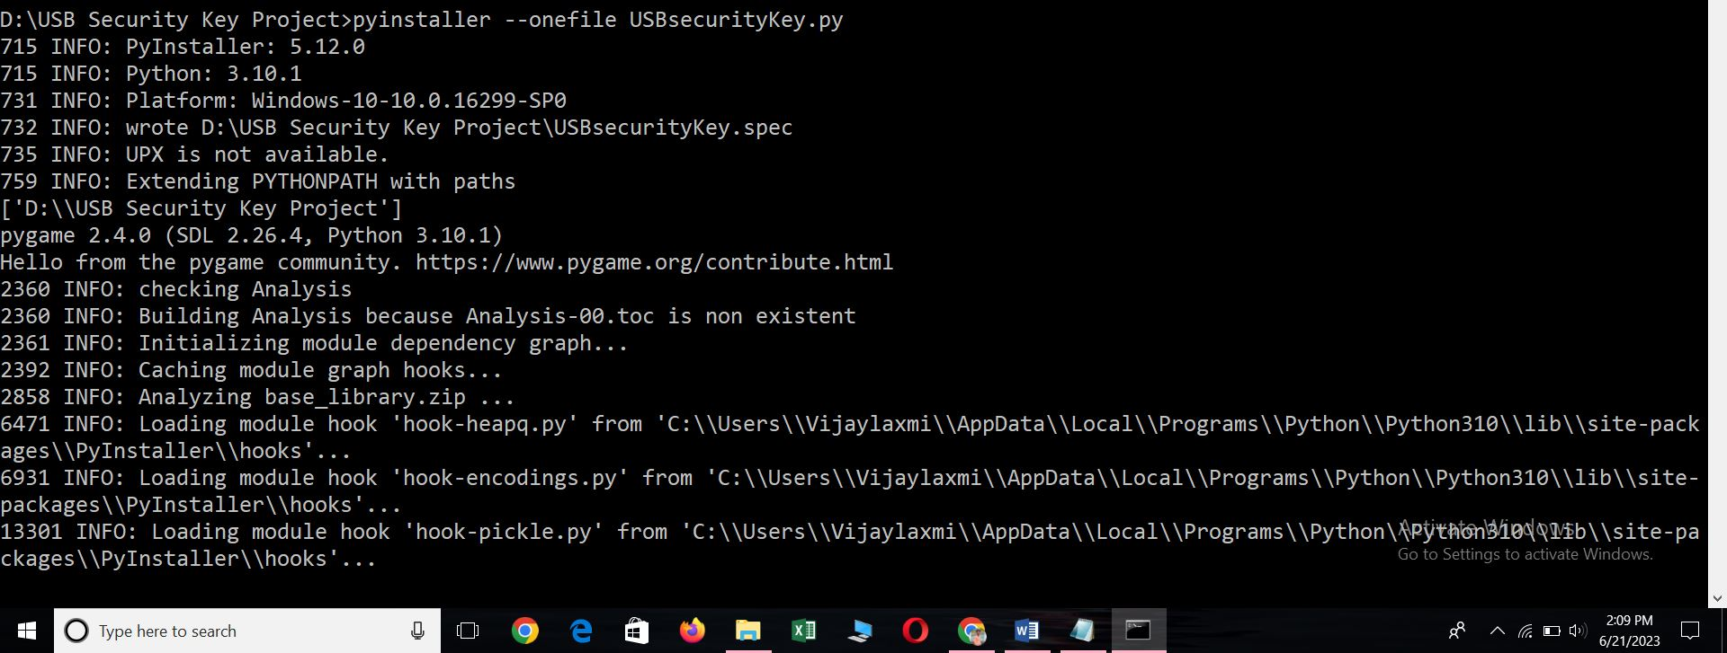
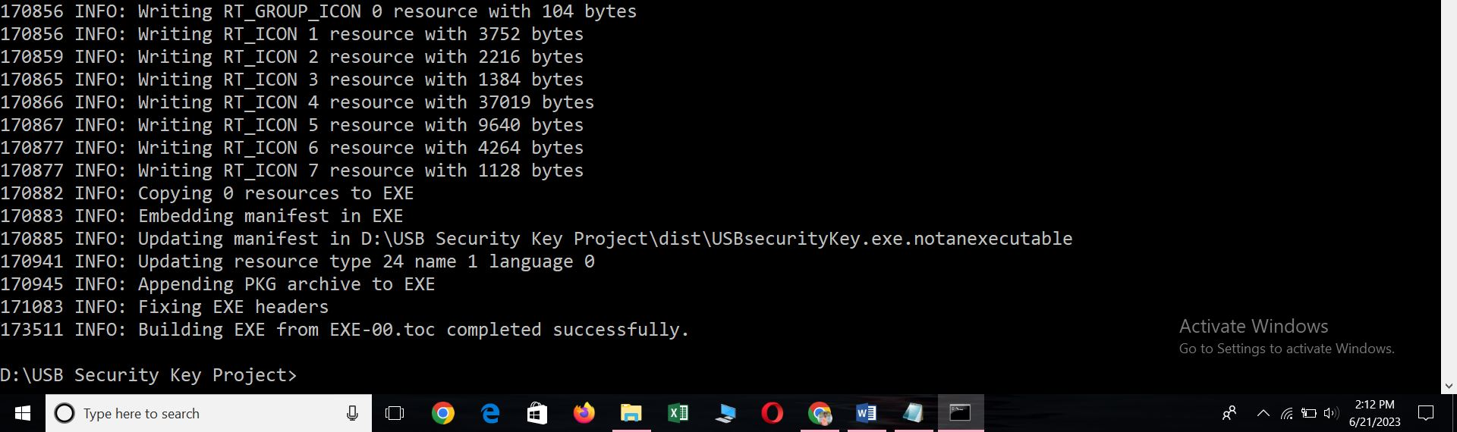

Here the Application has successfully installed…
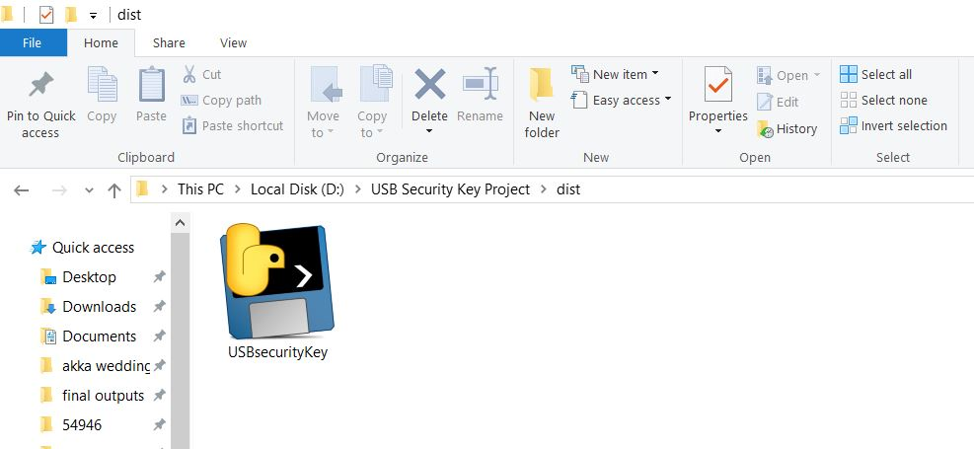

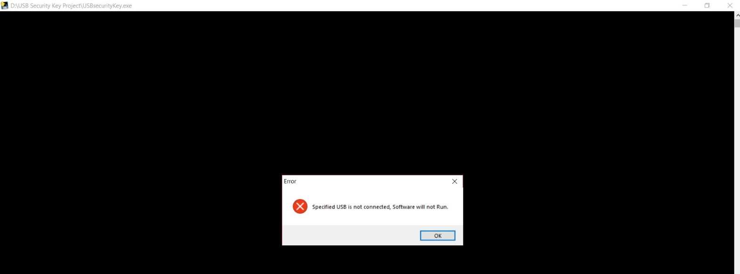
Let’s Start the Application

Here USB is not Connected >>> Close the Application
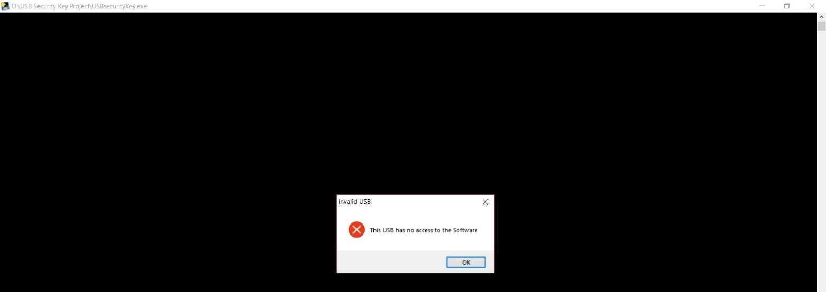

Here other USB is Connected >>> Application will not Run

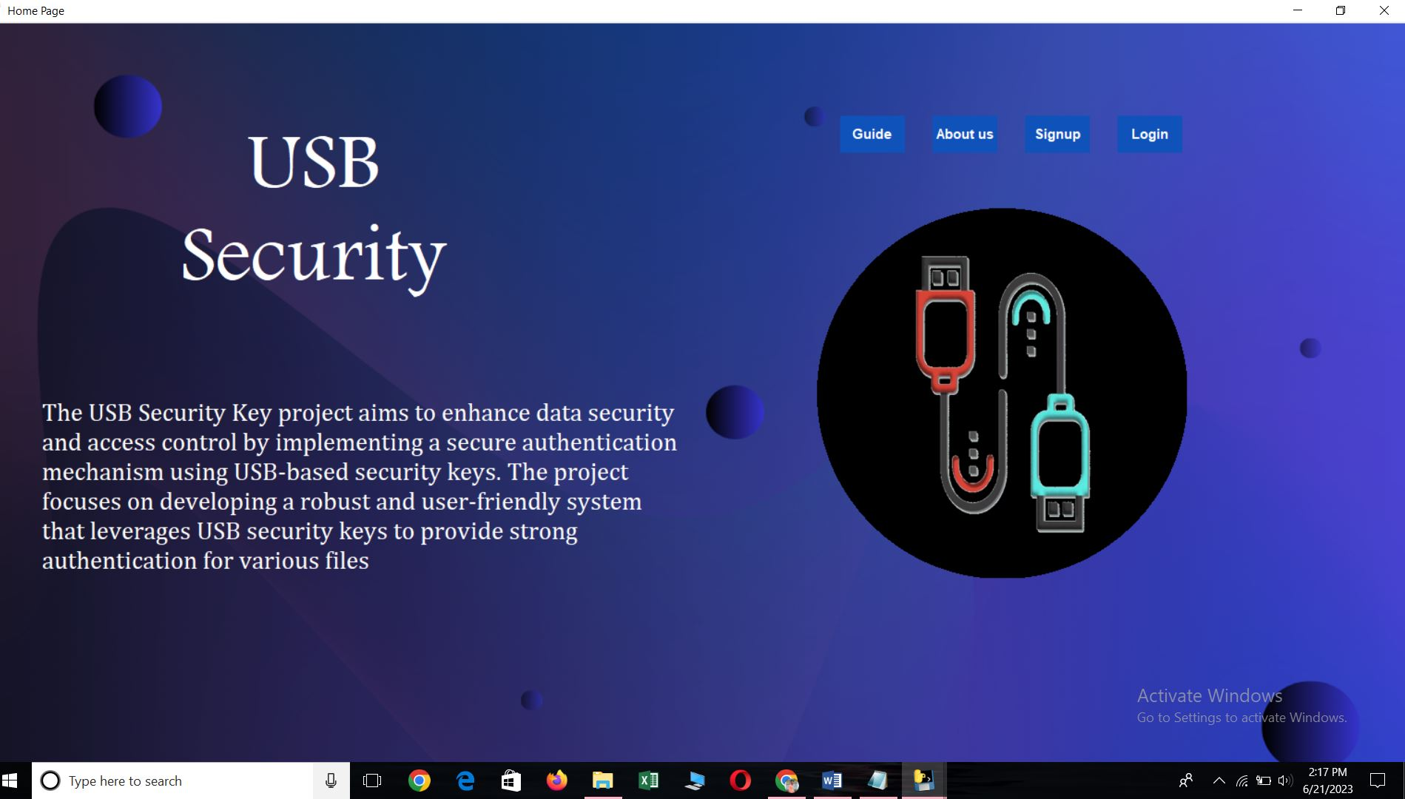

Output :



Click on Gide Button that will take you to Guide Page Window
Guide Button >> Guide Page Window

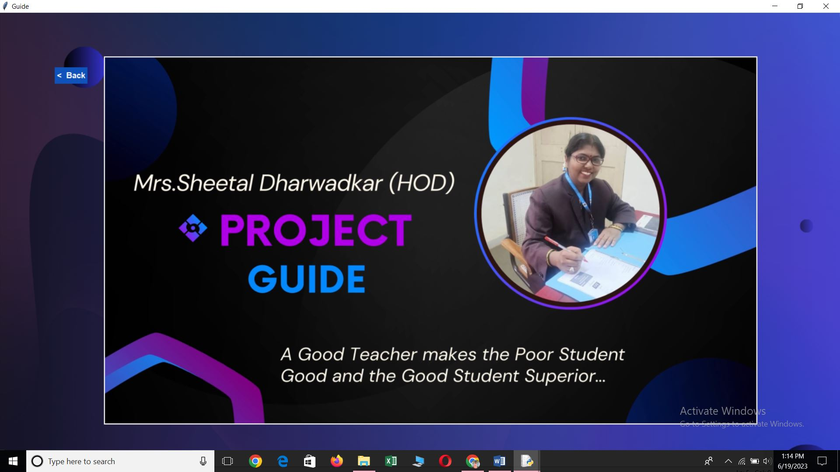

Click Back Button that will take back to Home Page Window
Back Button >> Home Page Window

On Home Page Window click on About us Button that will take you to the About us Page Window
About us Button >> About us Page Window

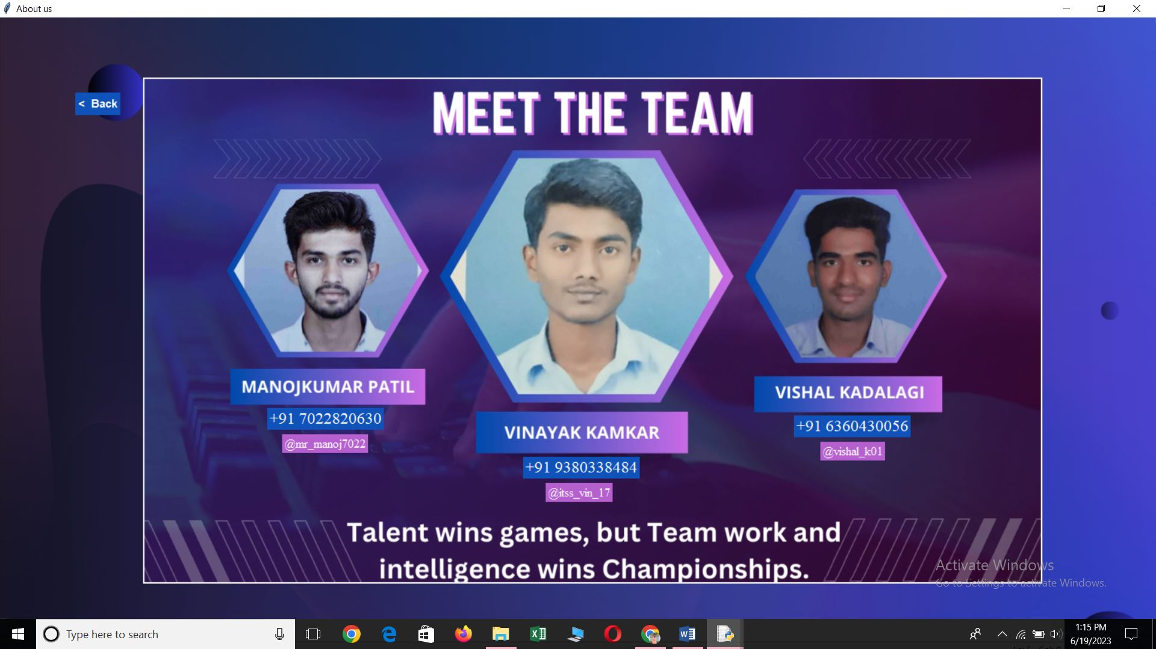
Click Back Button that will take back to Home Page Window
Back Button >> Home Page Window

########-------------------------------------

On Home Page Window click on Signup Button that will take you to the Signup Page Window
Signup Button >> Signup Page Window
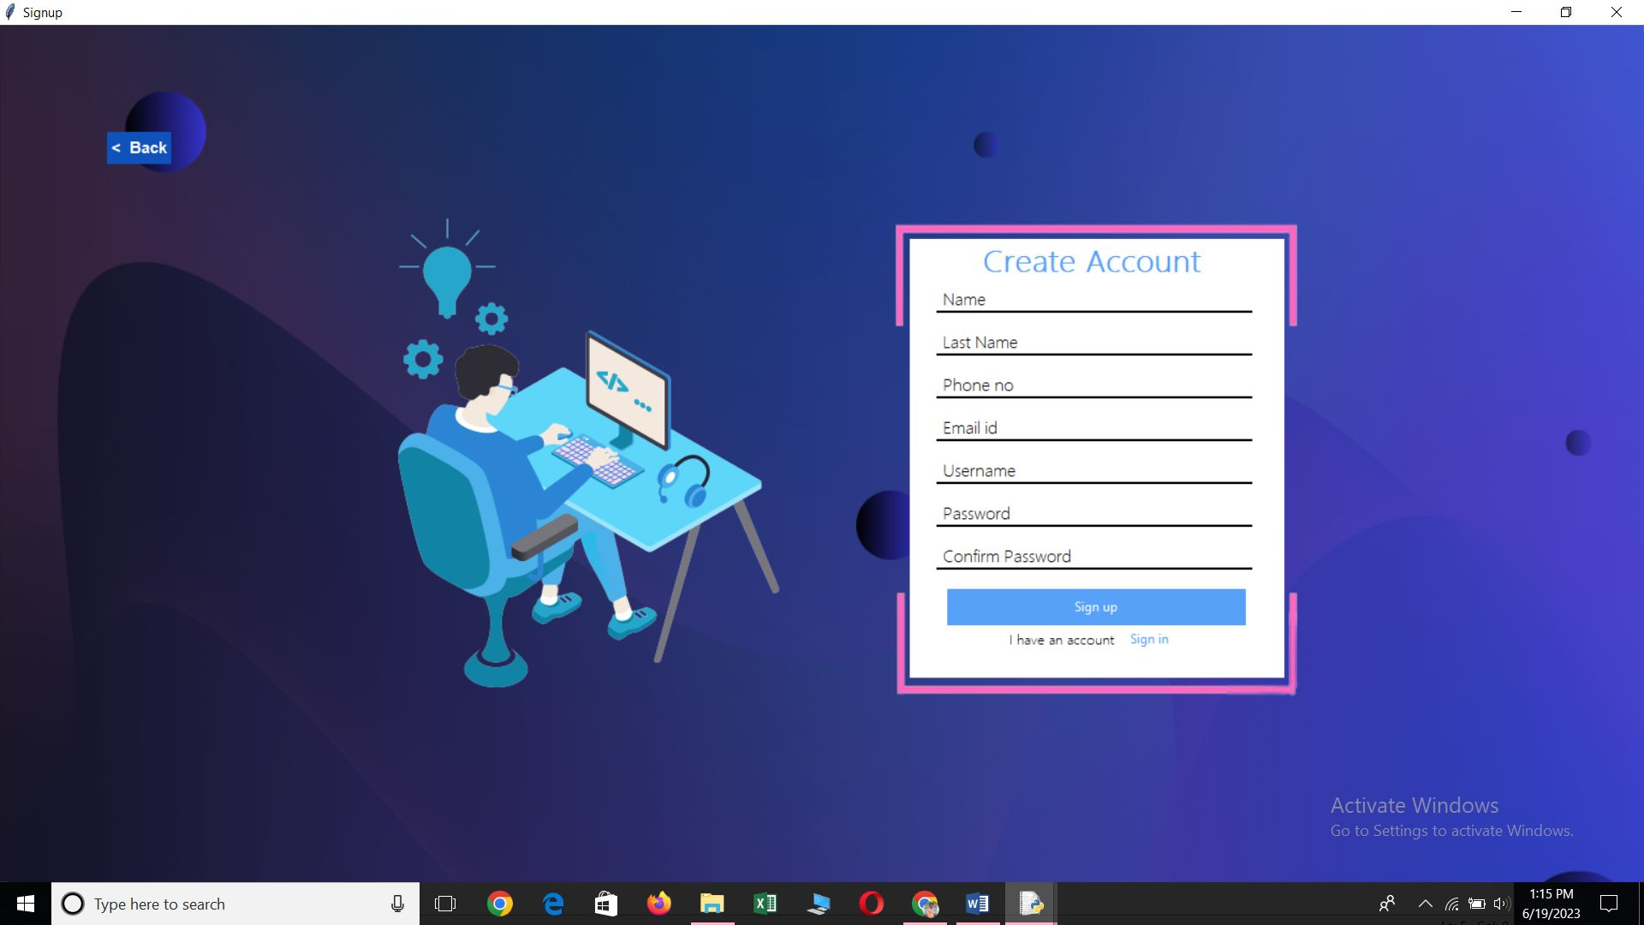
Click Back Button that will take back to Home Page Window
Back Button >> Home Page Window

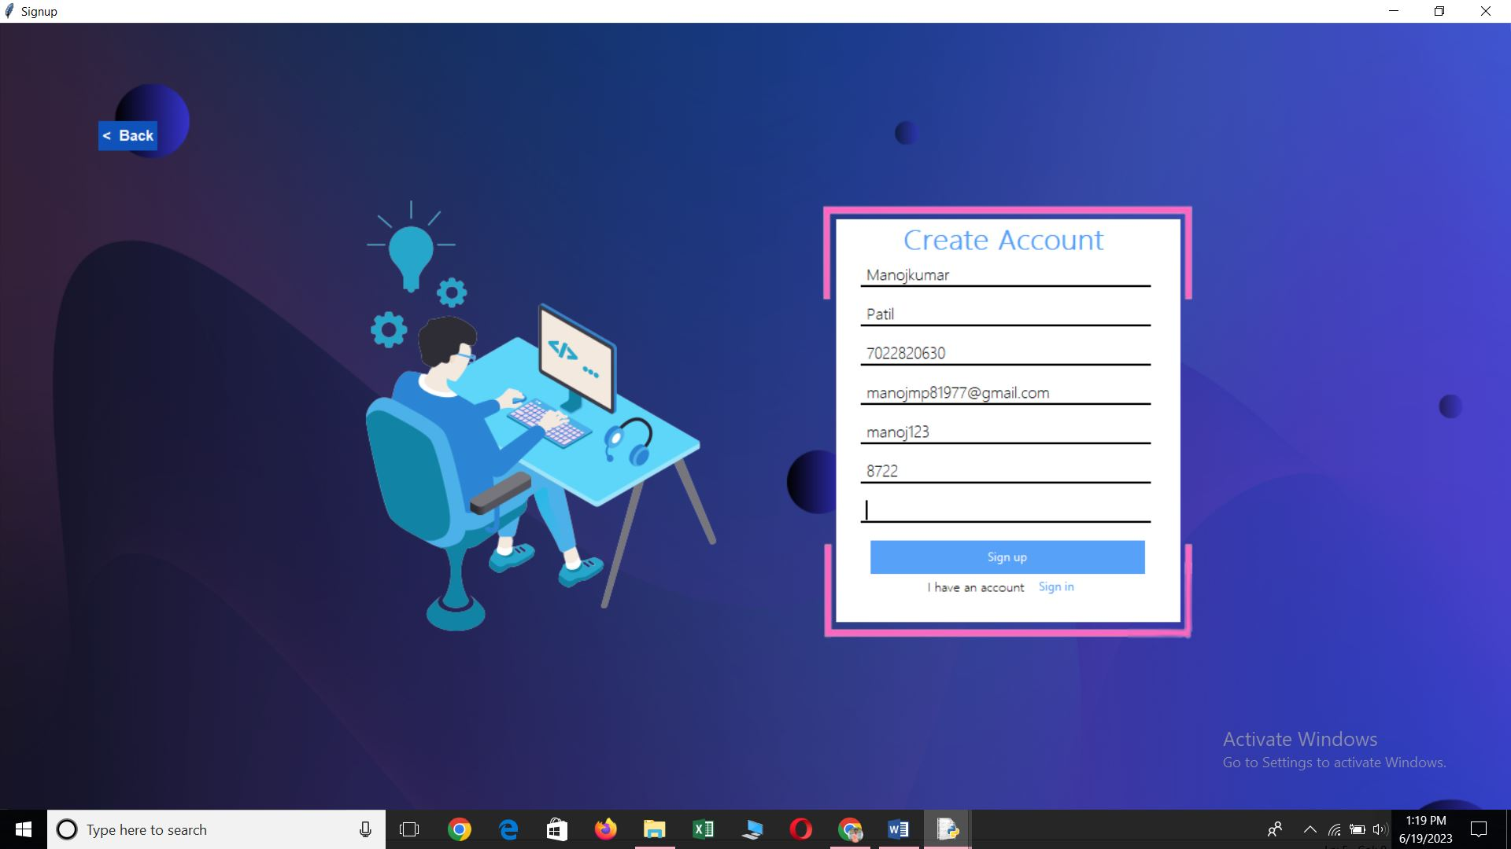

Click Back Button that will take back to Home Page Window
Back Button >> Home Page Window
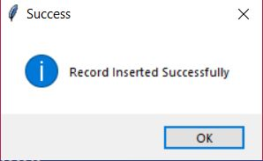
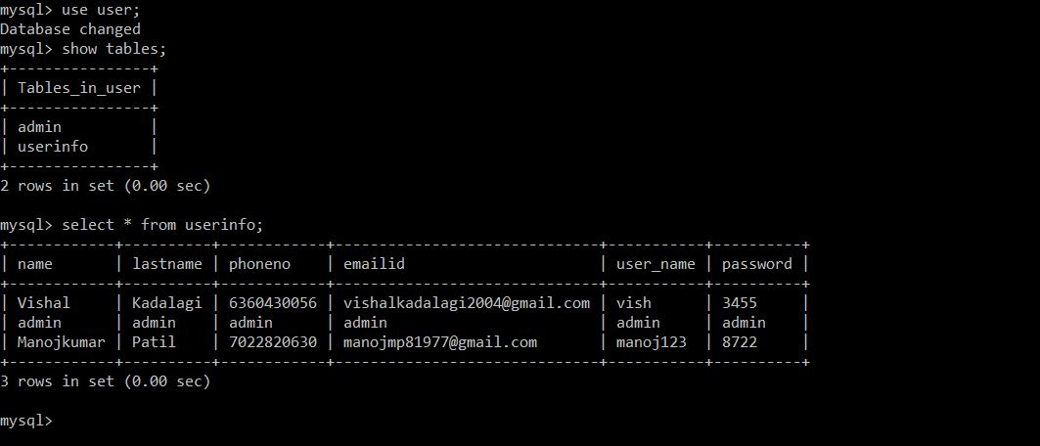


On Home Page Window click on Login Button that will take you to the Login Page Window
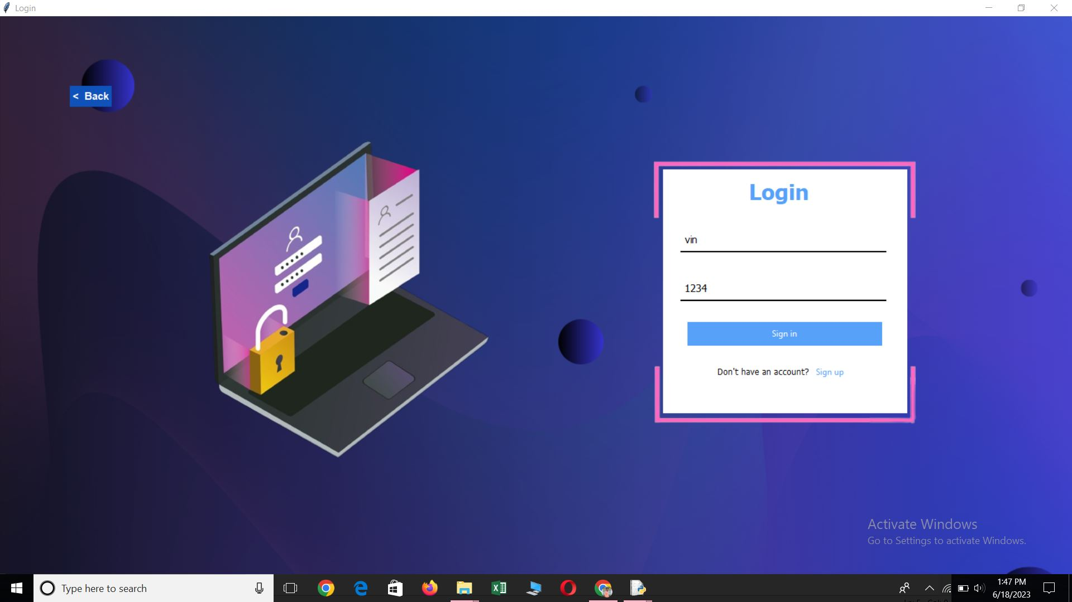
Login Button >> Login Page Window

Click on Sign in Button
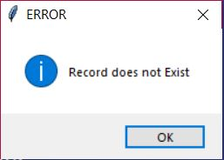
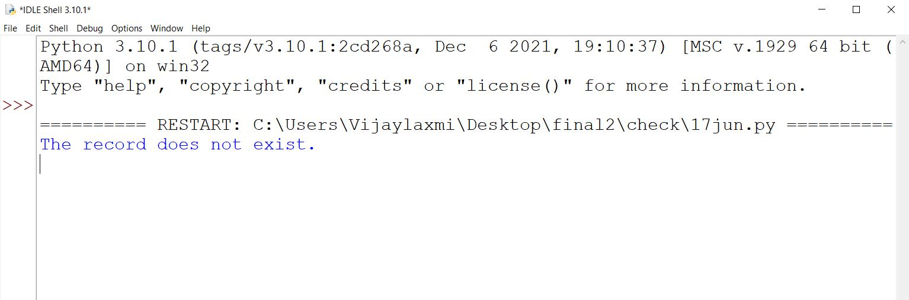

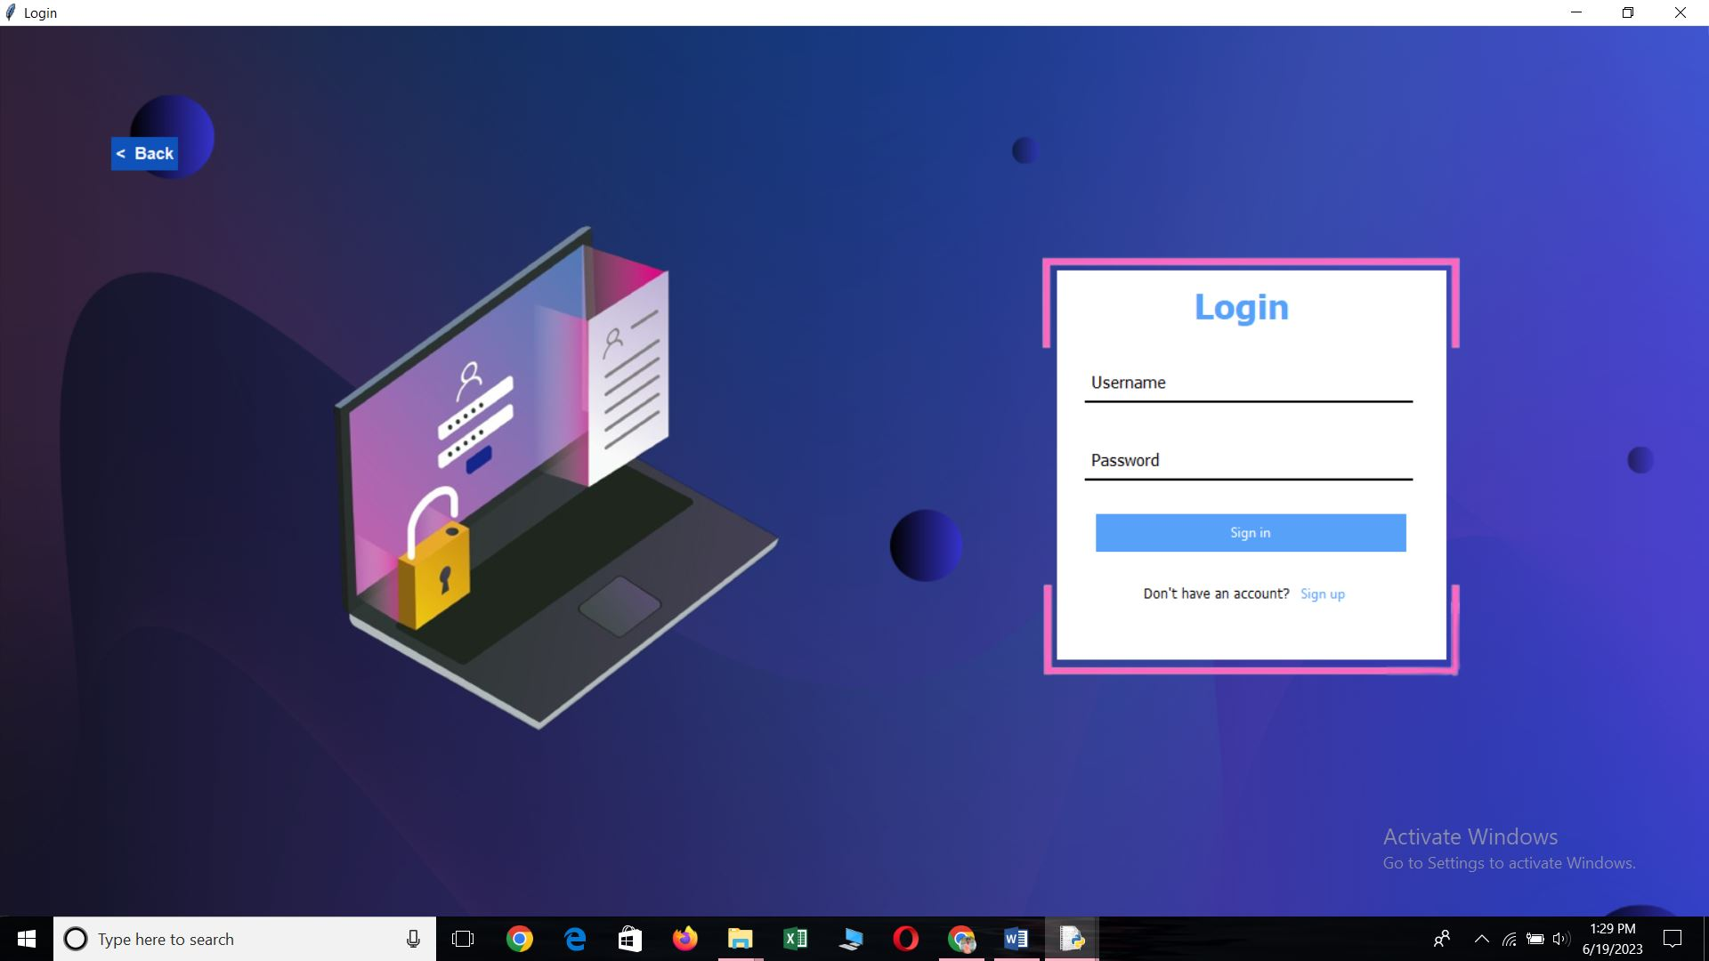
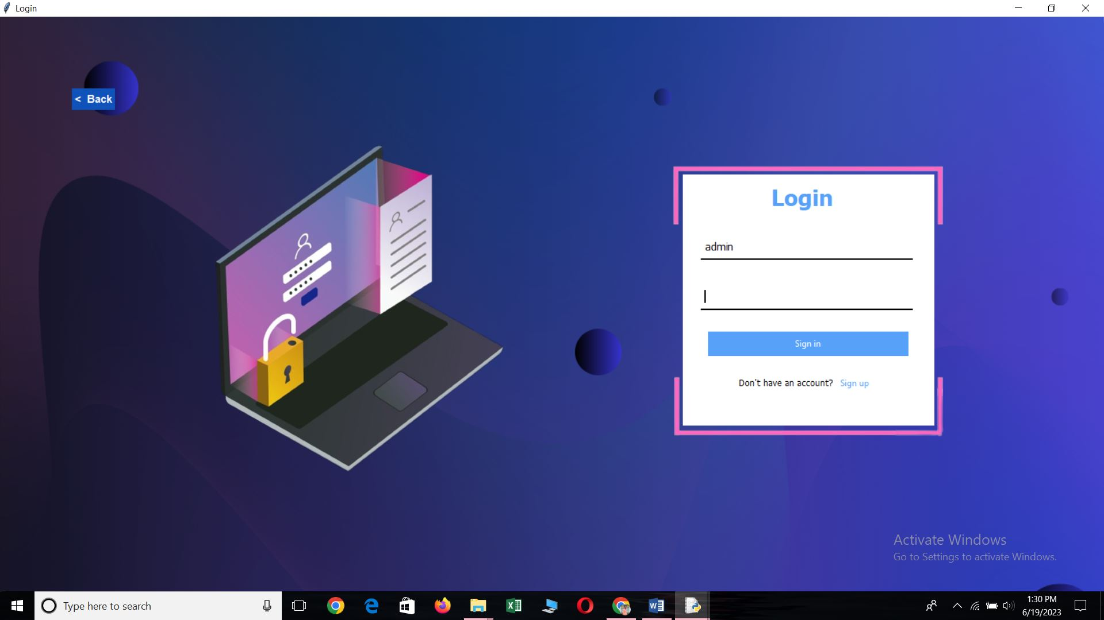

Username : admin
Password : admin
>>> click on Sign Button

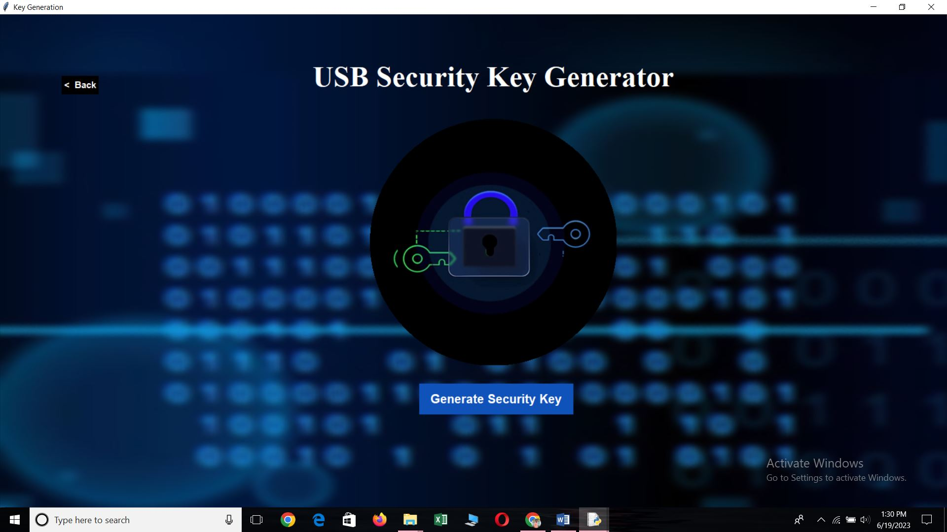

Click on Generate Security Key Button

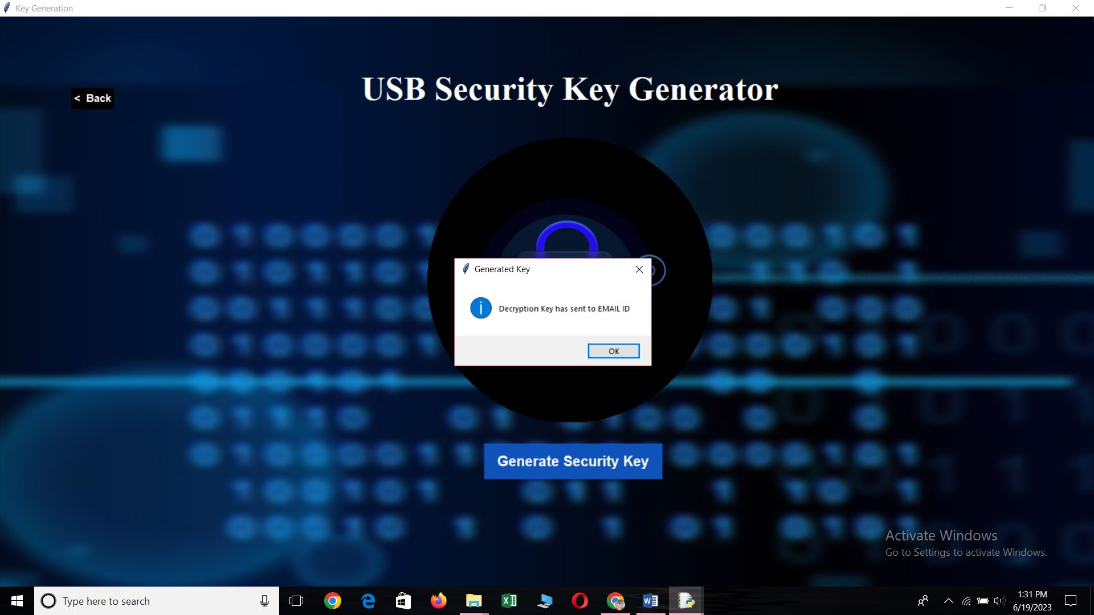
Click Back Button that will take back to Login Page Window
Back Button >> Login Page Window

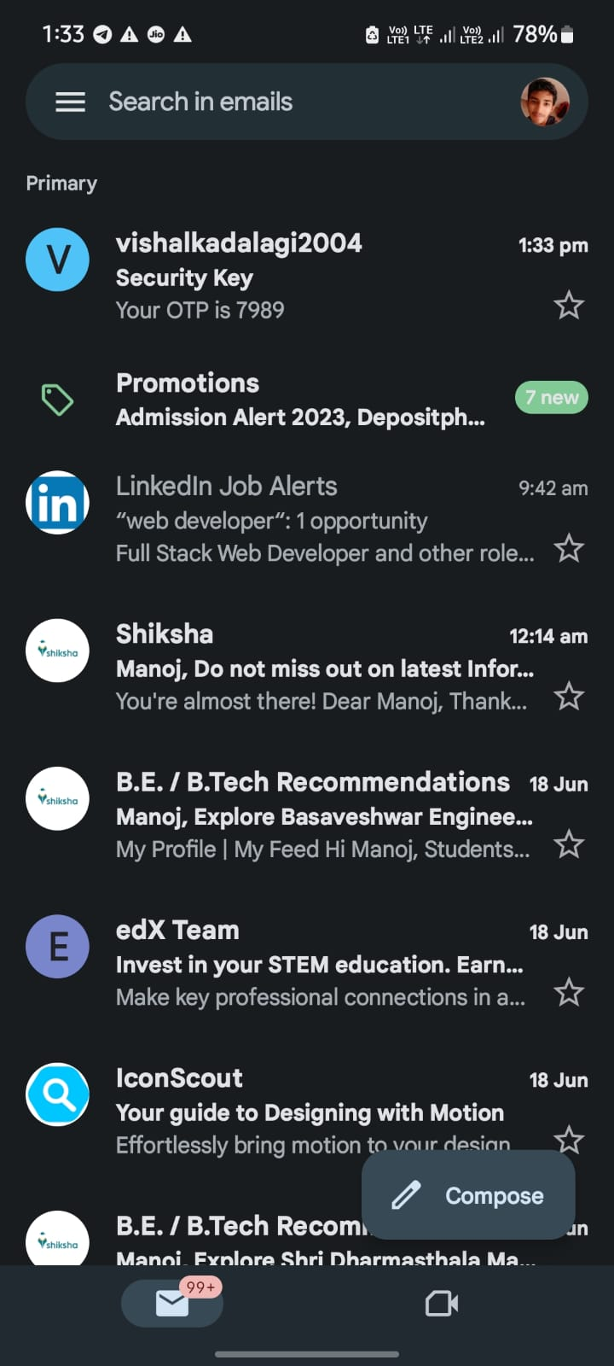
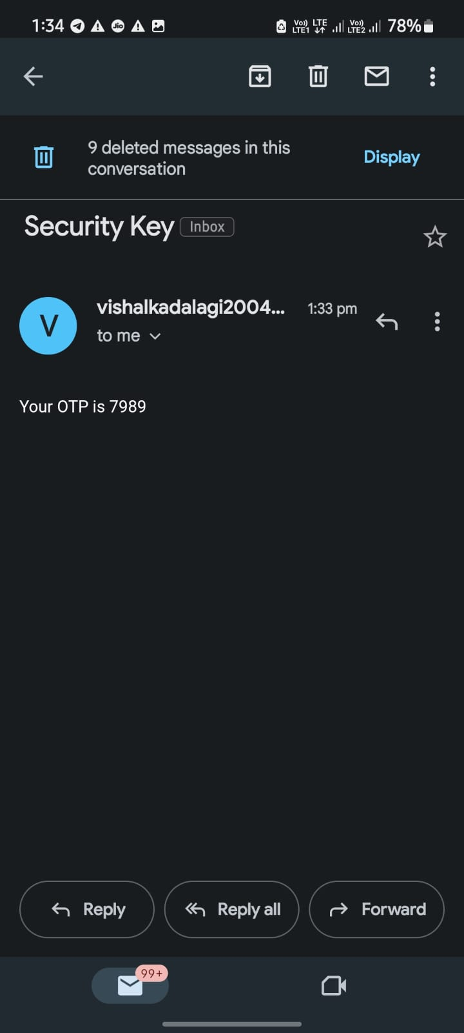
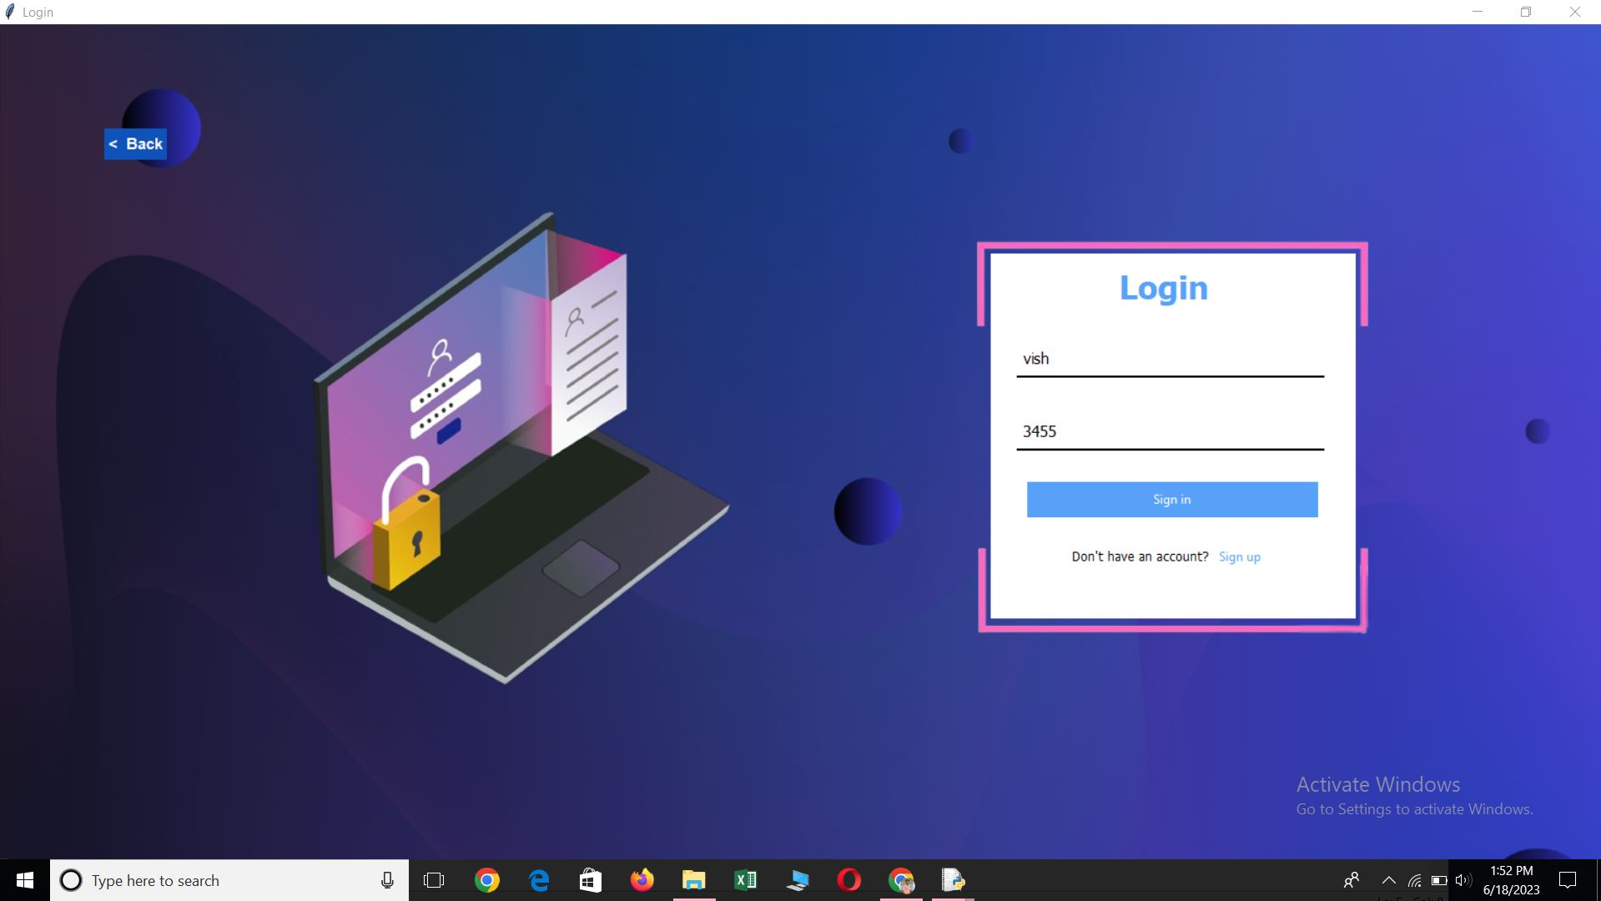

Username : vish
Password : 3455
Or use other Accounts
>>> click on Sign Button

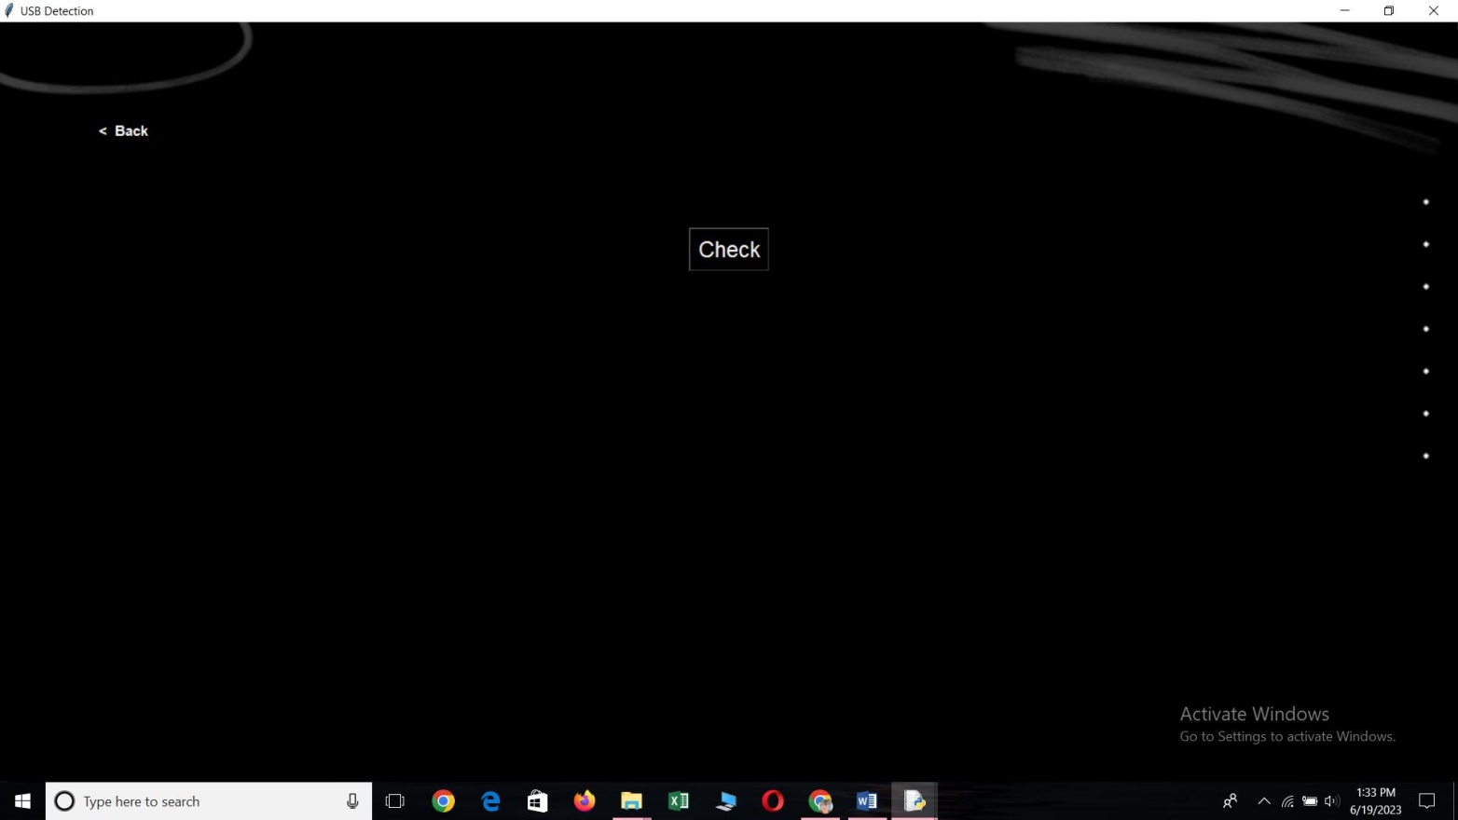

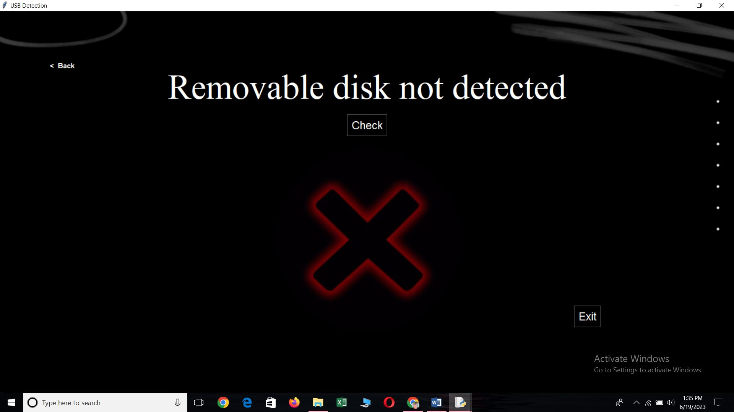
Click on Check Button

Here the USB or Removable disk is not connected, so it will not access to the Next Window
Click on Exit Button it will take you to Login Page Window
Exit Button >>> Login Page Window
So please kindly plug in your USB or Removable disk
Then RELOGIN



Username : vish
Password : 3455
Or use other Accounts
>>> click on Sign Button

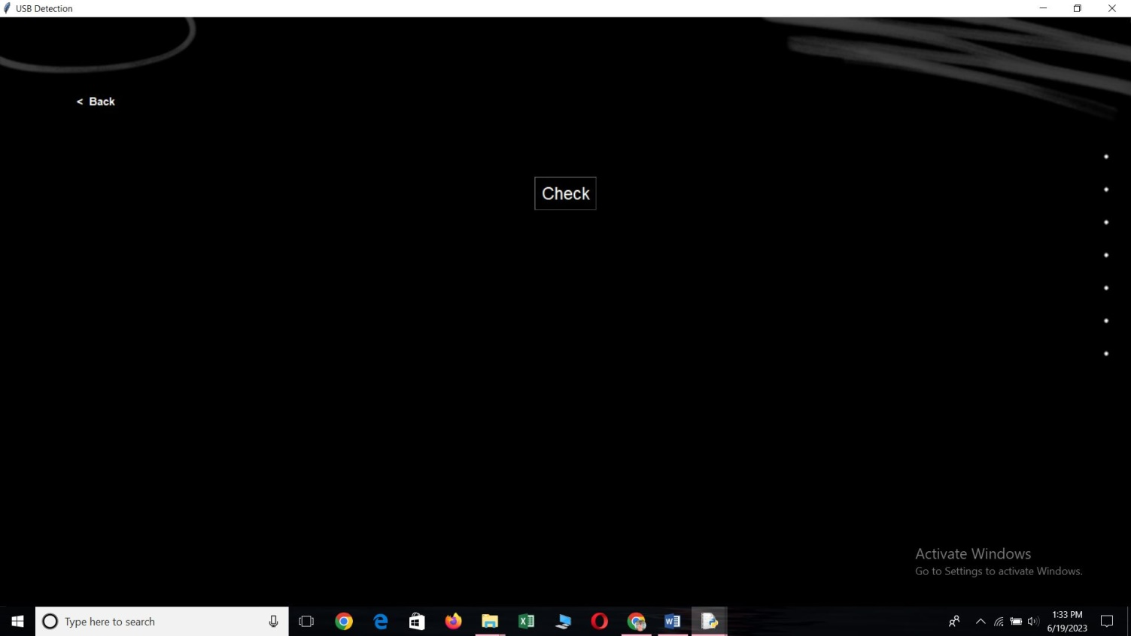

Click on Check Button

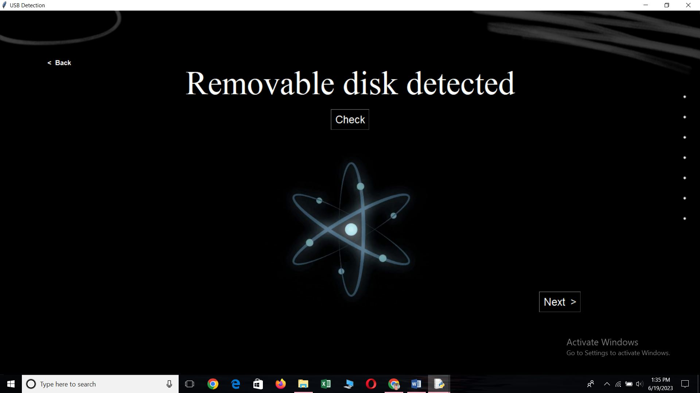

Click on Next Button

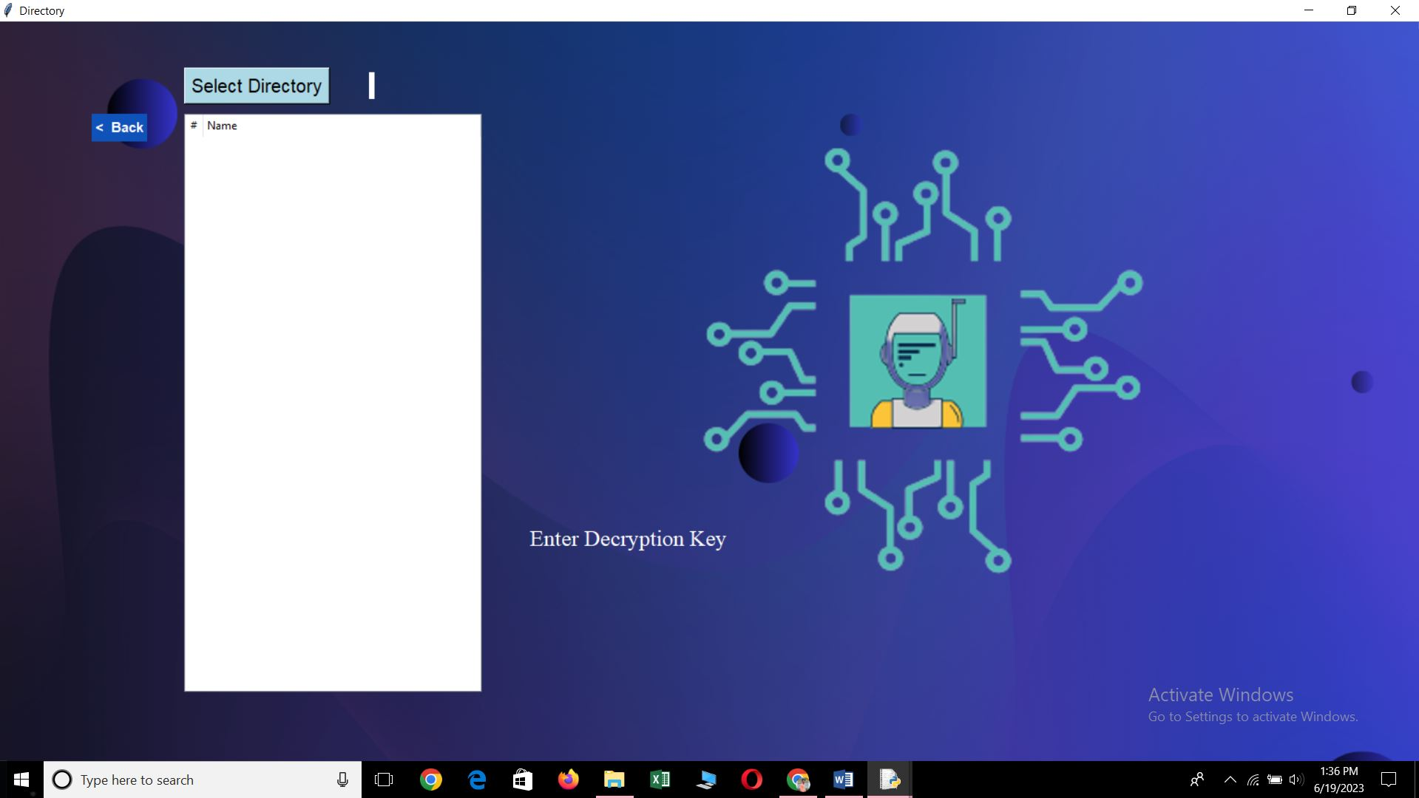

Select Directiory Button >>>

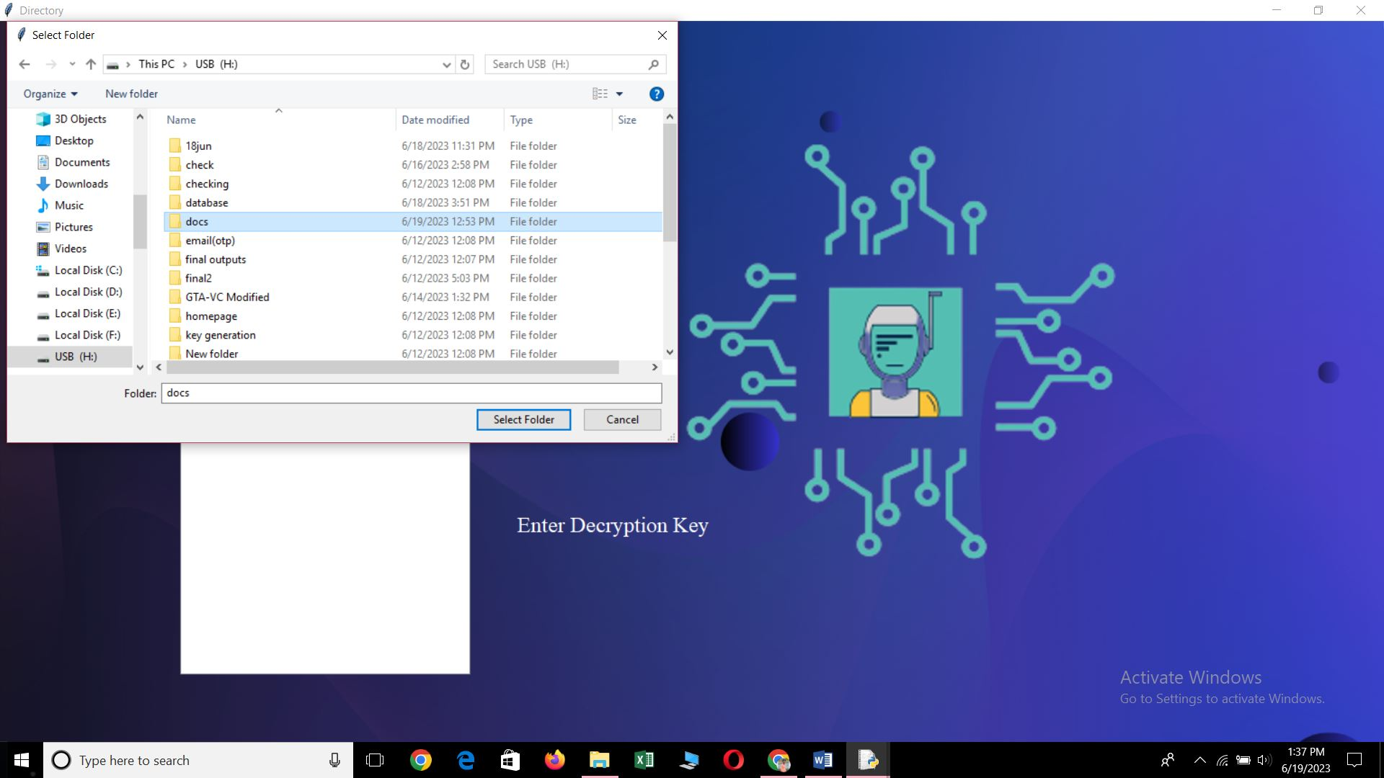

Select the Folder

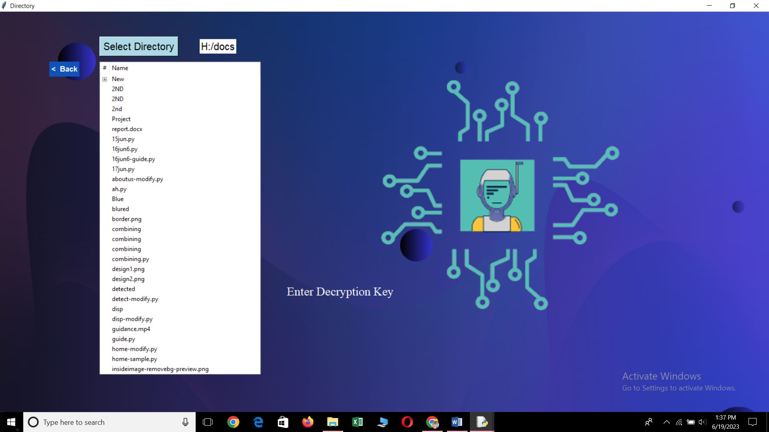

Double click on the file which you want to decrypt

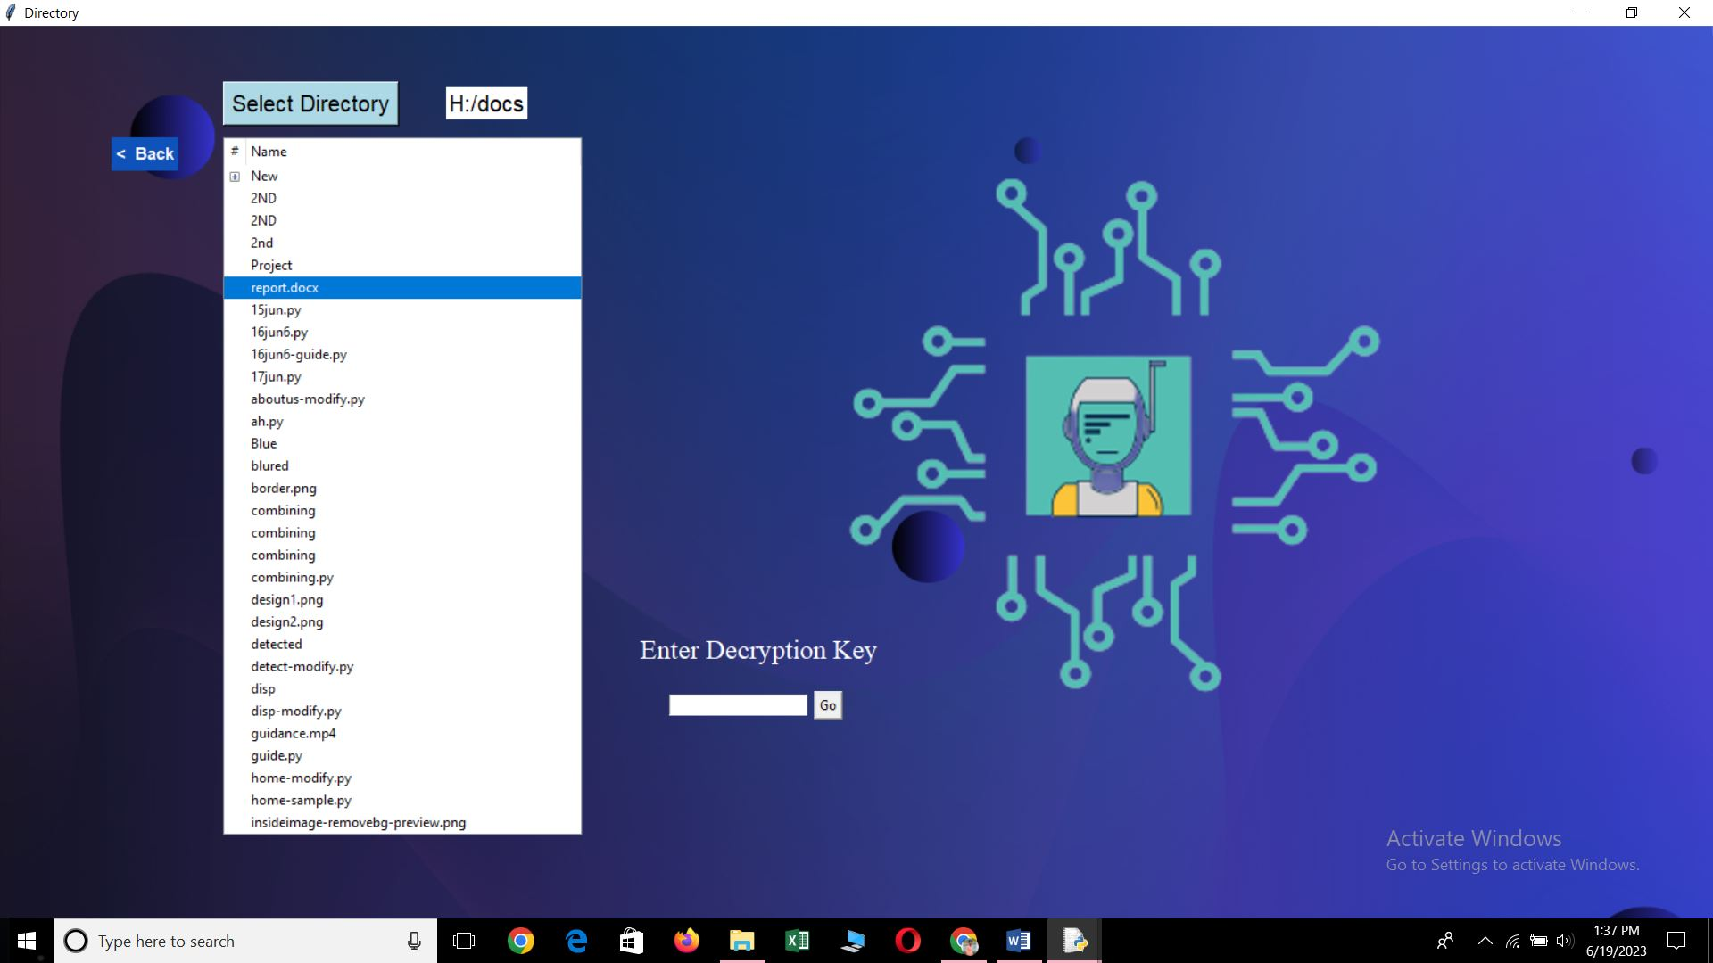

Bank box will get displayed

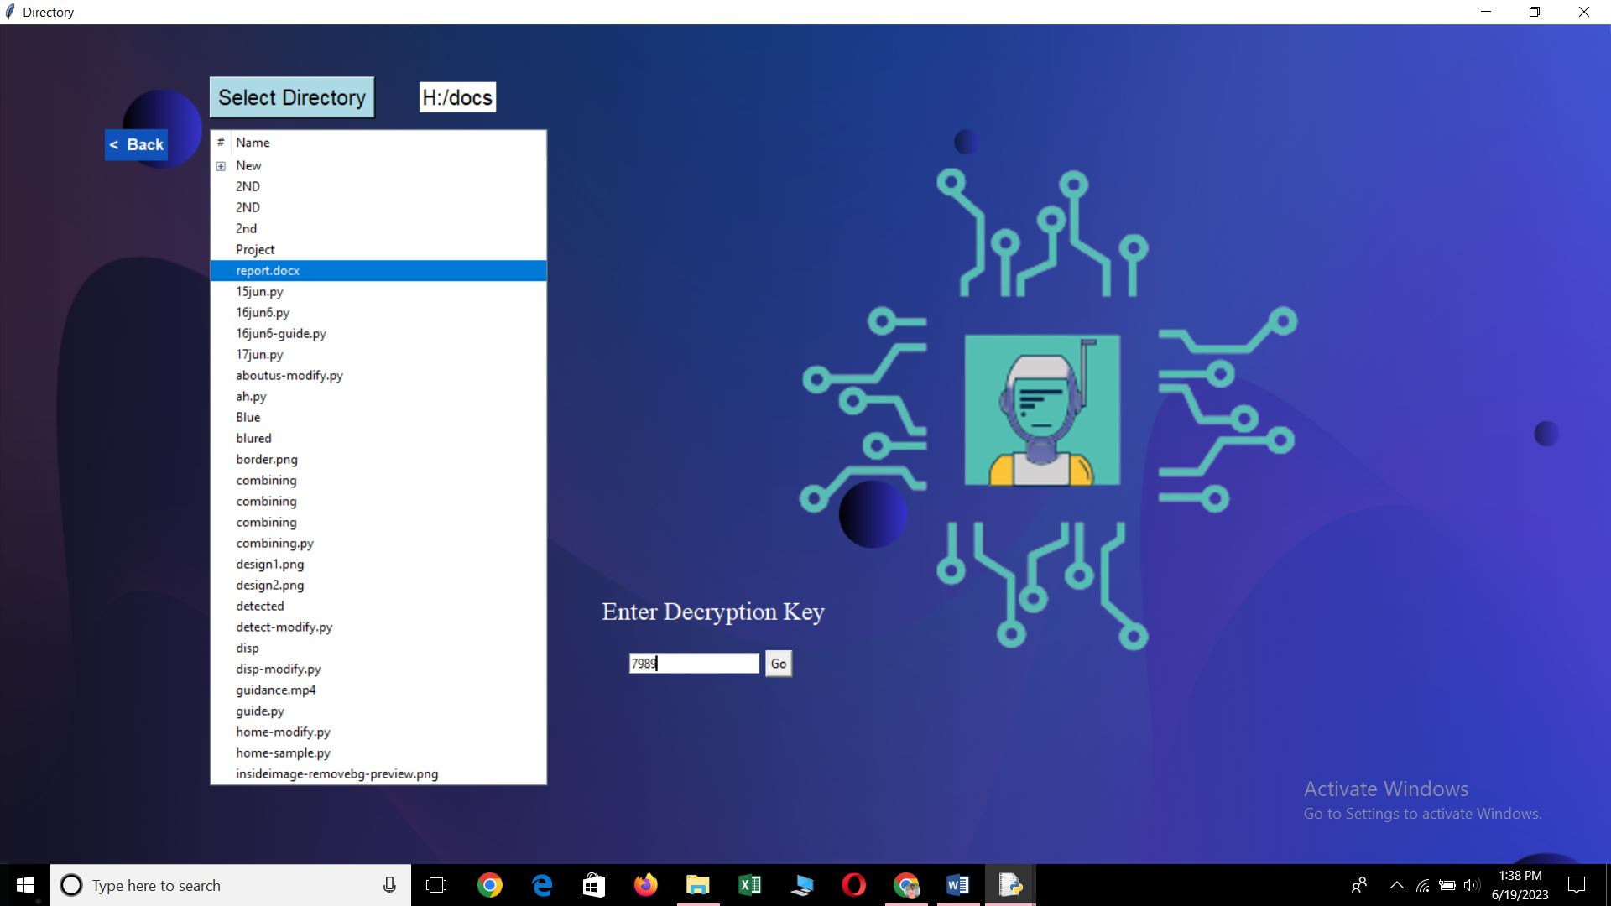

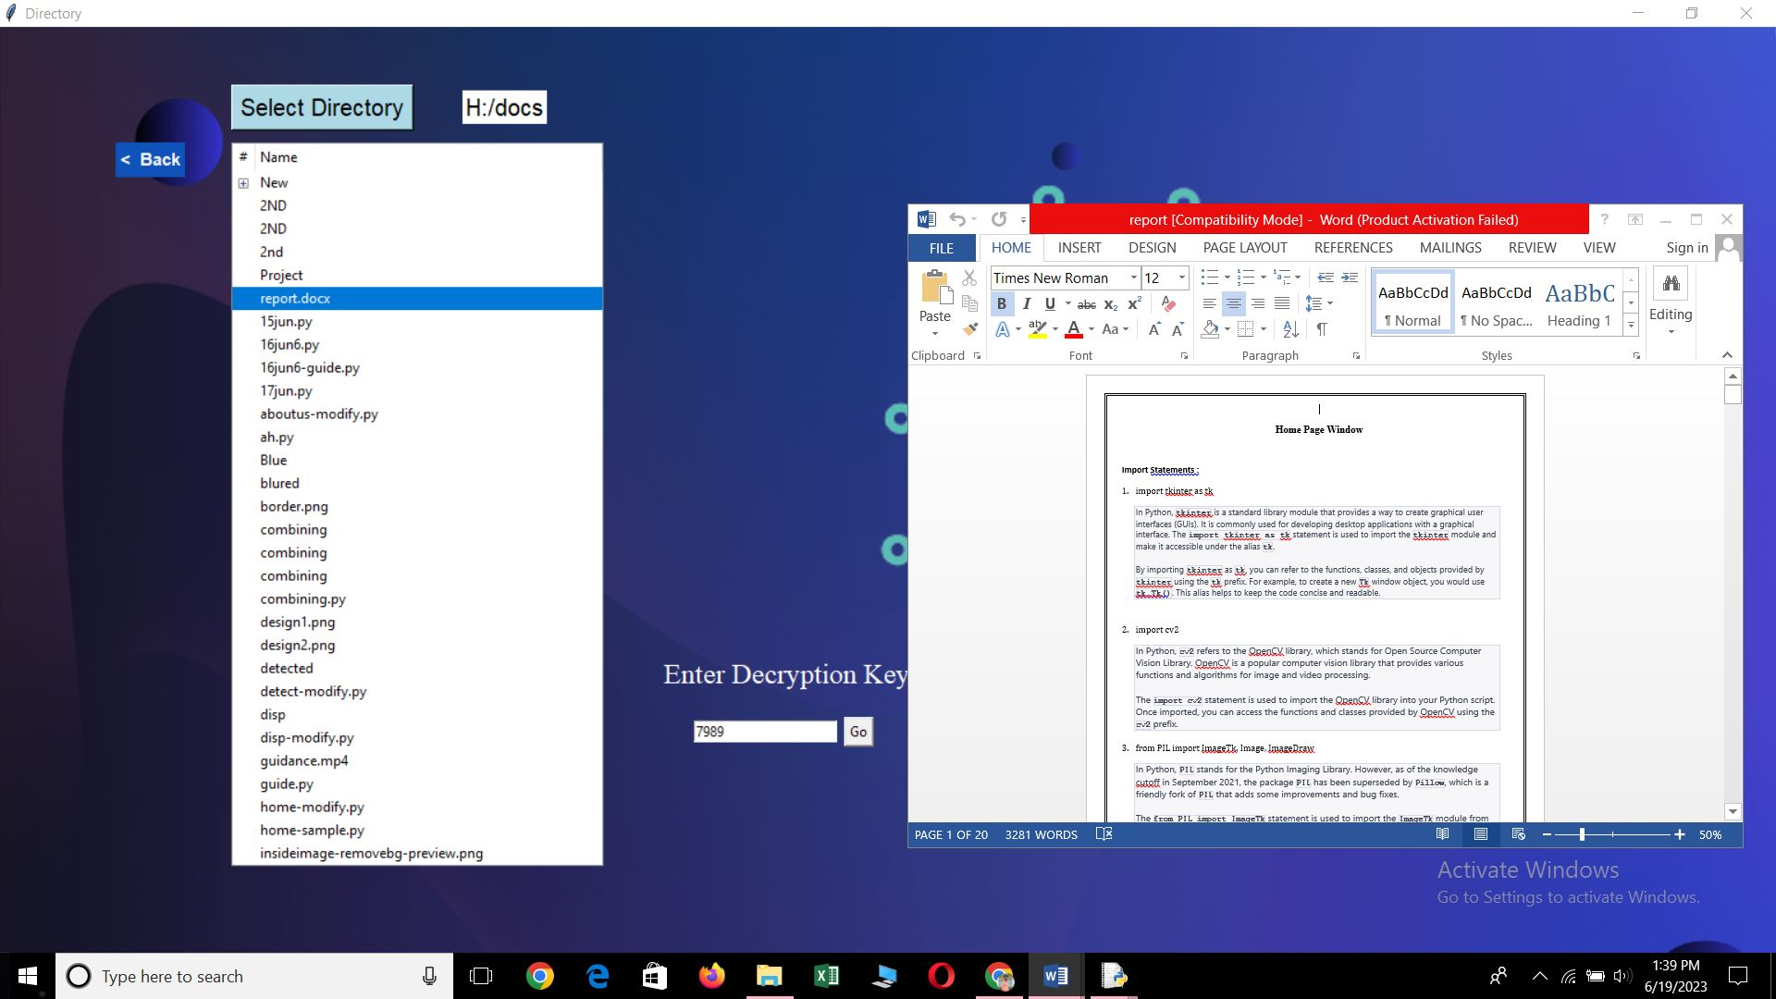

Enter the Decryption or the Security Key which sent to the EMAIL ID… >>> click on Go Button

Here the DOC file gets Decrypted and gets opened

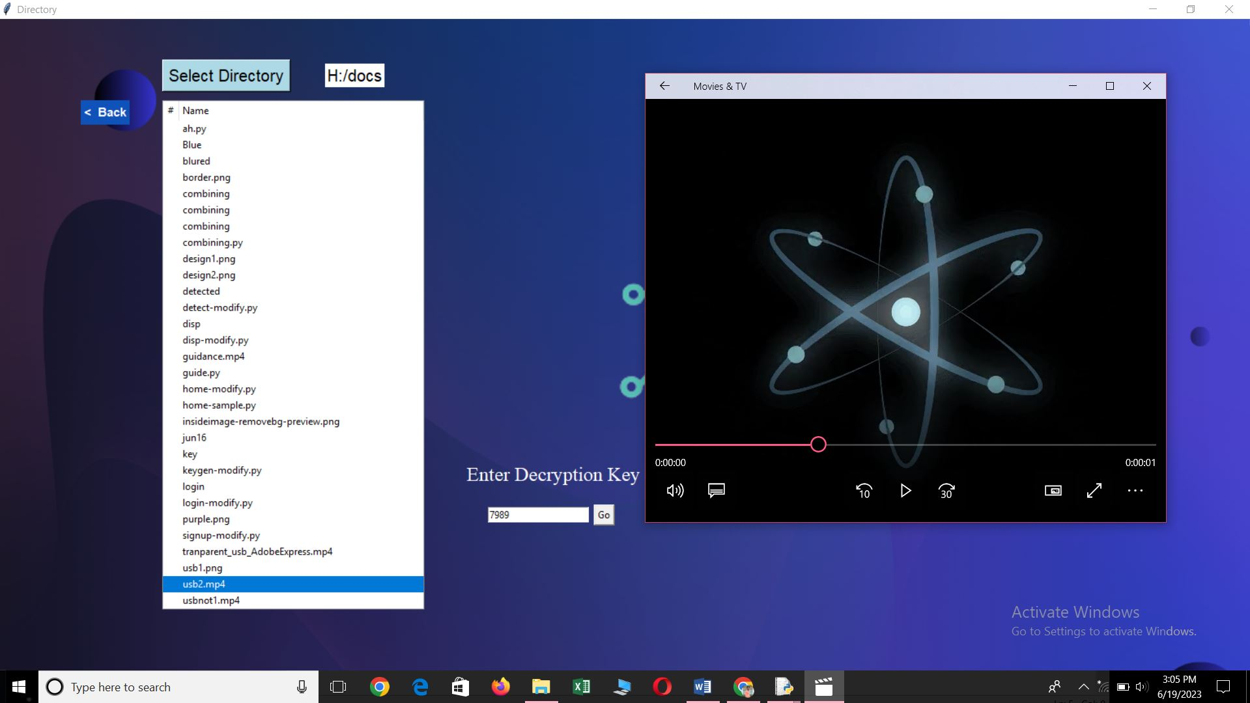

Here the mp4 file gets Decrypted and gets opened

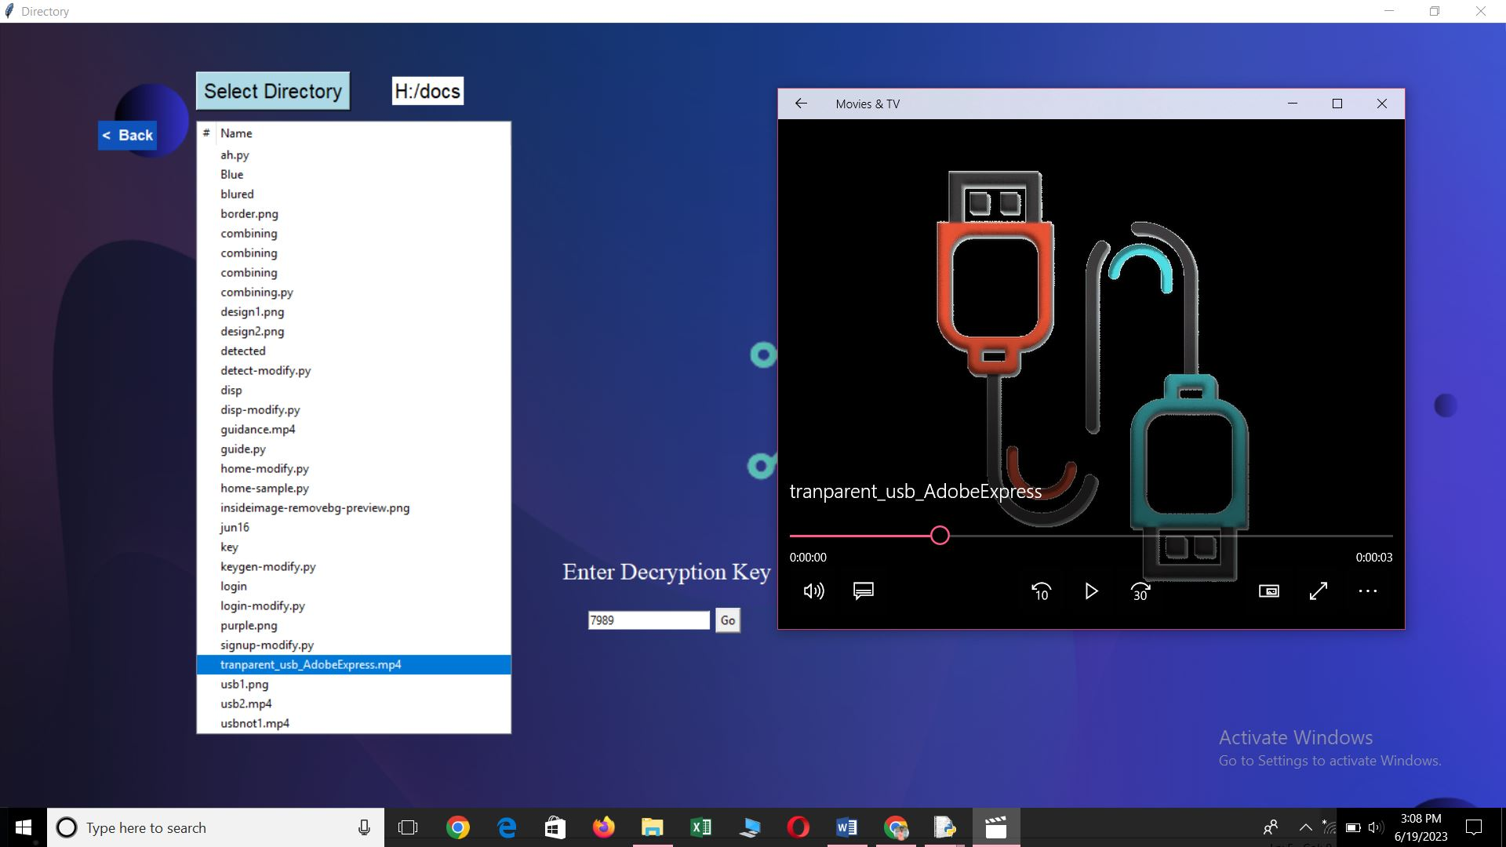

Here the mp4 file gets Decrypted and gets opened

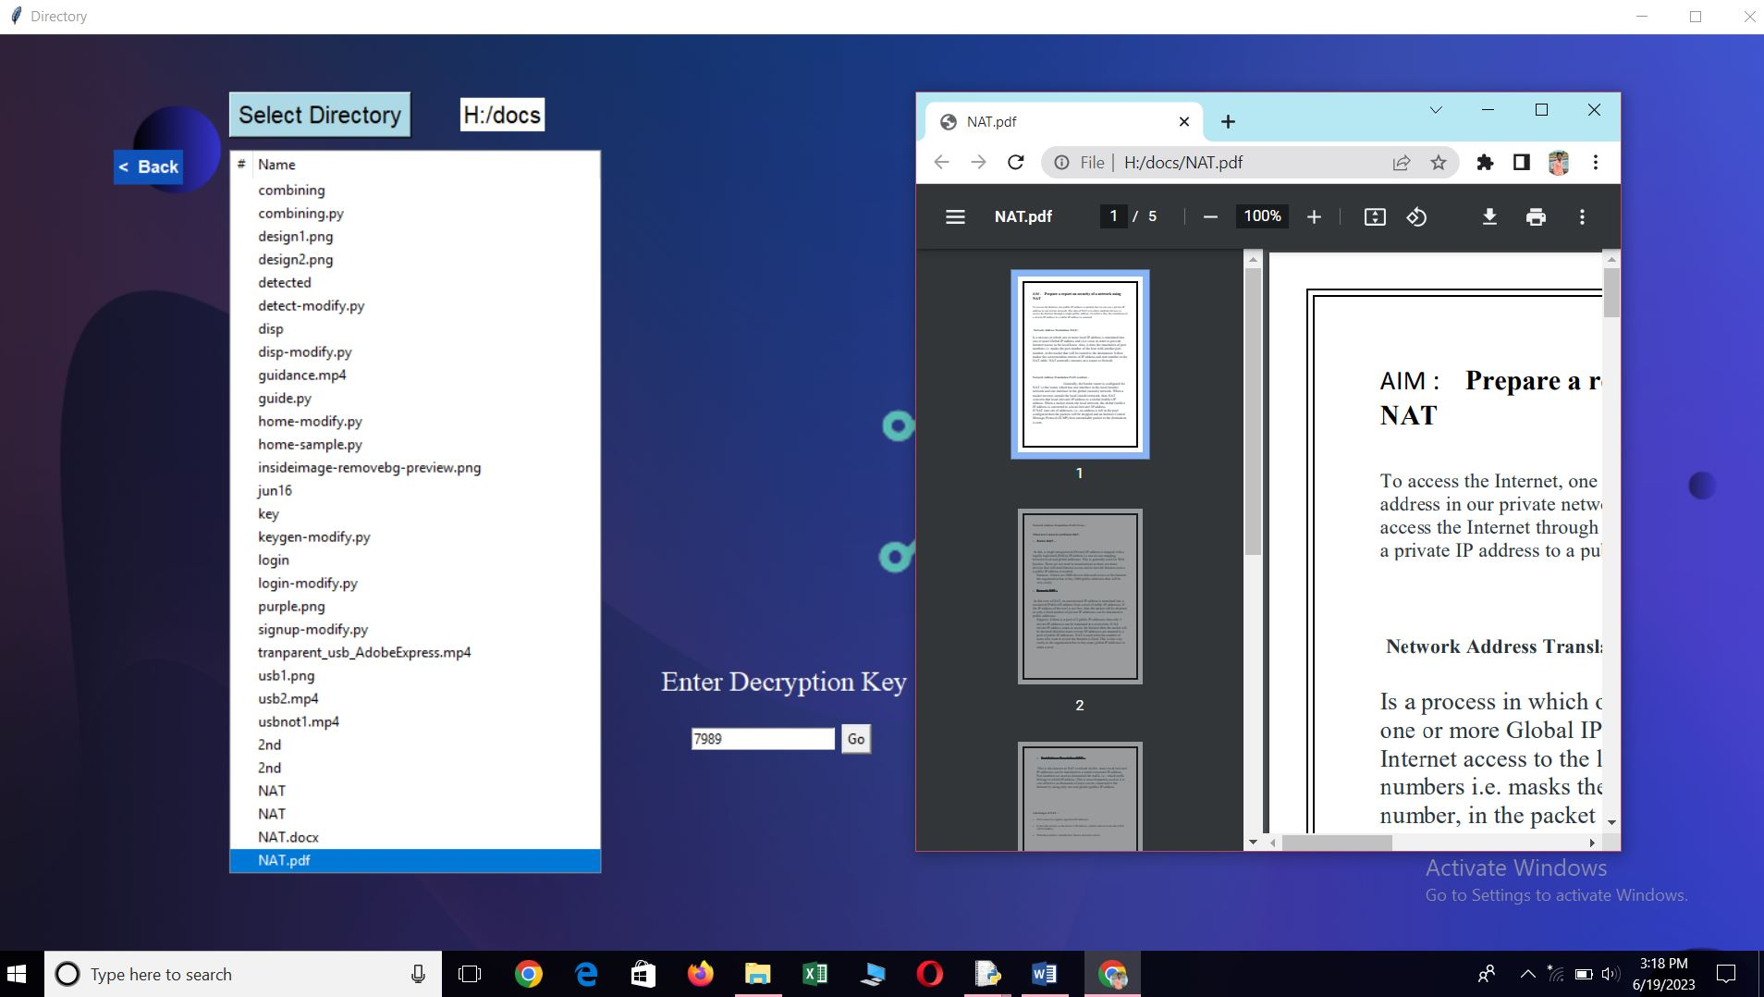

Here the PDF file gets Decrypted and gets opened

